2025-2026 Review Cycle TITLE PAGE

TABLE OF CONTENTS

Narrative: Page
- Overview of the Unit and Governance

- Actions taken in response to the most recent APR (and/or accrediting organization) review recommendations
- Undergraduate Program

- Graduate Program

- Faculty

- Vision and Strategic Direction

- Conclusions

List of Appendices:

- Unit’s Promotion and Tenure Guidelines (updated since the previous APR)

- Unit’s Annual Performance Evaluation Guidelines

- Most Recent Final Report (s) from Accrediting Organization(s) of the Degree Programs, if applicable.
- Faculty Mentoring Program (if applicable)
- Most Recent Strategic Plan of the College

- Most Recent Strategic Plan of the Unit (updated since the previous APR)

- Unit Program List (required - example template included)

NARRATIVE:
- Overview of the Unit and Governance - This section should provide general information about the unit, including a brief history since its inception and details on its academic and administrative governance.
  - State the importance of the program(s) offered by the unit to the university and the community as a whole.

  - Describe the unit’s leadership structure. List the director (or chair) and any vice- chairs and their duties. Describe how departmental (school) committees are organized, members appointed, and how they function. Indicate how these duties are taken into account in determining the overall workload of the faculty involved (e.g., are course reductions given?). Identify any problems with the administration of the unit and the academic programs housed in the unit and propose possible solutions.

  - If the unit has an advisory board, discuss the role of the advisory board in the governance or operation of the program(s).

  - Describe the faculty hiring and retention processes, include strategies for reaching out to a diverse group of candidates. Provide data on the number of faculty members who have left the department for reasons other than retirement during the past five years; and specify actions taken within the past five years to improve retention of faculty.

  - Provide the unit’s most recent promotion and tenure guidelines as Appendix I and annual performance evaluation guidelines as Appendix II. If possible, include the promotion and tenure guidelines from 2-3 peer or aspirational peer units and compare standards.

  - Describe unit’s efforts to recognize meritorious faculty including the nomination process for internal and external awards and recognition. List the faculty nominations and awards received since the last review.

  - Describe the adequacy of the unit’s current space in meeting the educational needs.

  - Describe the adequacy of the current staff in meeting the needs of the unit.

  - Describe the environment in which faculty, staff, and students work together and the role of the leadership in providing a cohesive and supportive work climate for the group. How does the unit assess the work environment quality?

  - Describe sources of financial support that aid the mission and goals of the unit, providing an overview of how the unit supports its program(s) financially. Provide a basic annual budget, including both revenues (including E&G funds, grant funds, college funds, OU Foundation funds, funds from AP courses) and expenditures by category.

  - Describe any fundraising efforts, plans, or recent successes.

  - Identify significant areas of financial need; describe how this need affects the goals of the unit.

  - Given the current budget constraints, describe how educational mission of the unit can be strengthened without any additional financial resources.

- Actions taken in response to the most recent APR (or accrediting organization) review recommendations - In this section, provide a response to each recommendation from the previous APR review. If a degree program (bachelor, masters, and/or doctoral) has (have) been reviewed by a national accrediting organization, provide their final review reports as Appendix III and discuss the unit’s action plans in this section.

- Undergraduate Program

General Information

    - List undergraduate degree programs, minors, and certificates offered by the unit.

    - Discuss the enrollment trends and projections for each of each program offerings.

    - Discuss student diversity. Describe efforts to promote and recruit diverse student groups into the program from K-12 schools and community colleges.

    - What are the one-year average retention and six-year average graduation rates from each of your unit’s programs and from OU for the first-time full-time degree seeking freshman cohort? Same for transfer students?

What are the reasons for such attrition rates? Have you taken any actions that were effective in decreasing the attrition rates? What actions should you undertake in order to improve one-year retention and six-year graduation rates from your programs?

    - Discuss academic preparedness of incoming freshman and transfer students. Describe services available to students to promote success within the first two years at the institution.

    - Describe the advising process for undergraduates including current processes for seamless transfer student advising.

    - Describe the undergraduate degree production trend for the unit and five- year goals for degree completions.

    - Discuss the student satisfaction survey results. Describe any planned changes in teaching, curriculum, advising, or other aspects of the program(s) or unit as a result of survey input.

    - Brief overview of the undergraduate degree programs (enrollment, graduation, employment, credit hours required, core areas, assessment, community engagement activities, including service learning courses, and other high impact teaching practices, etc.)

General Education Requirements

Discuss unit’s participation in the general education core program. Provide a list of the general education courses, including the unit’s capstone course(s), taught in the last five years, instructors of these courses, and average enrollment in each course.

  - Assessment: Documentation of Student Academic Achievement and Assessment of Student Learning Outcomes.
Because student learning is at the core of our mission and activities, it is vital that each department or program includes in its self study a report on how it uses assessment to monitor the quality of student learning in its degree program(s) as part of the overall continuous improvement process. Please provide assessment information on each of the following:
    - Expected Program Student Learning Outcomes: List the expected student learning outcomes for each degree program and, if applicable, any Graduate Certificates offered in the unit.

    - Assessment Activities: List and briefly discuss the activities used to measure the expected student learning outcomes. Activities should include direct and indirect measures of learning outcomes. Present a

summary of assessment activities in a table (see Example 1 for Undergraduate Programs and Example 2 for Graduate Programs). Include (if applicable) examples of tools (e.g., rubrics) used to gather student direct assessment data or survey tools used to collect indirect assessment data (student perceptions). Describe how faculty and students are involved in the development and implementation of the activities.
    - Assessment Findings: Report and discuss examples of key actual findings (on aggregate) from learning outcome assessment activities. This may include descriptions of summaries of rubric scores, comprehensive examination scores, descriptions of student performance in internships, survey responses to targeted questions, or narrative responses since the last APR.

    - Changes Made In Response To Findings: Describe whether and how assessment results have been used to improve student learning and teaching and/or overall departmental effectiveness since the last APR. Please cite specific examples.

For assistance and/or additional information regarding documentation of assessment of student learning, please contact Dr. Felix Wao at wao@ou.edu or call 325-3122.

Sample Assessment Activities Table for Undergraduate Programs
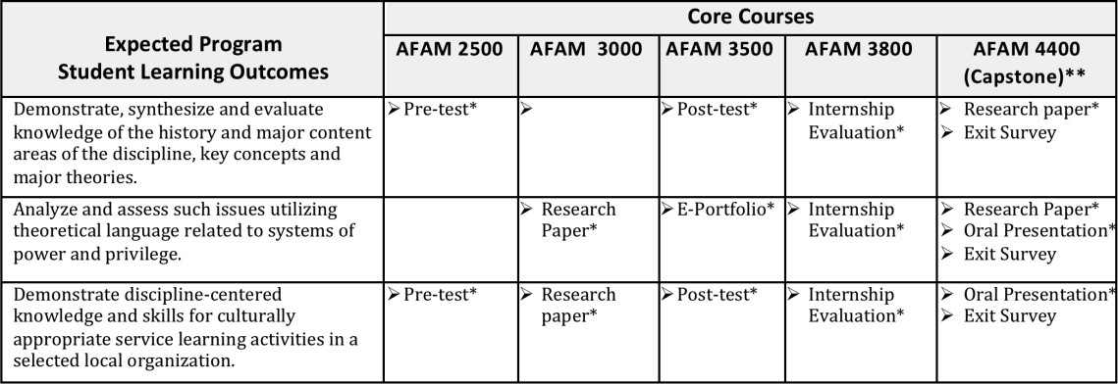

*Rubrics should be used to evaluate these. Each rubric should have criteria associated with the learning outcome.
**Students in capstone course take an exit survey in which they are asked, among other things, to rate their level of attainment of each of the learning outcomes.

- Graduate Program

General Information

    - List graduate degrees and certificates offered by the unit.

    - Discuss enrollment trends and projections.

    - Describe unit’s efforts in reaching out to the undergraduates or other potential recruits to promote graduate programs and in recruiting a diverse group of students to the program.

    - Describe the advising process for the graduate students.

    - Describe the graduate degree production for the last five years and discuss goals for the next five years.

    - Provide a COMPLETE list of most recent (last five years) Ph.D. graduates and their employment status. Discuss how the unit evaluates and uses this information to assess the quality of the Ph.D. graduates from the program.

    - Discuss the average time to degree for MS and PhD students. How does the unit address expected time to degree completion variations?

    - Brief overview of the graduate degree programs (enrollment, graduation, employment, credit hours required, research areas, assessment, community engagement activities, including service learning courses, and other high impact teaching practices, etc.)

Assessment: Documentation of Student Academic Achievement and Assessment of Student Learning Outcomes.
Because student learning is at the core of our mission and activities, it is vital that each department or program includes in its self study a report on how it uses assessment to monitor the quality of student learning in its degree program(s) as part of the overall continuous improvement process. Please provide assessment information on each of the following:

    - Expected Program Student Learning Outcomes: List the expected student learning outcomes for each degree program and, if applicable, any Graduate Certificates offered in the unit.

    - Assessment Activities: List and briefly discuss the activities used to measure the expected student learning outcomes. Activities should include direct and indirect measures of learning outcomes. Present a summary of assessment activities in a table (see Example 1 for Undergraduate Programs and Example 2 for Graduate Programs). Include (if applicable) examples of tools (e.g., rubrics) used to gather student direct assessment data or survey tools used to collect indirect assessment data (student perceptions). Describe how faculty and

students are involved in the development and implementation of the activities.
    - Assessment Findings: Report and discuss examples of key actual findings (on aggregate) from learning outcome assessment activities. This may include descriptions of summaries of rubric scores, comprehensive examination scores, descriptions of student performance in internships, survey responses to targeted questions, or narrative responses since the last APR.

    - Changes Made In Response To Findings: Describe whether and how assessment results have been used to improve student learning and teaching and/or overall departmental effectiveness since the last APR. Please cite specific examples.

For assistance and/or additional information regarding documentation of assessment of student learning, please contact Dr. Felix Wao at wao@ou.edu or call 325-3122.

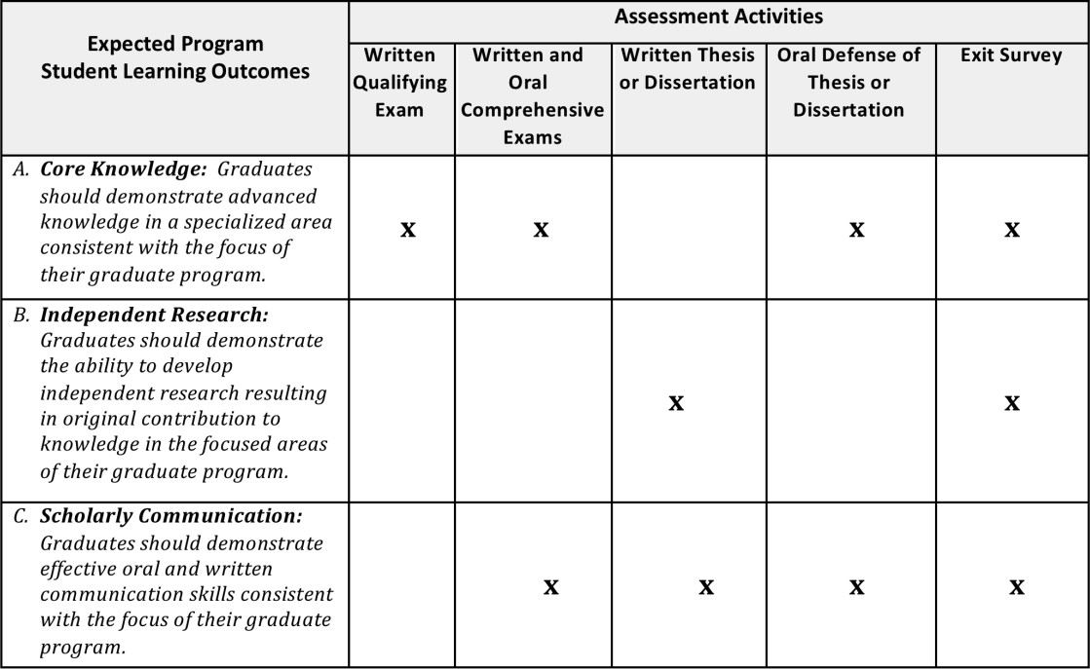
Sample Assessment Activities Table for Graduate Programs

*Rubrics should be used to evaluate the exams, thesis and dissertation as well as defense of thesis and dissertation based on criteria linked directly to the learning outcome.
**The Exit survey is used to gather student perceptions regarding each learning outcome.

- Faculty

  - General – Comment on the depth and breadth of faculty credentials in order to fulfill the teaching, research/creative activity, and service goals of the unit.

Teaching

    - Describe how teaching responsibilities are assigned. By rank, what is the average teaching load per faculty in each rank? How are adjunct professors supporting the unit’s teaching mission?

    - Describe evidence of excellence in teaching, such as teaching awards.

    - Describe how the unit supports and promotes educational innovations leading to improved student learning.

    - Describe support mechanisms available for instructional faculty to promote student success.

    - Describe, in detail, how Committee A evaluates the quality of teaching during the annual performance evaluation process. Include discussion of the extent to which course survey results (including student comments), peer observation, implementation of innovative instructional technologies, and methods incorporated into the instruction are factored into the evaluation of teaching performance.

Scholarly and Creative Activity

    - List 4-5 departments in other universities that you consider peers or close aspirational peers.

    - What are the unit’s top three areas of strengths that distinguish your unit from others in the peer group?

    - Describe the research productivity of the unit since the last APR cycle.

    - Describe multidisciplinary collaborative efforts engaged by the faculty since the last review.

    - Describe the core research areas represented by the faculty. Discuss any gaps or any potential strategic hire that will enable the unit to increase multidisciplinary research activities?

    - Compare your unit’s scholarly and creative activity to those in your peer group and discuss the unit’s efforts to foster and improve scholarly and creative activity.

    - Describe, in detail, the process Committee A follows when evaluating the annual performance of a faculty member’s scholarly and creative activity.

Service

    - Faculty advising and mentoring: Describe policies in place to encourage faculty mentorship of junior faculty, undergraduate, and graduate students. Are there formal mentoring programs available for junior faculty? If so, provide the program guidelines as Appendix IV.

    - State the key university, regional, national, and international leadership activities of the unit’s faculty. Are faculty members encouraged to take leadership roles, such as editor-in-chief of a reputable journal? How does the unit adjust the workload distribution regarding significant service load of a faculty member?

Professional Development

    - Describe the professional development activities of faculty in regards to instructional development, student learning, diversity and inclusion, and student mentoring.

    - Describe the professional development activities of faculty in the areas of scholarly and creative activities.

    - Does the department support leadership development activities for faculty? Provide examples of support.

- Vision and Strategic Direction – Each unit is expected to have a strategic plan, updated since the most recent Academic Program Review, consistent with the strategic plan of the college and the mission of the university. It is expected that the strategic plan be periodically reevaluated for revision.

  - State the unit’s mission statement. Provide the most recent strategic plan(s) for the college and your unit in Appendix V and VI, respectively. Provide comparative data on how your unit is performing compared to peers and aspirational peers. Based on these comparative data, conduct an evaluation of the

unit’s desired and actual performance and an analysis of what must be done in order to achieve the desired strategic goals. Provide a roadmap for achieving the goals stated in the plan.

- Conclusions - This section should provide an overall assessment and analysis of the unit's programs. Indicate whether the unit regards itself as a nationally, regionally, or locally competitive unit in its discipline, the level of recognition to which it believes it can reasonably strive, and the steps it needs to take to achieve its goals, noting areas where the unit excels. The section should convey how the unit is forward- looking and what is being done to improve the program. For example, cite the ways in which the unit could reorganize its resources in the near and long term to improve its performance. The unit should indicate the level of priority for the action items it proposes.

