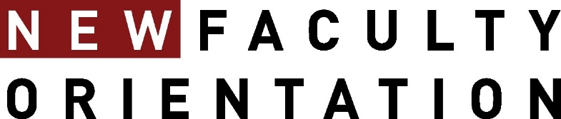

FALL 2025 In Depth Events
In-Depth sessions are held via Zoom. Please contact Karen Horne at khorne@ou.edu for access information.

September 30, 11:00-12:00 pm Community Engagement & Native Nations Center
CFE Cohost: Joy Pendley, Associate Director, CFE

October 14, 1:00-2:00pm NCFDD Resources
CFE Cohost: Julie Tolliver, Senior Fellow for Research & Creative Activities, CFE

October 31, 11:00am-12:00 pm Research & Creative Activities with CFE
CFE Cohost: Robert Scafe, Senior Faculty Professional Development Specialist, CFE

November 20, 3:00-4:00 pm Faculty Activity System FAS Review
CFE Host: Karen Horne, Managing Director, CFE

Lunch with the Provost by Invitation

