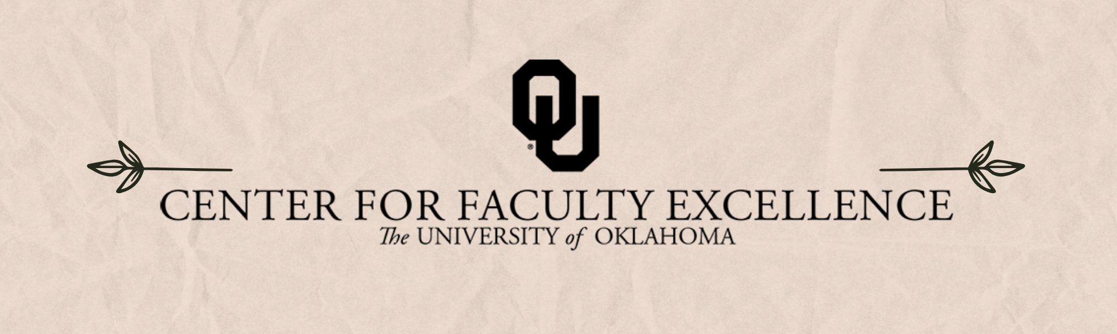

December 2025 – ISSUE 10

Calendar: | Phone: | Email:
https://calendar.ou.edu/cfe/all | 405-325-2323 | cfe@ou.edu

Dear Colleagues,
Welcome to the home stretch! I know we’re all focused on getting to the finish line of the Fall semester, and CFE traditionally has a lower-intensity line-up in the last few weeks, but there are still some offerings of note. Don’t forget to sign up for the (Humanities) Fellowship Proposal Writing Cohort with Julie-Françoise Tolliver (julietolliver@ou.edu), or the Introduction to the NSF CAREER Funding Opportunity workshop with our R&CA support team. (NOTE: If you will be submitting an NSF this year, schedule a consultation with Joy Pendley (pendley@ou.edu) to start designing your broader impact plans.) And as you finish preparing your Spring 2026 courses, consider taking advantage of the workshops offered during Teaching Preparedness week (January 12th-14th), listed in the CFE’s Upcoming Events section at the bottom of this newsletter.
Best Wishes,
Wayne Riggs, on behalf of the CFE team
cfe@ou.edu

Research & Creative Activities

Digital Humanities Research Support
Mondays, Fall 2025; 2:30 PM to 4:30 PM
Bizzell Library LL121E
Sam Huskey, Senior Faculty Fellow in Digital Humanities, will hold Digital Humanities office hours. Please drop by to talk about your project, to get help with technical problems, or just to have a place to work on DH research.

Strategies for Research and Creative Activity in the Arts and Humanities
December 9, 2025; 10:00AM to 11:30 AM via Zoom
Come develop your strategy for productive research! An interactive 90-minute workshop aimed at arts/humanities faculty who are starting a new book (or other multi-year) project, or who are in their first year at OU. The workshop will help participants identify the different moving pieces that are part and parcel of the project, integrating long-term and short-term strategic planning, grant development (internal and external), book writing, publication, and public-facing products. Participants will leave with a concrete timeline for the various components of their own projects.
This is workshop 116 within the Research & Creative Activities (R&CA) faculty development curriculum plan.

Apply for the Fellowship Proposal Writing Cohort
Applications due December 12, 2025; at 5:00 PM
The Fellowship Proposal Writing Cohort is a workshop program to help faculty craft and revise applications for prestigious fellowships like the National Endowment for the Humanities, National Humanities Center, Stanford, or Radcliffe. The Cohort program will provide analysis of sample narratives, clear deadlines, accountability, and revision support. The Cohort is limited to 10 faculty members.

Introduction to the NSF CAREER Funding Opportunity
December 16, 3:00 PM to 4:00 PM via Zoom
The NSF CAREER program is a prestigious funding opportunity for early career faculty researchers that funds work in a broad range of disciplines. This funding opportunity is more complex than other NSF funding opportunities with additional requirements. This introductory information session provides some basic guidelines and OU resources to help you think through your submission strategy. The CFE R&CA team provides a follow-up series of workshops over the Spring semester to help scaffold the full proposal development.
This is workshop 128 within the Research & Creative Activities (R&CA) faculty development curriculum plan.

Teaching
Consultations on Course Reflection Survey Results
Student feedback on their learning in our courses can be affirming, as well as transformative, in supporting our own growth as instructors. As you receive the results of your course reflection surveys, CFE's teaching team invites you to schedule a one-on-one consultation with Dr. Hong Lin. These consultations will center around interpreting student feedback so that you can document your teaching strengths and opportunities for growth, as well as support you in creating an action plan for future semesters. Schedule your one-on-one Zoom consultation by booking a consultation with Dr. Hong Lin.

Community Engagement

Designing Broader Impacts: Enriching Oklahoma, the Nation, and the World through Research and Creative Activity
If you plan to submit any NSF proposal in the next year, it is not too soon to think about your broader impact plan.
Broader impacts are the potential to benefit society and contribute to the achievement of specific, desired societal outcomes. Understanding your broader impact identity is an important part of successful proposal development. Consultations cover the basics of broader impacts, including what broader impacts of research are, why they matter, and the six essential elements of a successful broader impacts plan. We can also help you to make connections in the community and are happy to review your proposal. Reach out to set up a consult. Joy Pendley, pendley@ou.edu

Writing

Wednesday Faculty Writers Group
Wednesdays, Fall 2025; 9:00 AM to 11:00 via Zoom
We will begin each session with a check in and set intentions for our writing time. Those who wish will participate in a guided breathing/centering activity before settling in to write. We will check in again near the end of the session to celebrate accomplishments and set writing goals for the week. The facilitator will be available throughout the session for individual consultations. You are welcome to come and go as needed.

Monday Morning Writing Group Fall ’25
Mondays, Fall 2025; 10:00 AM via Zoom
Co-hosts: Sarah Tracy and Carla Eichler. This is one of the longest-running online writing groups at OU. A small but dedicated group of faculty writers. We welcome new members.

Lunchtime Inkspiration Writing Group
Wednesdays, Fall 2025; 12:00 PM to 1:00 PM via Zoom
From Dr. Ladan Mozaffarian (Division of Planning, Landscape Architecture & Design (PLAD) Institute for Community and Society Transformation): I am excited to invite you the “Lunchtime Inkspiration Writing Group” for Fall 2025. I have extended the Zoom invite that we had for the last spring and summer. This will be a focused writing time from 12 pm -1 pm every Wednesday and the sessions are a great way to carve out dedicated writing time. I hope to see many of you there this Fall!

Other Events /Opportunities

WRITE ON SITE
Tuesdays & Wednesdays, Fall 2025; 1:00 PM to 4:00 PM
Bizzell Memorial Library LL2 (Faculty Side)
This semester, the Forum will support in-person writing groups on Tuesday and Wednesday afternoons in the Faculty Side of the Zarrow Family Faculty and Graduate Student Center. We will provide coffee and snacks for Faculty who need a quiet space for writing in community with other writers. Daily goal check-in will take place from 1-1:15, after which writers will work on their individual writing projects either in the lovely Research Room (with stunning views of the Oklahoma Canyon Gardens) or in the individual faculty focus rooms. A conference room (LL2511) is also reservable if you want to organize a feedback-session with your colleagues. Join us for some focused productivity time away from your office.

Upcoming CFE Events
January 12 , 2026 (Re)Designing Your Course: Course Design Using Backward Design
January 12, 2026 Motivate Your Students from Day One: Syllabus Design
January 13, 2026 You Belong Here: Building Rapport with Students to Improve Academic Outcomes
January 13, 2026 Organizing Your Course Using Canvas: Pedagogical Approaches
January 14, 2026 Facilitating Group Discussion
January 15 & 16, 2026 2026 Academic Technology Expo
January 27, 2026 How to Support Students Under High Stress

Additional CFE Resources
Visit the Center for Faculty Excellence website for additional resources, consultations, and a variety of Canvas courses. Bookmark our CFE calendar for quick access to all upcoming events and workshops.

