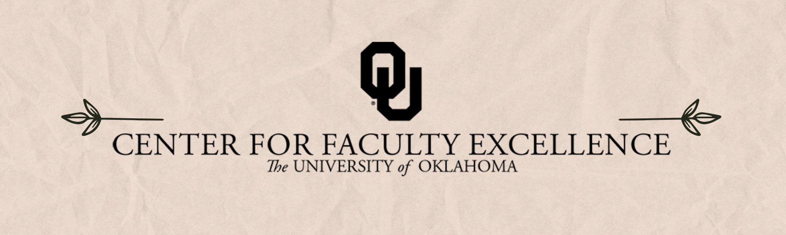

August 2025 – ISSUE 6

Calendar: | Phone: | Email:
https://calendar.ou.edu/cfe/all | 405-325-2323 | cfe@ou.edu

Dear Colleagues,

I hope you are in the midst of a relaxing and productive Summer “break.” I am thrilled to have begun my tenure as the new Director of the Center for Faculty Excellence on June 14th. I look forward to working with my colleagues around campus and the terrific staff here at CFE to help everyone reach their pedagogical and scholarly goals. As your mind turns toward preparing for the upcoming new academic year, I hope you will check out the beginning-of-semester offerings from CFE to help you get off to a terrific start!

Best wishes,

Wayne D. Riggs
cfe@ou.edu

Teaching

Course (Re)Design Learning Community
August 4th through August 9th, 2025; 9:00 AM to 11:30 AM in-person and via Zoom
Join this learning cohort for guided discussion and activities to aid you in designing a course for the first time or (re)designing a course using backwards design for learning. Each day, we’ll tackle a different topic in the process of course design. We’ll also provide optional activities to help you consider the use of Generative AI in your classroom – both for you and for your students.
- August 4: Writing Learning Outcomes and Objectives and Considering the Essential Questions of Your Course
- August 5: Designing Effective & Transparent Assessment
- August 6: Choosing Your Learning Activities and Communicating Your Plan to Students
- August 7: Peer review and discussion
- August 8: Revision and Application
Because we hope to foster a community that can provide support and feedback to one another during the course (re)design process, we ask that participants make their best effort to attend each day of the learning community.

(Re)Designing Your Course: Course Design Using Backward Design
August 11, 2025; 9:00 AM to 10:30 AM via Zoom
(Re)Design your course in a supportive, structured, and communal environment. Using a backward design approach, this workshop provides opportunity for you to work on your course (re)design by engaging in reflective activities to consider what, when, and how the course will be taught, as well as how the course objectives are achieved. This workshop is part of the CFE Teaching faculty development curriculum plan (TEACH 101).

Motivate Your Students from Day One: Syllabus Design
August 11, 2025; 1:00 PM to 2:00 PM via Zoom
A key component to student success is a sense of belonging in the classroom and at the university. This workshop provides participants with strategies to build rapport with students so that they feel more connected with you and their peers. Participants are encouraged to bring their own ideas, while also learning about Student Background and Experience surveys, icebreakers, establishing community expectations, and motivational language. This workshop is part of the CFE Teaching faculty development curriculum plan (TEACH 102).

You Belong Here: Building Rapport with Students to Improve Academic Outcomes
August 12, 2025; 9:00 AM to 10:30 AM via Zoom
A key component to student success is a sense of belonging in the classroom and at the university. This workshop provides participants with strategies to build rapport with students so that they feel more connected with you and their peers. Participants are encouraged to bring their own ideas, while also learning about Student Background and Experience surveys, icebreakers, establishing community expectations, and motivational language. This workshop is within the Teaching faculty development curriculum plan, TEACH 103.

Organizing Your Course Using Canvas: Pedagogical Approaches
August 12, 2025; 1:00 PM to 2:30 PM via Zoom
Canvas can be used strategically as a pedagogical tool to build community, help students make connections between course topics, and much more. We’ll discuss how to organize information using modules, making information easier for your students to find, as well as some of the external tools that can help make your Canvas a site for engagement and learning.

Assignments in the Era of Generative AI
August 13, 2025; 9:00 AM to 11:00 AM via Zoom
How do we get students to “think with” generative AI rather than rely on generative AI think for them? How does the use of generative AI align with your own teaching philosophy? In this workshop, you’ll articulate how you would like to address generative AI in assignments. We’ll then collaboratively work together to discuss what assignment types may limit the misuse of generative AI and which can incorporate generative AI to aid a student in their own learning. Throughout, we’ll situate student motivation as an important consideration in any assignment created. Be prepared to be asked to login to either Copilot, ChatGPT or ClaudeAI as part of our exploration. This workshop is part of the CFE Teaching faculty development curriculum plan (Assessment 209).

Streamline Your Grading with Gradescope: Faster, Easier Grading for Faculty in All Fields
August 13, 2025 1:00 PM to 2:00 PM via Zoom
Gradescope, available for free through OU’s enterprise license, facilitates grading approaches that cut down on grading time – for both online and paper-based assignments. If you are returning to paper and pen quizzes, exams, etc., in response to Generative AI, Gradescope is a great resource for you! Join instructors from Economics, Computer Science, and Women’s and Gender Studies to discuss how they use Gradescope to grade more effectively and provide students with feedback. From writing to art to equations to computer code, Gradescope can assist instructors in all fields. Instructors will share the benefits of Gradescope before answering your questions about how you can use Gradescope in your courses.

Facilitating Group Discussion
August 14, 2025; 1:00 PM to 2:30 PM via Zoom
This workshop includes tips for effective facilitation of group discussions. Many discussion-based classrooms quickly devolve into a dynamic of instructor-student Q and A, with a small percentage of students accounting for most of the participation. It doesn’t have to be this way. Drawing on Stephen Brookfield’s Discussion as a Way of Teaching, this workshop will show you how to coach student-to-student interactions, set expectations for participation from day one, and anticipate “flare ups” with proactive discussion guidelines. We will also learn how to leverage the discussion dynamic to model academic skills such as citation, collaboration, and problem solving. This workshop is part of the professional development plan for teaching under Active Learning 202.

Research & Creative Activities

Book Proposal to Fellowship Proposal
August 15, 2025, 10:00 AM to 11:15 AM via Zoom
Are you working on a book project? Do you have a partial draft of a book proposal floating around in your files? Why not turn it into a fellowship or grant proposal? This will help you update your book proposal, which will result in a better document to eventually send an editor—and it has the potential of getting you some dedicated leave time to write the book! Come learn how to adapt your book proposal to a range of possible fellowship applications.

Non-CFE Events/Opportunities

Compensated Study: OU Elevate Examination of Faculty Workload
The OU Elevate (NSF ADVANCE) project requests your participation in a study to better understand factors contributing to faculty time allocation and approaches to achieve teaching, research, or service workload objectives.
We invite tenured/tenure-track faculty members at OU to share your experiences to improve understanding of the challenges that faculty experience. You will be asked to complete two brief online surveys and track your daily work activities for two weeks using a time-tracking software platform. We recognize that this is an additional demand for your limited time, and in recognition of this, offer compensation via supplemental pay up to $400 dependent on study activity completion.

Additional CFE Resources
Visit the Center for Faculty Excellence website for additional resources, consultations, and a variety of Canvas courses. Bookmark our CFE calendar for quick access to all upcoming events and workshops.

