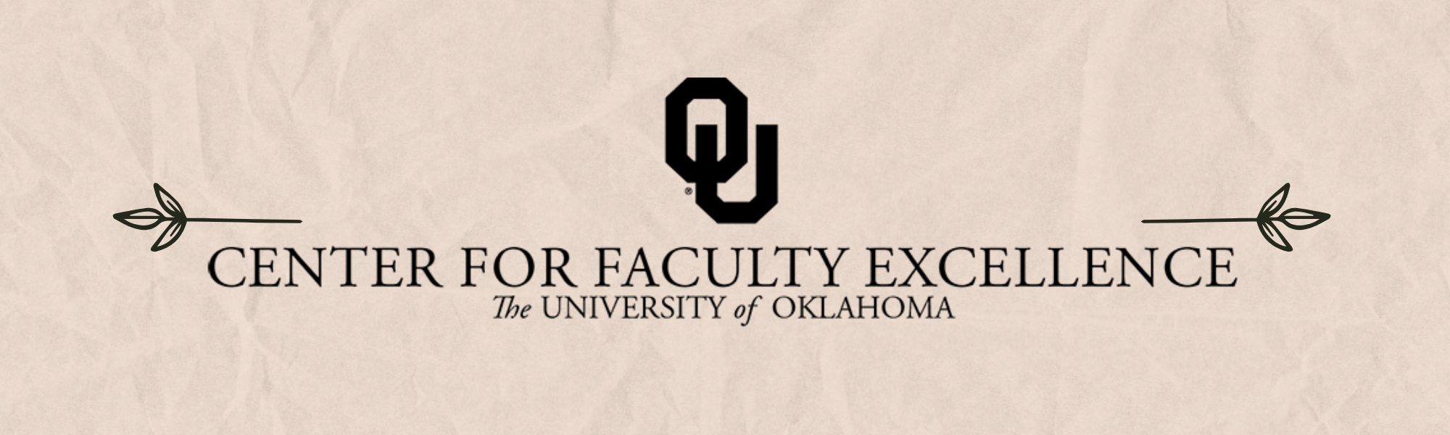

May 2025 – ISSUE 5

Calendar: | Phone: | Email:
https://calendar.ou.edu/cfe/all | 405-325-2323 | cfe@ou.edu

Dear Colleagues,
As we approach the end of the spring semester, I hope you will pause for a moment and pat yourself on the back for all you have accomplished amidst the recent events impacting higher education. The weeks following the end of the semester are often a time for reflection and establishing our plans for the summer. This May, we encourage you to consider joining one of CFE’s offerings aimed at strengthening your scholarship, teaching, service, and community engagement work, while also building connections with colleagues in other disciplines. Whether it be preparing a book proposal, building sustainable internship programs for students, processing your Course Reflection Survey feedback, or finding external funding opportunities beyond your normal targets, we have a workshop for you in May.

CFE is also excited to offer our impactful Developing Understanding and Engagement Together (DUET) Fellow Program again this fall. DUET brings together motivated students and faculty as pedagogical partners to explore learning and teaching together— We encourage interested faculty to apply by May 2nd.

Alas, this is my last newsletter as CFE’s Director, as my family will be moving to Michigan in June. I’m very thankful to have gotten to know many of you through CFE activities-- I’m continuously impressed by the impactful teaching, research and creative activities, outreach, and service you accomplish. It’s been a joy collaborating with CFE’s fantastic staff and faculty fellows to develop resources and programming that support your excellent work at OU.

I’m excited to welcome Dr. Wayne Riggs as CFE’s Director and I look forward to watching CFE continue its valuable work in the years to come! If you’d like to say goodbye (and welcome Wayne), please stop by Wallace Old Science Hall on Monday, May 12th from 2-4 pm. We’ll have food, games, stickers, and good company to share.

Best wishes,
Megan Elwood Madden
cfe@ou.edu

Research & Creative Activities

Digital Humanities Research Support
Spring 2025; 2:00 PM to 4:00 PM
Studio Meeting Space C on Lower Level 1 in Bizzell Library.
Sam Huskey, Senior Faculty Fellow in Digital Humanities, will hold Digital Humanities office hours. Please drop by to talk about your project, to get help with technical problems, or just to have a place to work on DH research.

Book Proposal Workshop
Three sessions held May 12, 14, and 16, 2025; 10:00 AM to 12:00 PM via Zoom
Are you planning to write a book proposal to send to publishers? The book proposal is a high-stakes document that can influence academic publishers and set your scholarly book production in motion. The Center for Faculty Excellence, in collaboration with the Arts and Humanities Forum, is offering a three-day workshop on writing your book proposal.
This is a sequence of meetings, so please plan to attend all three days. The workshop is online via Zoom. Facilitators will walk you through the steps and elements of writing an effective book proposal, beginning with finding the right press for your book, developing the documents you must send, and outlining a plan for writing the full manuscript. The first FIVE registered participants will receive a copy of The Book Proposal Book (Laura Portwood-Stacer), which is highly recommended as a guide for your process.

Finding External Funding & Writing a Proposal Summary
May 13, 2025; 3:00 PM to 4:30 PM via Zoom
This workshop will show you how to use the GrantForward search engine to identify external funding opportunities matching your research or creative activity. It will also introduce you to the art of writing a focused and concise proposal summary to share with grant program managers or potential collaborators.

Grant Proposal Writers Group (Weekly)
Thursdays beginning June 5, 2005; 10:00 AM to 11:30 AM
Scholars Lounge, Bizzell Library (LL2330)
Are you working on a grant proposal to fund your research or creative activity this semester? Join the CFE Research and Creative Activities team for a weekly writing group to meet in the beautiful Scholars Lounge in the Lower Level of Bizzell Library. This writing group will offer quiet writing time, mutual accountability, and help navigating the complexities of solicitations from federal agencies and other funding sources. We encourage participants to register for the regular weekly sessions, although drop-ins are also very welcome.

CFE Review of 2025 NSF CAREER Proposals
Sign up now for the review from June 9th to July 7th
The proposal development team at the Center for Faculty Excellence is now scheduling review of 2025 NSF CAREER proposal submissions. Review includes feedback on the project summary (1p) and full project description (15p), including feedback on the required education plan by the CFE teaching team.

Teaching

DUET Faculty Fellow Application Due
May 2, 2025
The Developing Understanding and Engagement Together (DUET) Fellow Program serves OU students and faculty as pedagogical partners as they explore learning and teaching together. This program is inspired by the Students as Learners and Teachers (SaLT) Program at Bryn Mawr University.
Faculty Fellows will be paid $500 in supplemental pay, not including fringe, for successful completion in this semester-long program. Participation will include weekly meetings with a DUET Student Fellow, biweekly small group meetings, and two cohort meetings to launch and end the program. Any OU faculty with the Norman campus is welcome to participate in the DUET Fellow Program. Faculty should be teaching at least one course during the semester in which they are participating.
We strongly encourage you to apply with another faculty member within your program or department. We hope that having two faculty participants from the same area will provide participants with greater support as they consider their teaching practices within their specific discipline, while they also build connections across campus with other members of the cohort.

Grading Oasis: Focus on Grading in a Communal Grading Space
May 8 & May 9, 2025; 8:00 AM to 5:00 PM on the Norman campus
Looking for a communal workspace to grade? Join us at CFE while you grade! We’ll have a member of the teaching team available, as well as light snacks. You may come and go throughout any of these time blocks. Registration is requested so that you can receive a calendar reminder and so we can plan for light snacks.

The Power of Their Words: Talking Through Course Reflection Surveys (CRS) Feedback
May 14, 2025; 10:30 AM to 12:00 PM on the Norman campus
Student feedback on their learning in our courses can be affirming, as well as transformative, in supporting our own growth as instructors. However, it can be challenging to hear negative feedback on courses when we’ve dedicated so much time, energy, and intellectual creativity to them, and not all feedback is created equally. Through guided reflection and peer support, we’ll spend time together reviewing our CRS feedback. To participate, register for the session you’d like to attend and bring your own survey responses. You can choose to read them privately in advance or use this session to process them for the first time, either on your own or with a buddy.
This workshop is within the Teaching faculty development curriculum plan, Feedback & Assessment 203.

Community Engagement

Consultation on Broader Impacts in Research
Broader impacts are “the potential to benefit society and contribute to the achievement of specific, desired societal outcomes” (NSF). If you are planning to submit a proposal in the next two years that includes a broader impact statement, please consider making an appointment with our team. Consultations take one hour and we are available for follow-up meetings to help you refine your plans before submission. We can also help you to connect with community partners, within OU and the wider community. It is not too soon to think about this aspect of your proposal.

Building Impactful Internships for Majors and Minors
May 21, 2025; 11:00 AM via Zoom
Students want work-based learning opportunities and employers value applicants with internship experience. Internships are recognized as high impact pedagogy, but not all internships are structured the same. CFE and The Career Center have created resources for departments interested in designing effective and impactful internship programs for student success. Please RSVP by filling out the registration form. This online workshop will be conducted over Zoom. We will send you the Zoom link a few days before the workshop.

Non-CFE Events/Opportunities

Compensated Study: OU Elevate Examination of Faculty Workload
The OU Elevate (NSF ADVANCE) project requests your participation in a study to better understand factors contributing to faculty time allocation and approaches to achieve teaching, research, or service workload objectives.
We invite tenured/tenure-track faculty members at OU to share your experiences to improve understanding of the challenges that faculty experience. You will be asked to complete two brief online surveys and track your daily work activities for two weeks using a time-tracking software platform. We recognize that this is an additional demand for your limited time, and in recognition of this, offer compensation via supplemental pay up to $400 dependent on study activity completion.

Additional CFE Resources
Visit the Center for Faculty Excellence website for additional resources, consultations, and a variety of Canvas courses. Bookmark our CFE calendar for quick access to all upcoming events and workshops.

