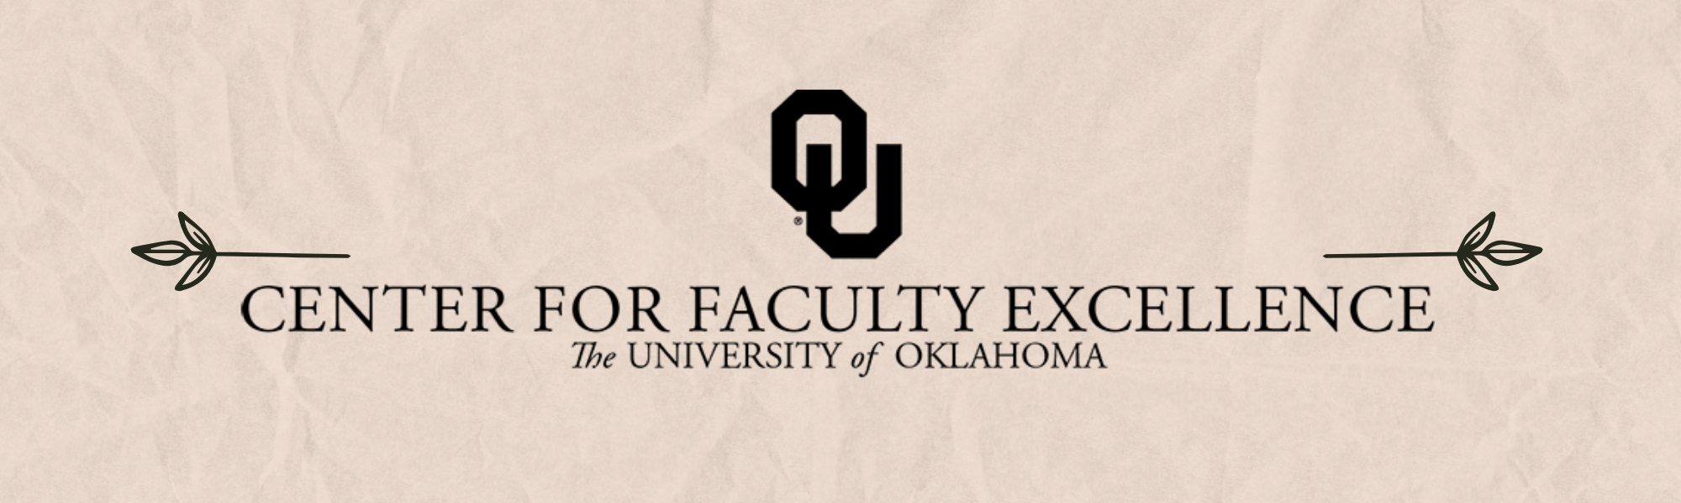

April & May 2025 – ISSUE 4

Calendar: | Phone: | Email:
https://calendar.ou.edu/cfe/all | 405-325-2323 | cfe@ou.edu

Dear Colleagues,

The next six weeks will be filled with graduate student defenses, exams and projects to be graded, awards ceremonies, and other end-of-year celebrations. While we take a workshop break after next week’s Sustainable Writing Practices event to give you some space during this hectic time, the CFE team is available and eager to meet with you - whatever your question, idea, or need may be. We invite you to submit a Resource Request or email cfe@ou.edu to schedule a consultation.

As we look towards finals week and the liminal space at the end of the semester, the teaching team will be hosting a communal grading space during finals week with snacks, venting opportunities, and comradery, as well as “The Power of their Words” a collaborative workshop to help faculty process and respond productively to student CRS responses. Our Research and Creative Activities team will also be hosting a Book Proposal Workshop series the week of May 12th. We also encourage anyone who is planning to submit an NSF CAREER proposal to sign up for a draft review slot (slots available between June 9th and July 7th).

Finally, applications for the DUET program (Developing Understanding and Engagement Together) are due by May 2nd. This highly successful program brings OU students and faculty together to work as pedagogical partners, where they share their different perspectives in order to explore, analyze, revise, affirm, or imagine ways of teaching and learning that will benefit the broader OU community and both partners.

Best wishes,
Megan Elwood Madden on behalf of the CFE team

Teaching
Consultations on Prevention of AI-assisted Misuses on Writing Assignments
As Artificial Intelligence (AI) is increasingly prevalent in the classroom, its capabilities also come along with some concerns in writing assignments. For example, some students can rely on AI as a shortcut to replace their own research, critical thinking, and problem solving, while some students can even submit AI output as their own work. Schedule a one-on-one Zoom consultation by booking a consultation with Dr. Hong Lin to review your writing assignments that have elements to prevent AI misuses or plagiarism, as well as strategies to communicate with your students about their writing outputs.

DUET Faculty Fellow Application Due
May 2, 2025
The Developing Understanding and Engagement Together (DUET) Fellow Program serves OU students and faculty as pedagogical partners as they explore learning and teaching together. This program is inspired by the Students as Learners and Teachers (SaLT) Program at Bryn Mawr University.
Faculty Fellows will be paid $500 in supplemental pay, not including fringe, for successful completion in this semester-long program. Participation will include weekly meetings with a DUET Student Fellow, biweekly small group meetings, and two cohort meetings to launch and end the program. Any OU faculty with the Norman campus is welcome to participate in the DUET Fellow Program. Faculty should be teaching at least one course during the semester in which they are participating.
We strongly encourage you to apply with another faculty member within your program or department. We hope that having two faculty participants from the same area will provide participants with greater support as they consider their teaching practices within their specific discipline, while they also build connections across campus with other members of the cohort.

Grading Oasis: Focus on Grading in a Communal Grading Space
May 8th and Friday, May 9th, 2025; 8:00 AM to 5:00 PM on the Norman campus
Looking for a communal workspace to grade? Join us at CFE while you grade! We’ll have a member of the teaching team available, as well as light snacks. You may come and go throughout any of these time blocks. Registration is requested so that you can receive a calendar reminder and so we can plan for light snacks.

The Power of Their Words: Talking Through Course Reflection Surveys (CRS) Feedback
May 14, 2025; 10:30 AM to 12:00 PM on the Norman campus
Student feedback on their learning in our courses can be affirming, as well as transformative, in supporting our own growth as instructors. However, it can be challenging to hear negative feedback on courses when we’ve dedicated so much time, energy, and intellectual creativity to them, and not all feedback is created equally. Through guided reflection and peer support, we’ll spend time together reviewing our CRS feedback. To participate, register for the session you’d like to attend and bring your own survey responses. You can choose to read them privately in advance or use this session to process them for the first time, either on your own or with a buddy.
This workshop is within the Teaching faculty development curriculum plan, Feedback & Assessment 203.

Research & Creative Activities

CFE Review of 2025 NSF CAREER Proposals
Sign up now for the review June 9th to July 7th.
The proposal development team at the Center for Faculty Excellence is now scheduling review of 2025 NSF CAREER proposal submissions. Review includes feedback on the project summary (1p) and full project description (15p), including feedback on the required education plan by the CFE teaching team. CFE will review proposals between June 9 and July 7.

Digital Humanities Research Support
Wednesdays, Spring 2025; 2:00 PM to 4:00 PM
Studio Meeting Space C on Lower Level 1 in Bizzell Library.
Sam Huskey, Senior Faculty Fellow in Digital Humanities, will hold Digital Humanities office hours. Please drop by to talk about your project, to get help with technical problems, or just to have a place to work on DH research.

Book Proposal Workshop
Three sessions held May 12, 14, and 16, 2025; 10:00 AM to 12:00 PM via Zoom
Are you planning to write a book proposal to send to publishers? The book proposal is a high-stakes document that can influence academic publishers and set your scholarly book production in motion. The Center for Faculty Excellence, in collaboration with the Arts and Humanities Forum, is offering a three-day workshop on writing your book proposal.
This is a sequence of meetings, so please plan to attend all three days. The workshop is online via Zoom. Facilitators will walk you through the steps and elements of writing an effective book proposal, beginning with finding the right press for your book, developing the documents you must send, and outlining a plan for writing the full manuscript. The first FIVE registered participants will receive a copy of The Book Proposal Book (Laura Portwood-Stacer), which is highly recommended as a guide for your process.

Writing

Establishing Sustainable Writing Practices (Scholar Squad Series)
April 2, 2025; 12:00 PM to 1:00 PM via Zoom
Establishing healthy, sustainable writing habits is a lifelong endeavor for academics as our personal and professional circumstances are ever changing. In this session, scholars in any stage of career and life will learn how to intentionally experiment with, reflect on, and grow writing practices and routines in order to stay productive and engaged as our goals, needs and conditions evolve over time. Our discussion will be led by Dr. Sandra Tarabochia, Associate Professor of English.
This event is co-sponsored by the OU Center for Faculty Excellence and the Scholar Squad, OU-Tulsa's informal support group for those interested/involved in research and other scholarly activities. Scholar Squad meetings are held monthly during the academic year and are open to all at OU-Tulsa, including faculty, staff, students, and residents.

Community Engagement

Consultation on Broader Impacts in Research
Broader impacts are “the potential to benefit society and contribute to the achievement of specific, desired societal outcomes” (NSF). If you are planning to submit a proposal in the next two years that includes a broader impact statement, please consider making an appointment with our team. Consultations take one hour and we are available for follow-up meetings to help you refine your plans before submission. We can also help you to connect with community partners, within OU and the wider community. It is not too soon to think about this aspect of your proposal.
Building Impactful Internships for Majors and Minors
May 21, 2025; 11:00 AM via Zoom
Students want work-based learning opportunities and employers value applicants with internship experience. Internships are recognized as high impact pedagogy, but not all internships are structured the same. CFE and The Career Center have created resources for departments interested in designing effective and impactful internship programs for student success.

Non-CFE Events/Opportunities

Compensated Study: OU Elevate Examination of Faculty Workload
The OU Elevate (NSF ADVANCE) project requests your participation in a study to better understand factors contributing to faculty time allocation and approaches to achieve teaching, research, or service workload objectives.
We invite tenured/tenure-track faculty members at OU to share your experiences to improve understanding of the challenges that faculty experience. You will be asked to complete two brief online surveys and track your daily work activities for two weeks using a time-tracking software platform. We recognize that this is an additional demand for your limited time, and in recognition of this, offer compensation via supplemental pay up to $400 dependent on study activity completion.

Additional CFE Resources
Visit the Center for Faculty Excellence website for additional resources, consultations, and a variety of Canvas courses. Bookmark our CFE calendar for quick access to all upcoming events and workshops.

