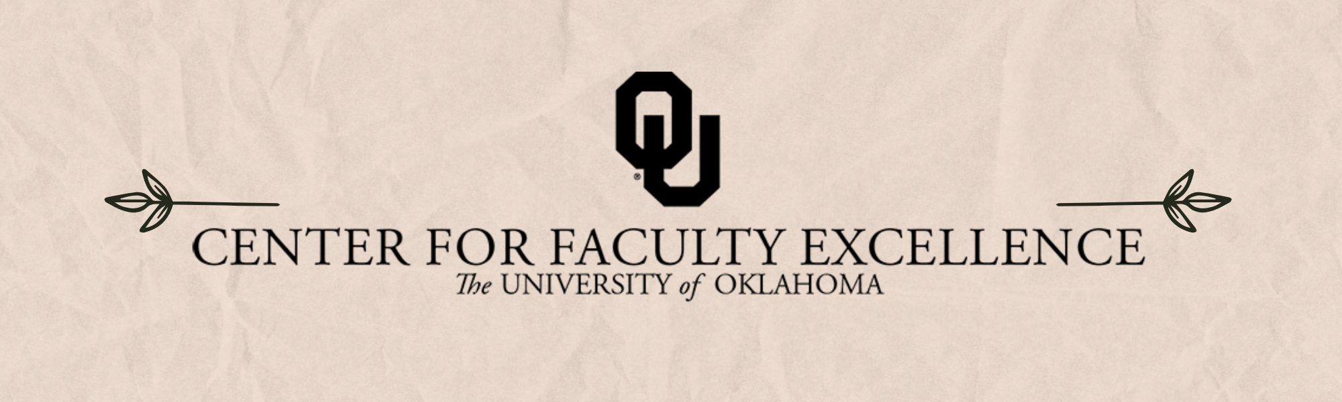

March 2025 – ISSUE 3

Calendar: | Phone: | Email:
https://calendar.ou.edu/cfe/all | 405-325-2323 | cfe@ou.edu

Dear Colleagues,
As the semester flies by and we approach midterms and spring break, we invite you to participate in one of our upcoming workshops focused on making your teaching and grading more effective and efficient. In each of these offerings we will discuss small changes that can have a big impact on both your workload and student learning.
Have you considered nominating a colleague for a campus, regional, or national award? Learn more about how to create effective nomination packages in our upcoming workshop co-led by Angela Person and Megan Elwood Madden. Want to reinvigorate your writing habits? We encourage you to join Dr. Sandy Tarabochia, our Senior Faculty Fellow for Writing, for an online workshop focused on developing effective writing practices and rituals in collaboration with OU Tulsa Libraries. Read below for more information on each of these workshops, including registration details.
The Center of Faculty Excellence is also excited to sponsor several faculty to attend NCFDD’s Faculty Success Program in the fall. This semester-long, intensive cohort coaching program is designed to help tenure-track and ranked renewable term faculty increase their scholarly productivity, while also improving work-life balance. Visit the CFE website to learn more—applications are due Tuesday, March 25th. In the meantime, all OU faculty (and grad students!) have free access to many of NCFDD’s professional development resources, including webinars, writing cohorts, and a weekly motivational newsletter. Learn how to activate your registration here.
Finally, OU ELEVATE is still seeking participants for their workload study- please consider volunteering for this compensated research project- more details below.
Best wishes,
Megan Elwood Madden on behalf of the CFE team

Faculty Career Progression and Well-Being

Building a Strong Faculty Award Nomination Package
March 25, 2025; 12:00 PM to 1:30 PM via Zoom
Recognizing our colleagues’ valuable work through awards is rewarding and important work, but the process can seem mysterious and daunting. In this workshop we will introduce the range of award opportunities at OU, explore historical trends in nominations, explain the submission process, and share tools and tips for creating effective award nomination packages. This workshop will help you develop a plan to efficiently build strong nomination packages for your deserving colleagues. This workshop is open to all faculty; Chairs, Directors, Members of Committees A, and Nominating Committee members are especially encouraged to attend.

Teaching

Consultations on Mid-term Survey Design and Implementation
As you approach mid-way through the semester, a mid-term survey allows you to take a pulse on your course before it is too late to make any significant changes.
A Mid-term Student Survey helps you:
- Show your students that you care about their success by responding to their feedback
- Adjust your curriculum to improve student outcomes in the second half of the semester
- Minimize surprises in the Student Experience Survey
- Receive more positive Student Experience Survey responses

Grading Productively: Feedback, Grading, and Rubrics
March 5, 2025; 9:00 AM to 10:30 AM via Zoom
If you want to assign writing but are wary of the grading work, this workshop is for you. We will learn how to make feedback more efficient and meaningful by clarifying expectations, distinguishing commenting from grading, and training student writers (and their peers) to evaluate their own work. You will learn to give specific, productive feedback instead of wasting time proofreading and micro-grading student work. And you will learn to use Canvas tools such as SpeedGrader, rubric templates, and peer review to create a feedback environment appropriate to your teaching style.

Interactive Lectures in Large Classrooms
March 10, 2025; 10:00 AM to 11:00 AM via Zoom
There are effective and dynamic ways to lecture that will keep your students engaged throughout your course. Join Drs. Amanda Kis (Meteorology) and Eric Lee (Biology), as well as OU students Hawaou Elhadji Abdou Moussa (Energy Management) and Ali Kassab (Mechanical Engineering), as we discuss best practices in interactive lectures, including tools and strategies that can be utilized across all disciplines and in any class size. You are also encouraged to bring your strategies to share with other session participants.

Research & Creative Activities

Digital Humanities Research Support
Spring 2025; 2:00 PM to 4:00 PM
Studio Meeting Space C on Lower Level 1 in Bizzell Library
Sam Huskey, Senior Faculty Fellow in Digital Humanities, will hold Digital Humanities office hours. Please drop by to talk about your project, to get help with technical problems, or just to have a place to work on DH research.

Community Engagement

Consultation on Broader Impacts in Research
Broader impacts are “the potential to benefit society and contribute to the achievement of specific, desired societal outcomes” (NSF). If you are planning to submit a proposal in the next two years that includes a broader impact statement, please consider making an appointment with our team. Consultations take one hour and we are available for follow-up meetings to help you refine your plans before submission. We can also help you to connect with community partners, within OU and the wider community. It is not too soon to think about this aspect of your proposal.

Writing

Establishing Sustainable Writing Practices (Scholar Squad Series)
April 2, 2025; 12:00 PM to 1:00 PM via Zoom
Establishing healthy, sustainable writing habits is a lifelong endeavor for academics as our personal and professional circumstances are ever changing. In this session, scholars in any stage of career and life will learn how to intentionally experiment with, reflect on, and grow writing practices and routines in order to stay productive and engaged as our goals, needs and conditions evolve over time. Our discussion will be led by Dr. Sandra Tarabochia, Associate Professor of English.
This event is co-sponsored by the OU Center for Faculty Excellence and the Scholar Squad, OU-Tulsa's informal support group for those interested/involved in research and other scholarly activities. Scholar Squad meetings are held monthly during the academic year and are open to all at OU-Tulsa, including faculty, staff, students, and residents.

Non-CFE Events/Opportunities

Compensated Study: OU Elevate Examination of Faculty Workload
The OU Elevate (NSF ADVANCE) project requests your participation in a study to better understand factors contributing to faculty time allocation and approaches to achieve teaching, research, or service workload objectives.
We invite tenured/tenure-track faculty members at OU to share your experiences to improve understanding of the challenges that faculty experience. You will be asked to complete two brief online surveys and track your daily work activities for two weeks using a time-tracking software platform. We recognize that this is an additional demand for your limited time, and in recognition of this, offer compensation via supplemental pay up to $400 dependent on study activity completion.

Listening Session for Access and Opportunity
March 5, 2025; 12:00 PM to 1:30 PM
Bizzell Library
Join us for an insightful workshop where faculty will explore and share their experiences around feelings of belonging and access to opportunities within the University of Oklahoma. Through open discussions and reflective exercises, we aim to better understand the challenges faculty face and how we can create more supportive environments for everyone. This is an opportunity to connect, reflect, and help shape opportunities at our institution.

DCFAS Faculty Symposium
March 5, 2025; 3:00 PM to 4:30 PM
Dale Hall Tower community room, 906
The Dodge Family College of Arts and Sciences is pleased to continue its support for excellence in research and creative activity through Junior Faculty Summer Fellowships (JFSF), Senior Faculty Summer Fellowships (SFSF), Collaborative Research Faculty Fellowships (CRFF) and a program to support Data Scholarship Initiatives and Research Collaborations (DSIRC). To learn more about what has been funded through these programs this past year come to our Research Fellow Symposium.

Faculty Guide to ADRC: Disability and Accessibility Awareness
March 26, 2025; 2:00 PM to 4:00 PM via Zoom
Webinar presented by Accessibility and Disability Resource Center.

Upcoming CFE Events

Book Proposal Workshop
May 12th, 14th, and 16th, 2025; 10:00 PM to 12:00 PM via Zoom

Additional CFE Resources
Visit the Center for Faculty Excellence website for additional resources, consultations, and a variety of Canvas courses. Bookmark our CFE calendar for quick access to all upcoming events and workshops.

