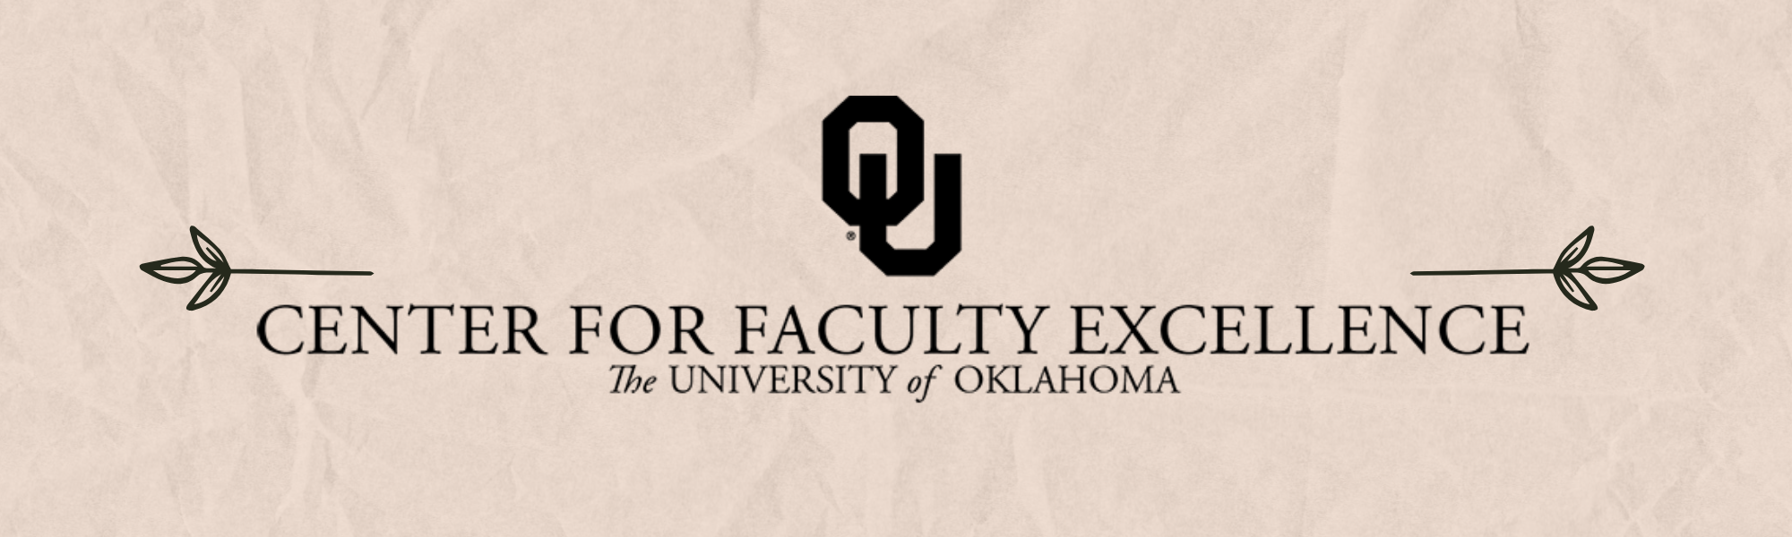

September 2024  ISSUE 9

|  |  |  |
| --- | --- | --- |
| Calendar | Phone | Email |
| <https://calendar.ou.edu/cfe/all> | 405-325-2323 | [cfe@ou.edu](mailto:cfe@ou.edu) |

Dear Faculty,

Welcome (back) to campus- we hope your classes are off to a great start!

As we launch into the new semester, we are excited to share our fall programming plans. Each of these workshops is designed to help you reaching your teaching, scholarship, and professional goals. We encourage each of you to engage with at least one workshop or online resource this fall that sparks your interests- whether it be developing a moderate-term [plan for your research](https://calendar.ou.edu/cfe/event/107401-defining-your-strategy-for-research-and-cre), finding ways to navigate [difficult conversations in the classroom](https://calendar.ou.edu/cfe/event/107417-making-conflict-productive-managing-difficu), or preparing to [engage with Tribal Nations](https://calendar.ou.edu/cfe/event/107407-fall-2024-tribal-engagement-101-with-tana-f). Registering for workshops is easy- simply click on the link at the end of each of the descriptions below. Within a few days, you’ll receive a calendar invitation with all the information you need to attend.

Did you know that OU now has an [institution-wide subscription to TopHat](https://itsupport.ou.edu/TDClient/30/Unified/Requests/ServiceDet?ID=72), so you can incorporate clicker questions and other active learning tools into your courses without any additional costs for students? TopHat will be hosting a [series of workshops Friday, Sept, 6th](https://calendar.ou.edu/cfe/event/106980-intentional-course-design-in-the-age-of-ai) to introduce faculty to different tools aimed at deepening classroom and online engagement.

We also encourage you to explore our online resources, including the recently revised [Generative AI online module](https://canvas.ou.edu/enroll/6FDETT) where you can learn about the opportunities and challenges created by AI in both our classes and scholarship, including example assignments and syllabus statements that can help set clear expectations for students.

Best wishes,

Megan Elwood Madden on behalf of [the CFE Team](https://www.ou.edu/cfe/our-team)

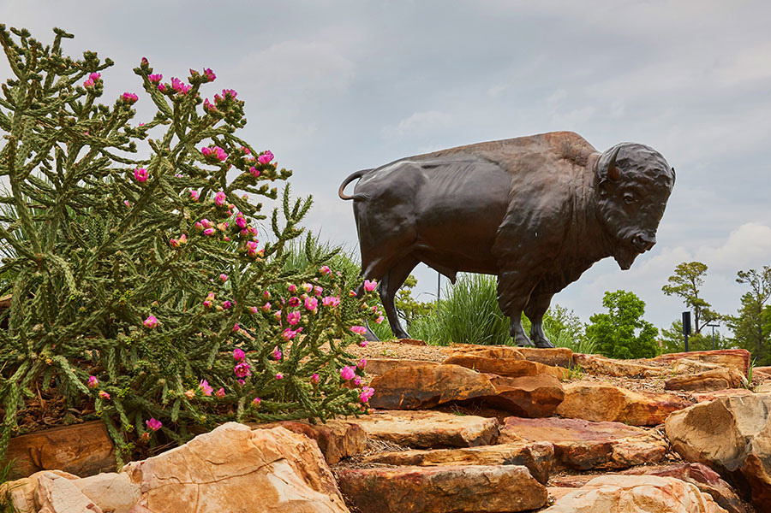

September 2024 CFE Events   
Community Engagement

### Thursday, September 5, 2024, 3:00PM-4:00PM

[Integrating Service Learning in First Year & Gen Ed Courses](https://calendar.ou.edu/cfe/event/107406-integrating-service-learning-in-first-year-)

Service-learning is often reserved for advanced majors within their disciplines, but first-year and non-major students can benefit from this widely recognized high-impact practice as well. In this information session, we will explore special considerations for integrating service-learning into first-year and gen ed courses. Dr. Chancellor will share her own experience doing so and discuss possibilities for developing service-learning versions of existing first-year and gen ed courses with interested faculty.

## Faculty Career Progression and Well-Being

### Wednesday, September 4, 2024, 1:00PM-2:00PM

NFO In-Depth: Graduate & Undergraduate Student Mentoring

Presenters: Megan Elwood Madden, Director, CFE; Liz Karr, Sr. Associate Dean, Graduate College; Milos Savic, Director, Undergraduate Research & Creative Activity UReCA

### Thursday, September 12, 2024, 1:30PM-2:30PM

NFO In-Depth: Student Life, Transfer Students, and Veteran Student Services

Presenters: Geneva Murray, Sr. Associate Director, CFE; Steven Fleming, Veteran Success Coordinator, Veteran Student Services; Johnnie-Margaret McConnell, Director, Transfer Student Success; Quy Nguyen, Student Life Director; Erin Simpson, Assistant Dean of Students

### Tuesday, September 17, 2024, 3:00PM-4:00PM

NFO In-Depth: Academic Publishing, Editing & Reviewing

Presenters: Megan Elwood Madden, Director, CFE; Ron Martinez, Faculty Writing Coach, CFE; Jennifer Davis Cline, Associate Professor, History; Daniel Hamlin, Associate Professor, Educational Leadership and Policy Studies

### Wednesday, September 25, 2024, 1:00PM-2:30PM

[Congrats! What’s Next?](https://calendar.ou.edu/cfe/event/107414-congrats-whats-next)

This hybrid workshop will help launch newly promoted associate professors on the path to full and help them navigate new challenges and opportunities that come at mid-career.

## Research & Creative Activities

### Wednesday, September 4, 2024, 12:00PM-1:00PM

[NSF Science & Technology Center RFP: Information Session with Lewis-Burke Associates](https://calendar.ou.edu/cfe/event/107794-nsf-science-technology-center-rfp-informati)

This informational webinar hosted by the Center for Faculty Excellence and our federal relations consultants at Lewis-Burke Associates LLC on the National Science Foundation’s (NSF) Science and Technology Centers (STCs) program. The STCs program is a seminal opportunity from NSF that supports innovative, complex research and education projects that require large-scale and long-term awards. During the webinar, Lewis-Burke will provide an overview of the program, analysis of NSF’s priorities, and other key considerations to orient faculty as they seek to pursue the current competition, for which preliminary proposals are due November 20, 2024. The sessions will feature a brief presentation followed by a Q&A.

### Thursday, September 12, 2024, 10:30AM-12:00PM

[Creating Biosketches: ORCiD/SciENcv](https://calendar.ou.edu/cfe/event/107375-creating-biosketches-orcidsciencv)

NSF requires submitted proposals to provide two ancillary documents—biosketches and current and pending support—in a specific format, and other federal agencies are joining this policy. This format must be produced through SciENcv, which can pull your scholarly information from ORCiD and retain it for re-use further down the road.  This webinar will walk you through the process of 1) registering in ORCiD and populating your information fields, 2) signing up for your NCBI account, and 3) creating your SciENcv documents. Participants will be able to complete a first biosketch during the webinar.

### Friday, September 13, 2024, 12:00PM-1:30PM

[Fine Arts + DISC + CFE: Ideating to Leverage Advanced Technologies for Improving Performance Education](https://calendar.ou.edu/cfe/event/107502-fine-arts-disc-cfe-ideating-to-leverage-adv)

Advanced technologies have improved rapidly, and researchers are discovering their benefits and limitations in many contexts. This workshop explores the application of advanced technologies in educating performers, relevant to students in the fine arts, athletics, communications, and public speaking relevant to all disciplines. To conduct this work requires experts that can create content, develop delivery methods, and /or assess impact. In this ideating event, leaders across campus will provide their perspectives on how these efforts could benefit their work, external funding opportunities will be presented, and OU researchers will present their interests in the topic area. Time will be provided for researchers to explore collaborations in preparation for an internal seed funding opportunity.

### Wednesday, September 18, 2024, 10:30AM-12:00PM

[Finding Internal and External Funding](https://calendar.ou.edu/cfe/event/107377-finding-internal-and-external-funding)

OU provides several internal funding opportunities to support faculty in their research and creative activities. This workshop will present these internal opportunities that can be leveraged to secure additional external funding for your research and creative activities and to broaden the impact of your work. We will orient you to GrantForward, an OU-subscribed funding database which allows you to customize a search that will regularly send you a list of funding opportunities relevant to your interests.

### Thursdays, 12:00PM-1:30PM, starting on September 19, 2024

[Grant Proposal Writers Group (Weekly)](https://calendar.ou.edu/cfe/event/107389-grant-proposal-writers-group-weekly)

Are you working on a grant proposal to fund your research or creative activity this semester? Join the CFE Research and Creative Activities team for a weekly writing group to meet in the beautiful Scholars Lounge in the Lower Level of Bizzell Library. This writing group will offer quiet writing time, mutual accountability, and help navigating the complexities of solicitations from federal agencies and other funding sources. We encourage participants to register for the regular weekly sessions, although drop-ins are also very welcome.

### Friday, September 20, 2024, 11:00AM-12:00PM (Tulsa Campus)

[Defining Your Strategy for Research & Creative Activities in Your Career](https://calendar.ou.edu/cfe/event/107768-defining-your-strategy-for-research-and-cre)

Attend this workshop to develop a strategy for achieving your research and creative activities goals over the next 5-7 years. Activities will be presented that can help uncover synergies across teaching, service, and research and creative activity efforts; identify resources and professional development activities of interest; and decide when to pursue internal and external funding.

### Friday September 20, 2024, 12:30PM-1:30PM (Tulsa Campus)

[Finding Internal and External Funding](https://calendar.ou.edu/cfe/event/107795-finding-internal-and-external-funding)

OU provides several internal funding opportunities to support faculty in their research and creative activities. This workshop will present these internal opportunities that can be leveraged to secure additional external funding for your research and creative activities and to broaden the impact of your work. We will orient you to GrantForward, an OU-subscribed funding database which allows you to customize a search that will regularly send you a list of funding opportunities relevant to your interests.

### Friday, September 20, 2024, 2:00PM-3:30PM (Tulsa Campus)

[Developing Your Project Idea](https://calendar.ou.edu/cfe/event/107796-developing-your-project-idea)

Project ideas can loom larger than life when developing in your mind. Getting the idea down into a document can launch your project development forward by creating opportunities to articulate details that may otherwise remain undefined. This workshop invites OU faculty to articulate their project ideas using the 4-question model towards developing a 1-pg project summary. This 1-pg summary is useful for project ideation, enticing others to collaborate, and checking alignment for funding with Program Managers. In this session, we provide activities to 1) crystallize your project idea with a writing exercise and 2) begin defining goals, objectives/aims, tasks.

### Thursday, September 26, 2024, 10:30AM-12:00PM

[Defining Your Strategy for Research & Creative Activities in Your Career](https://calendar.ou.edu/cfe/event/107401-defining-your-strategy-for-research-and-cre)

Attend this workshop to develop a strategy for achieving your research and creative activities goals over the next 5-7 years. Activities will be presented that can help uncover synergies across teaching, service, and research and creative activity efforts; identify resources and professional development activities of interest; and decide when to pursue internal and external funding. The workshop includes a brief introduction to the GrantForward, an OU-subscribed database for exploring funding opportunities.

## Teaching

### Tuesday, September 3, 2024, by 8:00AM

[Teaching Squares](https://calendar.ou.edu/cfe/event/106984-teaching-squares-registration)

Join us for the Spring semester’s cohort of the Teaching Squares Program at OU! This is an opportunity to reflect upon and enhance your teaching while learning from and growing with your colleagues. In this program, you will be paired with colleagues who represent a wide range of expertise and experience. Together, your “square” will engage in reciprocal classroom observations during the Fall semester. This peer observation is non-evaluative, supportive, and focused on the growth of all participants. At the end of the semester, all squares will gather for a celebratory discussion in which we will reflect on the various ways that observing our colleagues’ teaching enriched our own teaching.

### Biweekly, beginning Wednesday, September 4, 2024, through Wednesday, October 2, 2024, 1:00PM-2:30PM. Office hours in between meetings.

[Scholarship of Teaching and Learning: Using Action Research to Improve Pedagogy](https://calendar.ou.edu/cfe/event/106981-scholarship-of-teaching-and-learning)

This three-part series is a step-by-step guide to begin conducting action research in your classroom. Following participation, you’ll be prepared to implement action research the very next semester.

### Monday, September 9, 2024, 1:30PM-2:30PM

[Creating Assignments that Minimize Stress (for You and Your Students!)](https://calendar.ou.edu/cfe/event/106997-creating-assignments-that-minimize-stress-for-you)

Does it ever feel like students don’t know what you’re asking for on an assignment? Transparency (TILT) is a Universal Design for Learning (UDL) practice that emphasizes the importance of transparency when designing assignments in order to mitigate barriers to success and increase student motivation. This workshop will engage faculty in redesigning a course assignment using the TILT framework.

### Thursday, September 19, 2024, 10:30AM-11:30AM

[Break the Mold on Your Assignments: Varying Assessments for Universal Design for Learning](https://calendar.ou.edu/cfe/event/106998-break-the-mold-on-your-assignments-varying)

Reinvigorate your assessment strategy by offering students choices in how they demonstrate what they have learned. This approach aligns with Universal Design for Learning (UDL) framework to inform how we teach. We’ll work together to share varying assessment strategies and provide some tips about using podcasts, role play, self-assessment, and/or visual displays such as concept maps or infographics. Bring an assignment that you’re using to break the mold!

### Friday, September 27, 2024, 8:15AM-2:30PM

[Symposium on Learning, Assessment, and Teaching Excellence (SLATE)](https://calendar.ou.edu/cfe/event/107416-symposium-on-learning-assessment-and-teachi)

SLATE is designed to provide opportunities for faculty and staff to share engaging, informative presentations on research, best practices, insightful teaching and learning experiences, and innovative assessment methods that address academic quality.

## Writing

### September 9-November 15, 2024

[Write Your Journal Article in 10 Weeks](https://calendar.ou.edu/cfe/event/107418-write-your-journal-article-in-10-weeks)

This comprehensive modular course guides faculty through the entire process of developing a research manuscript for journal submission. Participants will learn effective strategies for crafting compelling introductions, robust methods sections, clear results presentations, and impactful discussions. The course covers critical aspects such as creating a research space, developing authorial voice, anticipating reviewer questions, and revising for clarity and impact.