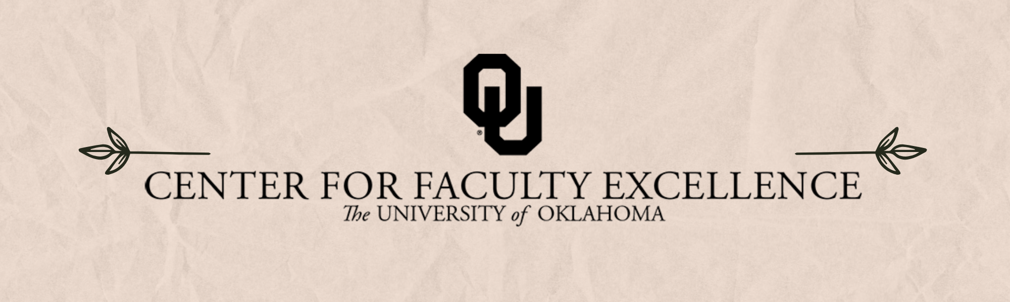

November 2024  ISSUE 11

|  |  |  |
| --- | --- | --- |
| Calendar | Phone | Email |
| <https://calendar.ou.edu/cfe/all> | 405-325-2323 | [cfe@ou.edu](mailto:cfe@ou.edu) |

Dear Faculty,

As October comes to a close, we hope that, even in these busy times, you can take a few moments to reflect on how far you have come, celebrate successes, and build connections within our OU community.  We have several upcoming opportunities within CFE to reflect and celebrate in community with other faculty:

We are celebrating our 5th Birthday this fall! Join us Friday, November 8th for CFE’s 5th Birthday Party with snacks, networking, and opportunities to celebrate five years of faculty excellence at OU.

* Join us for Caffeine, Community, and Conversation every Tuesday, Wednesday, and Thursday morning from 8-10am beginning Nov.  in our CFE Workshop space (223 Old Science Hall). Drop in and say hello, grab a cup of coffee or tea and a snack!
* Apply for the  [DUET Fellow program](https://www.ou.edu/cfe/teaching/duet-fellows) (faculty applications due on November 11). This pedagogical partnership program is action oriented, providing you with the tools and student insights that will highlight your teaching strengths and provide new perspectives guiding effective change.
* Consider joining the upcoming NEH Fellowship cohort – it is a great opportunity to work in supportive community with your peers as you each develop an individual fellowship proposal.
* Visit the NonProfit and Community Engagement Fair in the Union on Tuesday, Nov. 19th to learn more about opportunities to develop projects with community partners beyond OU
* Transform your writing habits by joining a writing group!  Faculty writing groups offer accountability and a sense of community to help you achieve your writing goals. [**Find a group here that fits your schedule**](https://ousurvey.qualtrics.com/jfe/form/SV_9S68qr47oPQGKzA)**.**

In addition to these events, we also host many more opportunities to expand and strengthen your skills across all areas of faculty work- see below for more details!

Best wishes,

Megan Elwood Madden on behalf of [the CFE Team](https://www.ou.edu/cfe/our-team)

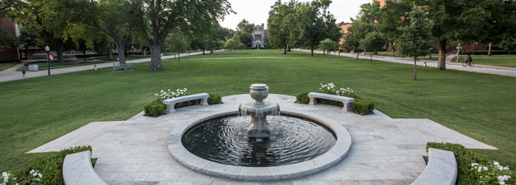

November 2024 CFE Events

**Community Engagement**

### Thursday, November 7, 2024, 12:00PM – 1:15PM

[**Fall 2024 ETE Series Keynote Bridging Gaps: Treaties and Treaty Rights – A Tribal Leader’s Perspective Lunch and Learn**](https://calendar.ou.edu/cfe/event/107410-fall-2024-ete-series-keynote-bridging-gaps)

Join Native Nations Center in collaboration with Tana Fitzpatrick, Associate Vice President of Tribal Relations at OU and the Center for Faculty Excellence as we offer a continuation of our Ethical Tribal Engagement Series which seeks to bridge Indigenous and institutional perspectives while highlighting values and responsibilities in ethical Tribal engagement. This ETE Series keynote will feature Comanche Nation Chairman Forrest Tahdooahnippah who will present on Comanche Nation’s treaties and treaty rights. Additional discussion topics will include the following: incorporation of Indigenous knowledge structures into westernized systems, centering tribal needs, legal implications, and cultural considerations around Tribal sovereignty.

### Tuesday, November 19, 2024, 11:00AM – 1:00PM

[**NonProfit and Community Engagement Fair in the Union**](https://calendar.ou.edu/cfe/event/107411-nonprofit-and-community-engagement-fair-in-)

Connect with local nonprofit organizations, schools and agencies.  This is a great opportunity to talk with community leaders about potential internships, service-learning projects, and research/creative activity opportunities.

### Tuesday, November 19, 2024, 2:00PM - 3:00PM

[**Developing Partnership with Community for Teaching and Research/Creative Activity**](https://calendar.ou.edu/cfe/event/107412-developing-partnership-with-community-for-t)

Are you interested in developing community engaged learning experiences or research and creative activity projects?  Join us to learn about nonprofit work in the Norman/OKC community and how you might connect.  This information session will feature four organizations from the Nonprofit Career Fair.

## **Faculty Career Progression and Well-Being**

### Thursday, November 7, 2024, 3:00PM-4:00PM

**NFO In-Depth: Faculty Activity System: FAS Review**

Presenters: Megan Elwood Madden, Director, CFE; Karen Horne, Managing Director, CFE

## **Research & Creative Activities**

### Registration Open from October 25, 2024, to November 20, 2024

**NEH Fellowship Cohort**

Are you interested in applying for an NEH individual fellowship? Would you like to work on your proposal with the support and accountability of peers? The NEH Fellowship Cohort, active from November 2024 to April 2025, will provide grant-writing support to 10 faculty members from the humanities (history, literature and language, history and theory of the arts, philosophy and ethics, archaeology, comparative religion, jurisprudence, social sciences and sciences employing humanistic methods).

### Friday, November 1, 2024, 1:30PM – 3:30PM

[**The 4th Annual ICAST Networking Event**](https://calendar.ou.edu/cfe/event/108632-institute-for-community-and-society-transformation-4t)

Save the date! On Friday, November 1st from 1:30 to 3:30, OU ICAST (Institute for Community and Society Transformation) is hosting its fourth annual networking event, and all are welcome. This event highlights ICAST's mission, latest updates, and resources and offers the opportunity to connect with other faculty and students on shared research interests and potential collaborations. We want to hear from our ICAST affiliates about topics of interest.

### Wednesday, November 6, 2024, 1:00PM-2:00PM

[**Overview of STEM Early Career Funding Opportunities**](https://calendar.ou.edu/cfe/event/107404-overview-of-stem-early-career-funding)

Several funding opportunities are available to early career faculty to support work in the STEM disciplines, but uncovering the opportunities that align with your area of interest and understanding the eligibility requirements and logistics can be challenging. This CFE information session presents a synopsis of early career funding opportunities from the U.S. Department of Defense (DOD), U.S. Department of Energy (DOE), and U.S. National Science Foundation (NSF), the National Institutes of Health (NIH) and pointers on how to develop the project overview. The hope is that from this information session, faculty can create a strategic plan to respond to funding opportunities relevant to their fields in the “early career” timeframe.

### Thursday, November 14, 2024, 12:00PM – 1:30PM

[**Developing Your Project Idea**](https://calendar.ou.edu/cfe/event/107405-developing-your-project-idea)

Project ideas can loom larger than life when developing in your mind. Getting the idea down into a document can launch your project development forward by creating opportunities to articulate details that may otherwise remain undefined. This workshop invites OU faculty to articulate their project ideas using the 4-question model towards developing a 1-pg project summary. This 1-pg summary is useful for project ideation, enticing others to collaborate, and checking alignment for funding with Program Managers. In this session, we provide activities to 1) crystallize your project idea with a writing exercise and 2) begin defining goals, objectives/aims, tasks.

### Monday, November 18, 2024, 11:30AM – 1:30PM

[**OU Networking with the Data Science Institute for Societal Challenges**](https://calendar.ou.edu/cfe/event/108341-ou-networking-with-the-data-institute-for-societal-ch)

This event convenes OU faculty to meet the leadership and affiliates of the [Data science Institute for Societal Challenges (DISC)](https://www.ou.edu/disc). You will hear about DISC initiatives and have the opportunity to meet other OU colleagues interested in and applying data science, visual analytics, human-guided AI and ML, among others. Previous DISC seed grant award winners will also share what they have done and how the award money benefited them.

### Thursday, November 20, 2024, 11:00AM - 12:15PM

[**Post-Award Overview, RFS + CFE**](https://calendar.ou.edu/cfe/event/107504-post-award-overview-rfs-cfe)

Once a proposal isrecommended for funding and theaward has been negotiated, the real fun of setting up the project financials and executing the project starts. This information session presents Research Financial Services and provides a basic introduction to OU's process of receiving grant funds from external funding agencies and how the many offices and support processes involved executing the project.

## **Teaching**

**Reinvigorate the Classroom Environment: Motivating Students in November**

Schedule a consultation as you move into the second half of the semester. November is a great time to explore strategies and tips to help your students stay motivated, engaged, and prepared in the classroom. Reinvigorate your teaching, and address your teaching challenges, in November by [booking a one-on-one consultation with Dr. Hong Lin](https://outlook.office.com/bookwithme/me).

### Monday, November 11, 2024

[**DUET Faculty Fellow Application Due for Spring 2025**](https://calendar.ou.edu/cfe/event/108357-duet-faculty-fellow-application-due-for-spring)

The Developing Understanding and Engagement Together (DUET) Fellow Program serves OU students and faculty as pedagogical partners as they explore learning and teaching together. This program is inspired by the [Students as Learners and Teachers (SaLT) Program](https://tli-resources.digital.brynmawr.edu/programs-and-opportunities/salt-program/) at Bryn Mawr University.

DUET Faculty Fellows will be compensated $500 in supplemental pay, not including fringe, once they have successfully completed the program. Participation will include weekly meetings with a DUET Student Fellow, biweekly small group meetings (total of five), and two cohort meetings to launch and end the program. Any OU faculty with the Norman campus is welcome to participate in the DUET Fellow Program. Faculty should be teaching at least one course during the semester in which they are participating.

We strongly encourage you to apply with another faculty member within your program or department. We hope that having two faculty participants from the same area will provide participants with greater support as they consider their teaching practices within their specific discipline, while they also build connections across campus with other members of the cohort. Visit our [DUET website](https://www.ou.edu/cfe/teaching/duet-fellows) for more information about the program.

### Monday, November 18, 2024, 1:00PM – 2:00PM

[**Authentic Assessment: Using Gradescope to Save Time, Beat AI**](https://calendar.ou.edu/cfe/event/108688-authentic-assessment-using-gradescope-to-save-time-be)

This webinar is perfect if you are considering a return to paper to avoid AI temptation or already doing paper-based assessment and looking to save time.  Join a member of the Gradescope team to learn more about Gradescope and hear how other instructors have been able to use Gradescope to:

* Solve common challenges and frustrations faced during the grading process in large lecture, multi-section and lab courses.
* Reduce opportunities for students to use generative AI during exams or homework.
* Increase consistency and grading efficiency while providing more feedback to students.
* Gain insights needed to support student learning, understand trends, and improve teaching
* Use positive rubrics to connect student feedback to learning objectives.

### Friday, November 22, 2024, 1:00PM – 2:00PM

[**Support Hour with Gradescope**](https://calendar.ou.edu/cfe/event/108689-support-hour-with-gradescope)

Have you heard about how Gradescope can help you grade quicker, but you’re not sure how to get started? A member of the Gradescope team will be available on Zoom to answer questions you have about how to get started with Gradescope.