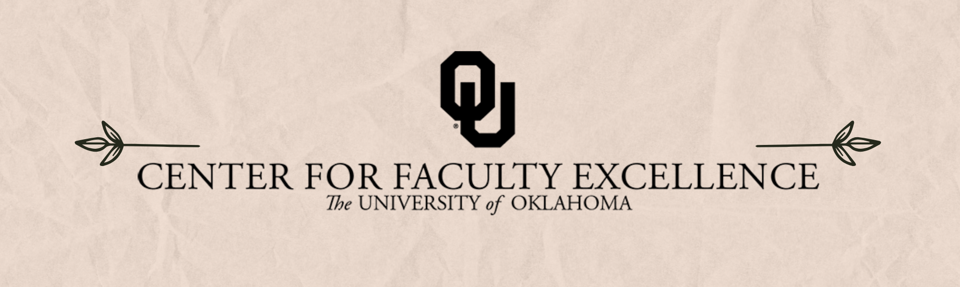

December 2024  ISSUE 12

|  |  |  |
| --- | --- | --- |
| Calendar | Phone | Email |
| <https://calendar.ou.edu/cfe/all> | 405-325-2323 | [cfe@ou.edu](mailto:cfe@ou.edu) |

Dear Colleagues,

December will be a month of changes in CFE- that liminal time between semesters and a period to prepare for upcoming staff transitions. Both Clara Smith (Associate Director for Research and Creative Activities) and Ron Martinez (Faculty Writing Coach) are looking forward to new adventures in January. Over the past five years, Clara has helped CFE develop robust resources to support faculty proposal writers and helped initiate many multi-disciplinary teams across campus. While her day-to-day efforts will be missed, she has helped to build solid professional development infrastructure that will continue to support faculty for years to come! Similarly, Ron has provided writing support for numerous faculty across campus during his year at OU.

While we will certainly miss these two key members of the CFE Research and Creative Activities team, Kathy Volz, Robert Scafe, and Julie Tolliver are well-prepared to carry on our mission to support faculty as they develop ideas, collaborations, projects, and proposals. Check out the R&CA Team’s updated [consultation website](https://www.ou.edu/cfe/research/securing-funding) for a list of services offered and the lead-times needed for document feedback. Faculty interested in any of these services should email [cfe@ou.edu](mailto:cfe@ou.edu) or fill out our [Resource Request survey](https://ousurvey.qualtrics.com/jfe/form/SV_3sWpho1lIEoCYDk).

As we head into finals week, we will resume workshops before the winter break- see below for more details about upcoming events. January brings a suite of teaching-focused workshops and the first of the Promotion and Tenure series on January 25th.

Best wishes,

Megan Elwood Madden on behalf of the [CFE team](https://www.ou.edu/cfe/our-team)

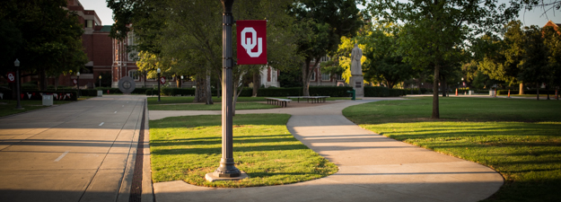

December 2024 CFE Events

**Community Engagement**

### Monday, December 9, 2024, 11:00AM – 12:00PM

### [**Integrating Service Learning in First-Year and Gen Ed Courses**](https://calendar.ou.edu/cfe/event/107413-integrating-service-learning-in-first-year-)

## Service-learning is often reserved for advanced majors within their disciplines, but first-year and non-major students can benefit from this widely recognized high-impact practice as well. In this information session, we will explore special considerations for integrating service-learning into first-year and gen ed courses. Dr. Chancellor will share her own experience doing so and discuss possibilities for developing service-learning versions of existing first-year and gen ed courses with interested faculty.

## **Research & Creative Activities**

### Wednesdays, August 21st – December 4, 2024, 2:00PM – 4:00PM

### **Digital Humanities Research Support**

### Sam Huskey, Senior Faculty Fellow in Digital Humanities, will hold Digital Humanities office hours on Wednesdays from 2:00 to 4:00 p.m. in the **Studio Meeting Space C on Lower Level 1 in Bizzell Library**. Please drop by to talk about your project, to get help with technical problems, or just to have a place to work on DH research.

### Tuesday, December 10, 2024, 10:00AM – 11:30AM

[**Strategies for Research and Creative Activity in the Arts and Humanities**](https://calendar.ou.edu/cfe/event/107522-strategies-for-research-and-creative-activi)

Come develop *your* strategy for productive research! An interactive 90-minute workshop aimed at arts/humanities faculty who are starting a new book (or other multi-year) project, or who are in their first year at OU. The workshop will help participants identify the different moving pieces that are part and parcel of the project, integrating long-term and short-term strategic planning, grant development (internal and external), book writing, publication, and public-facing products. Participants will leave with a concrete timeline for the various components of their own projects.

### Tuesday, December 10, 2024, 2:00PM – 3:00PM

### **[Creating a Mentoring Plan for Graduate Researchers and Post-Docs](https://calendar.ou.edu/cfe/event/109064-creating-a-mentoring-plan-for-graduate-researchers)**

NSF requires submitted proposals to provide several ancillary documents; a new requirement is to provide a Mentoring Plan whenever graduate student researchers are supported by the proposed project. While the required document is short (no more than 1 page), it is a great place to showcase your research preparedness and your compassion for researchers-in-training. This workshop invites you to reflect on your research training experience, consider the overarching experience you want your research trainees to have, and points you to available resources for both you as a mentor and your trainees as mentees.

## **Teaching**

### **Consultations on Course Reflection Survey Results (formerly known as the Student Experience Survey)**

Student feedback on their learning in our courses can be affirming, as well as transformative, in supporting our own growth as instructors. As you receive the results of your course reflection surveys, CFE's teaching team invites you to schedule a one-on-one consultation with Dr. Hong Lin. These consultations will center around interpreting student feedback so that you can document your teaching strengths and opportunities for growth, as well as support you in creating an action plan for future semesters. [Schedule an appointment with Dr. Hong Lin.](https://outlook.office.com/bookwithme/user/e05bdb70ac40428a9a4ee5c24e2c5bc2%409c7de09d-9034-44c1-b462-c464fece204a/meetingtype/09705449-c7ee-4131-b1b9-3e961b18baf2?anonymous)

### Friday, December 13, 2024

### **[Collaborative Workspace: Grading Space at CFE](https://calendar.ou.edu/cfe/event/108537-collaborative-workspace-grading-space-at-cfe)**

Looking for a communal workspace as you grade finals? Join us at CFE! We’ll have a member of the teaching team available, as well as light snacks. You may come and go throughout the day. Registration is requested so that you can receive a calendar reminder and so we can plan for light snacks.