University of Oklahoma - East Asia Institute and the National Consortium for Teaching about Asia (NCTA) at Columbia University

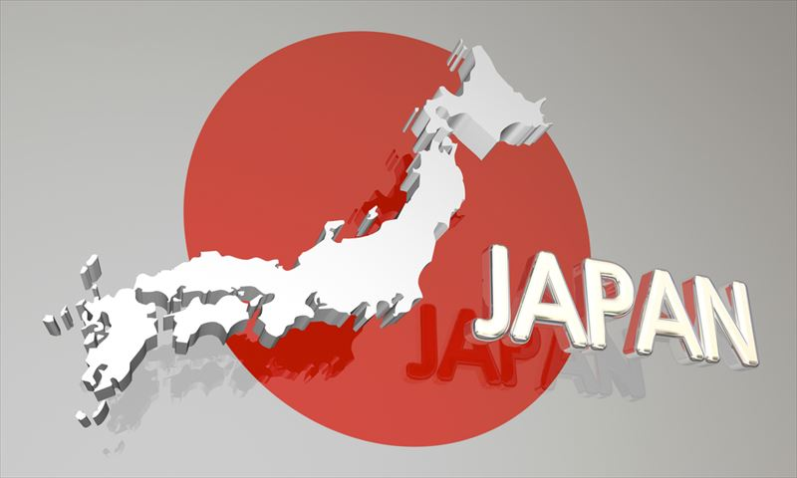
Introduction: We are excited about the upcoming year’s seminar sessions and the opportunity to introduce the Chinese, Japanese and Korean cultures to K-12 administrators and teachers in our state.
日 本

Japan Seminar Discussion Topics

Session 1: Women in Japan
Date: December 5 Time: 10:00 am - 11:00 am
Zoom link: Session 1 Zoom link

Session 2: The Samurai of Japan

Date: December 12 Time: 10:00 am – 11:00 am
Zoom link: Session 2 Zoom link

Presenter: Dr. Elyssa Faison – Associate Professor of History at the University of Oklahoma
_________________________________________________________________________

Registration:

Register on Facebook https://fb.me/e/3ZzGBd3FQ or email Rex Burnett at rexburnett@ou.edu

Benefits:

• Two sessions -Two 30-minute prerecorded videos/one 1-hour live Zoom (each session)
• 4 hours of professional development credit hours
• Access to East Asia resources and other educational materials
- Aligned with Oklahoma Standards

Expectations:

- Watch two prerecorded videos for discussion during each Zoom session.
- Readings for class provided before each Zoom session.

For more information, please contact Rex Burnett at
918-660-3497 rexburnett@ou.edu or visit us at ou.edu/cas/eai/

