University of Oklahoma – the East Asia Institute (EAI) and
the National Consortium for Teaching About Asia (NCTA)

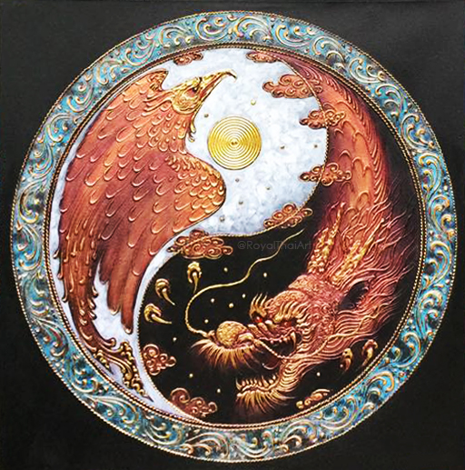
China Online Seminar Overview - China: Will the Dragon Soar Higher Than the Eagle?

China has a long history of isolationism, but with strong economic and military growth (hard power) combined with the spread of Chinese language and culture throughout the world (soft power), China has elevated its’ status from mere observer to a real player on the world stage.

This online course is a look into the foundations of Chinese culture, Chinese philosophies (Confucianism,
Taoism, Buddhism), Tang Poetry, China’s economic development, and national security concerns.

Who: K-12 educators; social studies, history, art, geography, and world languages
When: Sat. - April 3, 10, 17, 24; May 1 When: Wed. – April 7
Time: 10:00 am to 11:30 pm Time: 5:00 pm – 6:30 pm
Sessions: 6 total Platform: ZOOM
Stipend: Receive $100.00
PD hours: 11 hours (class) and 6 (lesson plans) – 18 total
Requirements: Attend 5 of 6 sessions and complete 5 lesson plans based on presentations.

Aligned with Oklahoma Academic Standards

Schedule:

- Apr 3 (Sat) Chinese: One of the Four Ancient Civilizations - Rex Burnett (OU)
- Apr 7 (Wed) National Security: China’s Active Defense Strategy -Dr. Li Xiao Bing (UCO)

Zoom register (Wed only): https://oklahoma.zoom.us/meeting/register/tJIpdO6hrj8oHdIP0vlYVxcIU28CWt0NJCfW

- Apr 10 (Sat) Poetry: Tang Poetry’s Influence on Modern China - Dr. Jonathan Stalling (OU)
- Apr. 17 (Sat) Philosophy: The Thought of Chinese Culture - Dr. Tom Buoye (TU)
- Apr. 24 (Sat) China: World’s Fastest Growing Economy - Dr. Paul Bell (OU)
- May 1 (Sat) Taoism: Go With the Flow - Rex Burnett (OU)

Zoom Register (All Sat) https://oklahoma.zoom.us/meeting/register/tJElde2spjIvEtQ_I0tKrwQGnMBdfgrZDLxS

For more information contact Rex Burnett at rexburnett@ou.edu or call 918-660-3497.

Visit us at https://ou.edu/cas/eai/

