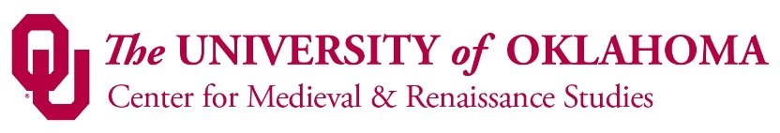

CMRS NEWSLETTER, SEPTEMBER 2, 2015

Welcome-back plus organizational meeting, Sept. 25, 3-5 pm

Picking up from last September’s very successful welcome-back plus organizational meeting, we invite all CMRS members and interested other people to join us in Ellison Hall, room 220, on Friday, Sept. 25, from 3-5 pm.
As before, there will be food and drink, and time to chat and catch up with each other plus meet new people. Then we’ll sit down and discuss various current and potential activities related to study of the medieval and/or Renaissance periods.

TABLE OF CONTENTS

- LOOKING FORWARD TO 2015-16
- August 2015-August 2016: “Galileo’s World”
- January 2016: “First Folio! The Book That Gave Us Shakespeare”
- And another CMRS – First Folio connection
- CMRS-sponsored talks
  - CMRS Brown Bags
  - Medieval Fair / CMRS Lecture Series
- “The Scientific Revolution”: speakers for Prof. Kathleen Crowther’s Presidential Dream Course
- Members’ news
  - Sam Huskey awarded major grant for Digital Latin Library
  - Su Fang Ng grants
- Medieval Fair / CMRS Lecture Series
- New Med/Ren colleagues
- Medieval & Renaissance Studies courses: Things are moving!
- Medieval & Renaissance Studies minor
- CMRS and the Medieval Academy of America
- Do you have a kid in high school?
- LOOKING BACK AT 2014-15: The CMRS’ accomplishments for the academic year 2014-15

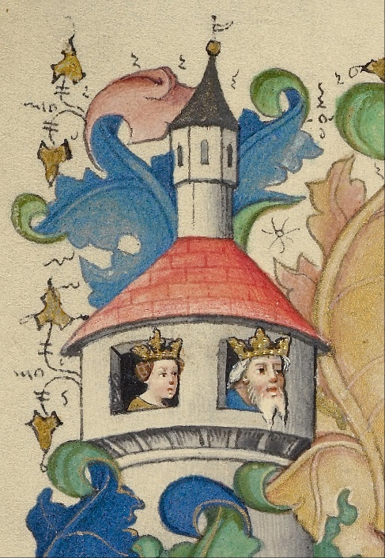
LOOKING FORWARD TO 2015-16

At the end of this newsletter you’ll find a list of CMRS achievements from 2014-15—but let’s start with the future (which, as we all know, is usually based on the past anyway).
Below are some events and news concerning the upcoming academic year. They include major exhibi-tions focused on two of the most creative men in human history—Galileo Galilei and William Shakes-peare, appearing together on campus serendipitously at the start of OU’s 125th anniversary—as well as many other opportunities for faculty and students to expand their intellectual horizons and meet interesting fellow-scholars. The CMRS’ Events calendar (cas.ou.edu/ cmrs) is bulging!
Send your students—and come yourself!

August 2015–August 2016: “Galileo’s World”

OU Libraries Special Collections has organized a
dazzling array of exhibits and events focused
around Galileo Galilei

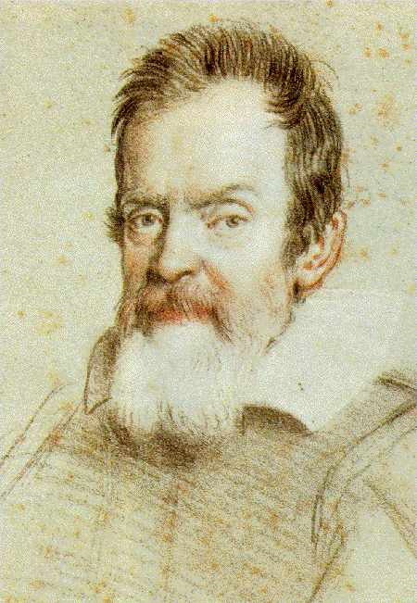
OU Libraries’ Special Collections is calling it “an exhibition without walls – 20 exhibits, 7 locations, 3 campuses.” It offers the once-in-a-lifetime opportunity to view in one setting a complete set of first editions of Galileo’s printed works published during his lifetime. This includes the four first editions of Galileo’s works with annotations in his own handwriting that are owned by OU: Compasso (1606); Difesa (1607); Sidereus nuncius (Venice, 1610); and Dialogo (Florence, 1632).
The exhibits comprise “A New Physics,” “An Artful Observation of the Cosmos,” “Controversy over the Comets,” “Copernicus and Meteorology,” “Galileo and China,” “Galileo and Experimentation,” “Galileo and Kepler,” “Galileo and Space Science,” “Galileo and Sports,” “Galileo and the Health Sciences,” “Galieo and the Microscope,” “Galileo and the Scientific Revolution,” “Galileo Today,” “Galileo, Natural History, and the Americas,” “Music and the Spheres,” “Oklahomans and Aerospace,” and “The Galileo Affair.”
Participating venues are the Bizzell Memorial Library, the Sam Noble Museum of Natural History, the National Weather Center, the Fred Jones Jr. Museum of Art, Headington Hall, the Robert M. Bird Health Sciences Library, and the OU-Tulsa Schusterman Library.
Events include talks, a film, a concert, sky-watching, an “interactive family festival,” and a play.
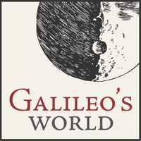
As curator Kerry Magruder poetically writes: “Galileo’s World will connect every academic program of the University, sustaining a multidisciplinary conversation that brings our worlds together across time and space. A portion of Tuscany was transplanted to the windswept plains of Oklahoma, and now the story of Galileo has become part of every student’s and researcher’s experience at OU. The interconnectedness of science and culture which characterized Galileo’s world, and which connects Galileo’s world to our own day, remains the common heritage of humanity which we explore across the University and beyond Oklahoma to the world.”
To learn more, go to https://galileo.ou.edu. For suggestions about how to use the exhibits in your teaching, contact JoAnn Palmeri (research coordinator, History of Science Collections, and acting curator, John and Mary Nichols Collection; 325-2741, palmerij@ou.edu).

January 2016: “First Folio! The Book That Gave Us Shakespeare”

The CMRS successfully initiated an application
and is providing event programming for a First
Folio exhibition at OU in January 2016
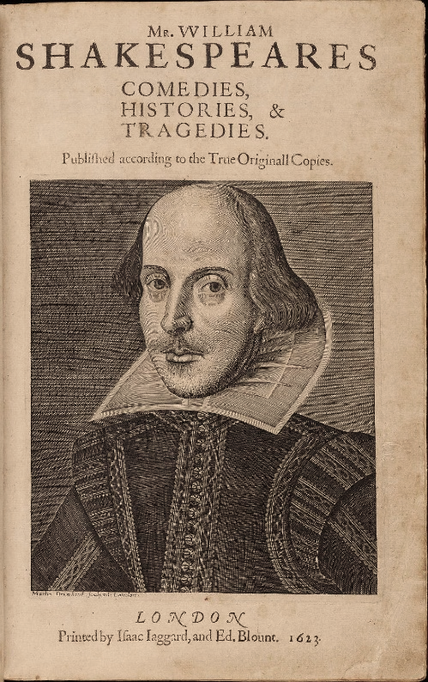
Thanks to the vigorous efforts of a group of CMRS professors and OU librarians, the university was selected to be the Oklahoma host of the traveling exhibit, “First Folio! The Book That Gave Us Shakespeare” in January 2016. The exhibit will include a copy of Shakespeare’s First Folio. Published in 1623, the work is the first complete collected edition of Shakespeare’s plays and the only source for Macbeth, Julius Caesar, Twelfth Night, The Tempest, and Antony and Cleopatra, along with thirteen other plays.
The call for proposals was issued by the Folger Shakespeare Library in collaboration with the Cincinnati Museum Center and the American Library Association. Their goal is to honor the 400th anniversary of Shakespeare’s death by touring the exhibit to all 50 states, Washington, D.C., and Puerto Rico. The group convened to draft an OU proposal consisted of Joyce Coleman (English and director, CMRS); early modernists David Anderson, Kenneth Hodges, and Su Fang Ng from English, with Sara Coodin from Classics & Letters; and Special Collections librarians, particularly JoAnn Palmeri (acting curator, John and Mary Nichols Collection).
Tom Luczycki, head of exhibits at the Sam Noble Museum of Natural History, and his staff eagerly joined the project. With their support, OU beat out several other applicants to be chosen the Oklahoma host. The Museum’s outstanding exhibit space, experienced personnel, abundant parking, and excellent auditorium make it a perfect venue to house the First Folio, along with other materials provided by the Folger, for an exhibit and events intended to have wide public appeal.
The original group of CMRS professors were then joined by Tom Huston Orr and Alissa Mortimer, respectively director and professor in the School of Drama, to create a schedule of events, as mandated by the Folger. The exhibit will be open in the Sam Noble Museum’s Great Hall from January 4, but in order to reach a bigger crowd, the official launch will be on Saturday, January 16, from 1:00 to 2:00 p.m. Kelly Damphousse, dean of the College of Arts & Sciences, will introduce the event, followed by talks on the First Folio and on acting Shakespeare (“Such Stuff as Dreams Are Made on”). The launch event will be followed directly, from 2:00 to 4:00 p.m., by a Family Day in celebration of the Folio. There will be various activities in the Great Hall, at the site of the exhibit, while the Kerr Auditorium will host sessions on love in Shakespeare and demonstrations of stage-fighting techniques (“Love and War”). As of the time of writing, it looks likely that the Medieval Fair’s Medieval Midwinter Ball will take place in the Great Hall that evening, to cap the day of med/Ren celebration.
Further related events include presentations in the Kerr Auditorium on January 19 (“Living Shakespeare”) and 26 (“If Music Be the Food of Love ...”); a CMRS/Medieval Fair public lecture about one of Shakespeare’s most notorious characters, Shylock, delivered on January 22 by Prof. Sara Coodin (Norman Public Library); and a teacher-training session tentatively scheduled for January 23, at the Weitzenhoffer Theatre, Catlett. All the events will be listed on CAS’s events calendar (http://cas.ou.edu/ events-calendar) and on the CMRS’s website (http://cas.ou.edu/cmrs/First Folio).
One important byproduct of this ambitious CMRS project has been to considerably raise our visibility and value to the College of Arts & Sciences. CAS staff helped me (Joyce) draft funding proposals to CAS and to the Oklahoma Humanities Council. Other members of CAS’ staff have been working on publicity, with an article by Jerri Culpepper on the Galileo and First Folio exhibits due out in CAS’s magazine, Kaleidoscope (prominently featuring CMRS’s role), and another pending for Norman Magazine. Thanks go to Angela Startz, Kristie Morgan, and Cassie Gilman.
“First Folio! The Book That Gave Us Shakespeare” is made possible in part by a major grant from the National Endowment for the Humanities: Exploring the Human Endeavor and by the generous support of Google.org and Vinton and Sigrid Cerf. The CMRS also appreciates generous donations from the Departments of English and of Classics & Letters.

And another CMRS – First Folio connection

History of Science professor Steve Livesey was
involved, behind the scenes, in the discovery of
the St. Omer First Folio

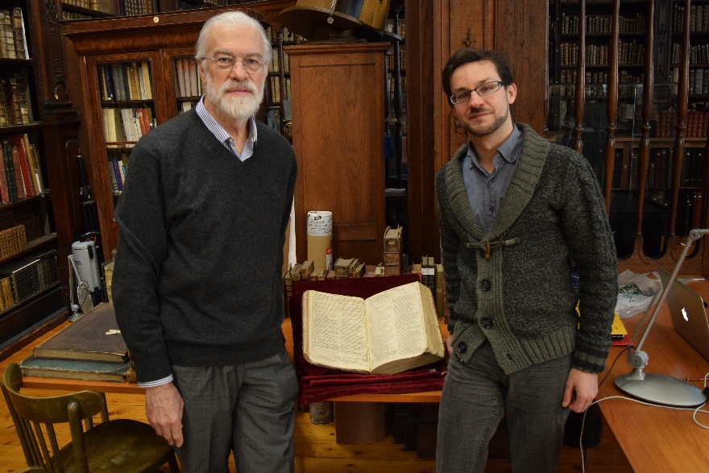
You may have seen, in one of the many news stories last fall covering the discovery, that a previously unknown copy of, yes, Shakespeare’s First Folio turned up in the collection of the Bibliothèque de l’Agglo-mération de Saint-Omer.
Only Sooner Magazine has the full story, though—which is that CMRS member Steve Livesey was on a Fulbright at the time, working in the St. Omer library, and witnessed the attempts of his friend, curator Rémy Cordonnier, to identify and authenticate the book.
The article, “Hiding in Plain Sight,” by Susan Grossman (Sooner Magazine, Spring 2015, pp. 23-27 and back cover) can be read at https://www.oufoundation.org/SM2/ Spring2015/story/Hiding_in_Plain_Sight. Since the site doesn’t have the photos supplied by Steve, however, I am attaching a pdf. (See the back-cover image for a dream-vision of a medieval abbey.)
The Sooner Magazine article also represents the first effort by myself (Joyce Coleman) to place a news item about a CMRS member (after I heard from Steve by email about his experience). I hope to repeat this success in the future, so if you have a story that you think deserves some press coverage, please think of sending it along to me. Such efforts help raise the profile not only of individual professors but of the CMRS and med/Ren studies at OU.
Also: look forward to a visit to OU by Steve’s friend, Rémy Cordonnier, funded by CAS with the help of support letters from, among others, the CMRS.

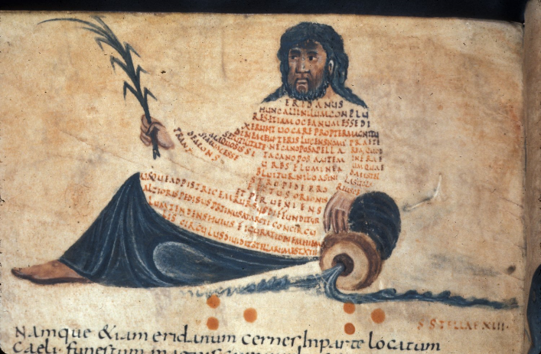
CMRS-sponsored talks

CMRS Brown Bags
Sara Coodin (Letters) will again be organizing a series of CMRS brown bags. Contact Sara (coodin@ou.edu) if you are interested in presenting a talk on your current research in a friendly, stimulating environment.

Medieval Fair / CMRS Lecture Series
Last year we organized six Medieval Fair / CMRS lectures, with a total attendance of 258 people: an average of 43 attendees per lecture. The lectures take place at the Norman Public Library, where the audiences are a cross-section of general public, high-school and college students, and professional colleagues. The series has been running since 2009, and has proven a highly successful form of public outreach for medieval and Renaissance studies—as has been recognized by the Medieval Academy of America! (See below, under “CMRS and the Medieval Academy of America.”)
Here’s a run-down of the speakers and topics scheduled for AY 2015-16’s Medieval Fair / CMRS Lecture Series:

- August 28: Jerry Benson, “The Revival of Traditional German Longsword Fighting”

- Sept. 25: Allison Palmer (Art History), “The Birth of the City in Late Medieval Italy”

- Oct. 23: Brian McCall (Law), “What We Can Learn from the Medieval Conception of Law”

- Nov. 20: Fred Striz (Aerospace & Mechanical Engineering), “Fortifications and siege Warfare through the Ages”

- Jan. 22: Sara Coodin (Classics & Letters), “Was Shakespeare’s Shylock Jewish?”

- Feb. 19: Steve Law (UCO), “Medieval Brewing: Evidence, Inference, and the Educated Guess”

- March 25: Kevin Caliendo (Rose State College) on Anglo-Saxon culture

- April 15: Bill Endres (English), “Digitizing the St. Chad Gospels: Intrigues and Revelations”

Check http://cas.ou.edu/cmrs for full details as they emerge—and think about attending and/or sending your students.

“The Scientific Revolution”: Speakers for Prof. Kathleen Crowther’s Presidential Dream Course (HSCI 3833, Fall 2015)

Prof. Crowther wanted to share the roster of upcoming talks for her dream course, taught concurrently with the “Galileo’s World” exhibit. Please note that details in italics are tentative; check http://cas.ou.edu/events-calendar or http://cas.ou.edu/cmrs for updates.

- Sept. 17, 4:30-6 pm: Eileen Reeves (Comparative Literature, Princeton Univer-sity), “Five Shades of Gray: Galileo, Goltzius, and Astronomical Engraving,” Bizzell Library Lower Level, Room LL 118 / Helmerich Collaborative Learning Center Community Room

- Oct. 1, 4:30-6 pm: Meredith Ray (Italian, University of Delaware), “Astronomy, Astrology, and Poetics in Seventeenth-Century Rome: Margherita Sarrocchi’s Letters to Galileo,” Bizzell Library Lower Level, Room LL 118 / Helmerich Collaborative Learning Center Community Room

- Oct. 29, 4:30-6 pm: Monica Azzolini (European History, University of Edinburgh), “The Material Culture of Astrology in Late Medieval and Renaissance Courts,” Bizzell Library Lower Level, Room LL 118 / Helmerich Collaborative Learning Center Community Room

- Nov. 12, 7-9 pm: Pablo F. Gómez (Medical History, University of Wisconsin, Madison), “Creating a New World: Nature, Knowledge, and Power in the Early Modern Caribbean,” Sam Noble Museum

- Dec. 2, 4:30-6: Antonio Barrera (History and Africana & Latin American Studies, Colgate University), Title TBA, Bizzell Library Lower Level, Room LL 118 / Helmerich Collaborative Learning Center Community Room

Members’ News

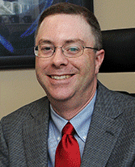
Prof. Sam Huskey, chair and Joseph Paxton Presidential Professor in the Department of Classics & Letters, is the principal investigator for a $1 million grant from the Andrew W. Mellon Foundation for the continued development of the Digital Latin Library.
When complete, in 2017, the Digital Latin Library will offer a catalogue, texts and reference materials, archival materials, and working space for both individuals and groups. It will also provide tools to facilitate the creation and publication of open, born-digital critical editions and other scholarly and pedagogical resources.
Sam’s colleagues in this project are June Abbas, OU School of Library and Information Studies; Chris Weaver, OU School of Computer Science; Hugh Cayless, Duke University Collaboratory for Classical Computing; and Tom Elliott, New York University Institute for the Study of the Ancient World.

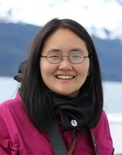
Prof. Su Fang Ng of the English Department has been awarded a visiting fellowship at the Heidelberg Centre for Transcultural Studies at Heidelberg University. She will be working on a new book project on east–west relations through the lens of early modern study of eastern languages. She will be in residence at Heidelberg from October to March, 2015-16, after which she continues her research at Oxford University, where she will be holding a visiting fellowship at All Souls College from April to June, 2016.

New Med/Ren colleagues

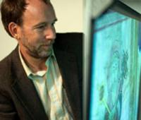
Prof. William Endres has joined the English Department this Fall, to teach in the Composition, Rhetoric, and Literacy division. Prof. Endres wrote his 2008 dissertation at Arizona State University on “Rhetorical Invention in the Book of Kells: Decoration and Images on Their Flight to Meaning.” He has combined his interest in early English manuscript production with digital humanities through his project to digitize the St. Chad Gospels using reflectance transformation imaging. To see what he’s been up to, go to https://lichfield.as.uky.edu.

Adrienne DePrisco and Sherif Lotfy have joined the English Department’s MEMS (Medieval and Early Modern Studies) graduate-student cohort this fall. Both are doing Master’s degrees.

Let me know if your department has any new faculty or grad students who should join our mailing list.

Medieval & Renaissance Studies courses: Things are moving!

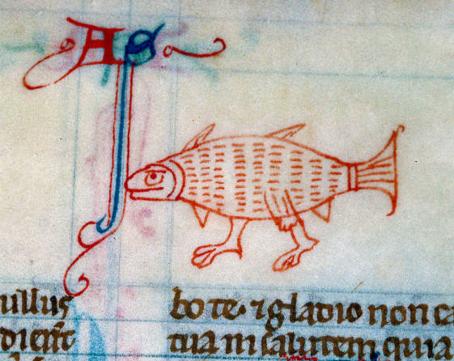
The CMRS’ Curriculum Committee—consisting of Joyce Coleman (English and CMRS), Kathleen Crowther (History of Science), Roberta Magnusson (History), Jennifer Saltzstein (Musicology; on leave for fall 2015), and Rienk Vermij (History of Science)—has successfully overseen the revision of the MRS course-list. Our offerings have been streamlined and updated, and the changes officially approved and added to the university’s catalogue.
Here are the descriptions:
- MRS 3023 Exploring Medieval and Renaissance Studies. Prerequisite: junior standing or above, or permission of instructor. Provides an overview of the history, literature, and art of the Middle Ages and Renaissance, including hands-on work with medieval manuscripts and early printed books. This course will be taught by a series of faculty lecturing in their area of expertise, coordinated by a faculty member who will be present at every class and will serve as instructor of record. (Irreg.)

- MRS 3990 Independent Study. Prerequisite: junior standing or above and permission of instructor. May be repeated; maximum credit six hours. Independent study on a topic in medieval and/or Renaissance studies. (F, Sp)

- MRS 4903 Seminar in Medieval and Renaissance Culture. Prerequisite: junior standing or above, or permission of instructor. May be repeated once with change of topic; maximum credit six hours. Specialized study in selected topics in medieval and Renaissance culture. This course may be taught by an individual faculty member or by a series of faculty lecturing in their area of expertise, coordinated by a faculty member who will be present at every class and will serve as instructor of record. (Irreg.)

Beginning in Fall 2015, the CMRS Curriculum Committee will plan out a syllabus for the 3023 class, which is intended to serve as a gateway course for study in either or both the Middle Ages and Renaissance. As the course description states, we will be recruiting individual professors to cover a class or two within their area of expertise. One person, or perhaps a team of a few people, will take responsibility for the administrative aspects of the class, and will attend all classes to ensure continuity. We hope to be able to offer the 3023 class in Fall 2016.
Obviously, we are counting on the support of our extended CMRS community—many of whom have shown great interest in and excitement about this course. I think we can all agree that it would help to recruit and energize students for study in our own disciplinary areas. As we create and revise the syllabus, and decide how the pragmatics of the course will work, we will be in touch with people we think might want to contribute a lecture or two.
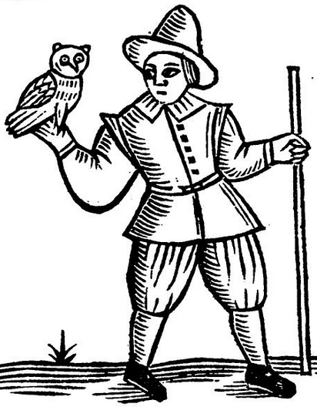
Of course, please feel free to contact us at any point to volunteer or offer suggestions (see below for email addresses). Any CMRS member who wants to is welcome to attend Curriculum Committee meetings (and/or to join the committee). All meeting dates will be announced to the whole membership, and drafts of the syllabus will be circulated to everyone. Anyone who has ideas but can’t make a meeting is welcome to communicate directly with me or the other members of the committee.
Anyone or any group that would like to teach an MRS 4903 class is welcome to do so; just please get in contact with the committee to let us know. We will also be looking at setting up a first run of this course, when we’ve got 3023 launched. Similarly, if you want to teach an independent study as an MRS 3990, please feel free but let us know.
The suggestion has also been made that we set up a freshman-level MRS course called “Topics in Medieval and Renaissance Studies.” The idea would be to teach some accessible and interesting aspect of the period(s), to get students excited about it and enrolling in our departmental courses. We will be talking this fall about designing and proposing such a course.
Finally: money. As of right now, we don’t have any. All work on these courses, in planning and teaching, will have to be donated by generous faculty. However, we will be looking into ways of seeking financial support for development and for teaching buy-outs, as well as strategies that could persuade department chairs to allow their professors to get in-load credit for serving as convener on these courses. Any advice or ideas are welcome!
To contact some or all members of the committee, email:
joyce.coleman@ou.edu; kcrowther@ou.edu; rmagnusson@ou.edu; rienk.vermij@ou.edu

Medieval & Renaissance Studies minor

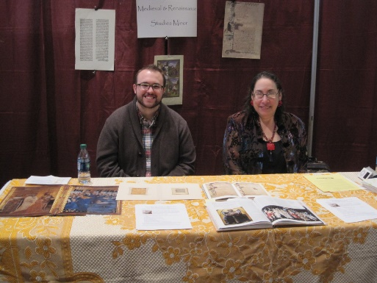
The MRS minor has been revised and approved, and is on OU’s website at http://checksheets.ou.edu/ 14checksheets/MRS%20minor%202014.pdf. Roberta Magnusson (rmagnusson@ou.edu) has volunteered to act as advisor.
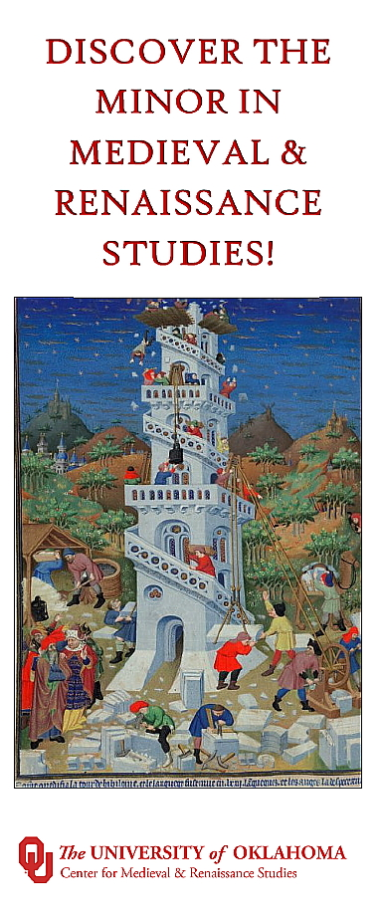 We will need to revise the minor checksheet to reflect the new array of MRS courses, and perhaps make other small changes. However, the minor is available now, so do think about directing interested students towards it. It offers bright undergrads a unique opportunity for interdisciplinary, interrelated work in a fascinat-ing field.
Trevor McMichael and Joyce Coleman at the MRS Minor table, Majors and Minors Fair
We have several plans underway for promoting the minor. Last February, we made our first appearance at the Majors and Minors Fair, arousing a lot of interest with our colorful table and interesting displays. I have designed a brochure advertising the minor. The brochure has been vetted and approved by the Office of Public Affairs, but currently, alas, there are no funds to print it; I attach a pdf so you can see it at least (and possibly distribute it to your students). I am pursuing funding options.
I also will try to speak about the MRS minor to a meeting of undergrad advisors and to get a story into the student newspaper. All attempts to help promote the minor will be appreciated! Let me know if you have any other ideas.
As part of this effort, the CMRS also acquired a logo, which you can see at the top of this newsletter and at the bottom of the MRS brochure. The logo was provided by the Office of Public Affairs, in line with their strict requirements for consistent OU design.

CMRS and the Medieval Academy of America

Lunch with CARA and a shout-out to the CMRS /
Medieval Fair lecture series at a Medieval Academy session

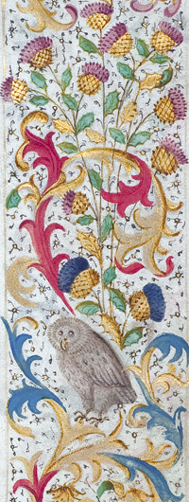
At this year’s International Medieval Congress (aka Kalamazoo), I attended a CARA lunch organized by the Medieval Academy of America. CARA is the Academy’s Committee on Centers and Regional Associations, and this is the first time, I believe, that OU’s CMRS has connected with it or with the Medieval Academy itself.
The tables were organized by the participants’ interests. I chose to sit at the table interested in Funding, and heard some good ideas from the other guests. By lucky chance, the execu-tive director of the Medieval Academy, Dr. Lisa Fagin Davis, sat at the same table. By even nicer luck, it turns out that she is from Oklahoma; see her blog-post, “Manuscript Road Trip: Oklahoma,” at https://manuscriptroadtrip.wordpress.com/ tag/university-of-oklahoma.
To keep up the connection, I sent Lisa a description of our program at OU, which was published in the June 2015 edition of the CARA Newsletter (which can be uploaded from our website’s homepage; look for p. 5).
Also: CMRS member Catherine Barrett (Architecture) can be heard on a podcast recently posted by the Medieval Aca-demy boasting about our Medieval Fair / CMRS lecture series. The podcast concerns “The Future of Medieval Studies” and was recorded at the most recent meeting of the Academy, at the University of Notre Dame in March 2015.
In a discussion of how to create value for medieval studies in the eye of the public, and of university administrators, Catherine says: “I just wanted to offer one example of outreach, at the University of Oklahoma. They have a medieval fair in Norman, every year, and so the CMRS there tapped into the organizers of the fair, and they now work together on a lecture series where sometimes people [from the community] present on their specialties, but more often than not it’s professors from the university. But they’re very well attended, at the local library.”
Thanks, Catherine! It’s great to see that the CMRS and our lecture series are getting national attention.
To hear the podcast of the “Future of Medieval Studies,” go to https://www. dropbox.com/s/ryfclf1d5ea9hqd/Futures%20of%20Medieval%20Studies.MP3?dl=0. The lecture-series shout-out starts at about 1:24:00.

Do you have a kid in high school?

Shacked in ignorance, disciplined by fear, ...

If you have a child in advanced-placement high-school classes, he or she may be getting a slightly warped idea about the Middle Ages.
In a recent Medieval Academy of America newsletter, MAA president Barbara Newman quoted from the book her granddaughter had been assigned for AP History. It describes the transition from the Middle Ages to the Renaissance this way:

Shackled in ignorance, disciplined by fear, and sheathed in superstition, they [medieval people] trudged into the sixteenth century in the clumsy, hunched, pigeon-toed gait of rickets victims, their vacant faces, pocked by smallpox, turned blindly toward the future they thought they knew—gullible, pitiful innocents who were about to be swept up in the most powerful, incomprehensible, irresistible vortex since Alaric had led his Visigoths and Huns [sic] across the Alps, fallen on Rome, and extinguished the lamps of learning a thousand years before.

The source is William Manchester’s 1992 opus, A World Lit Only by Fire. Prof. Newman reports that the book is on a list of texts recommended by the national AP Development Committee, which is an arm of the College Board. Apparently, AP European History courses begin in 1450—since, as Mr. Manchester establishes, nothing of any importance happened before that date.
For more on the state of K-12 education about the Middle Ages, and the MAA’s response, see Prof. Newman’s “From the President” column in the June 2015 edition of the Medieval Academy News (no. 199); http://www.themedievalacademyblog.org.

LOOKING BACK AT 2014-15

The CMRS’ accomplishments for the
academic year 2014-15

Some of the past academic year’s accomplishments are encapsulated in material presented above, but here is an overview. Working as individuals or groups, the CMRS last year:

- Created and received approval for two new MRS courses.

- Manned our first table at the Majors and Minors Fair.

- Created and received approval for an MRS Minor brochure. (Currently trying to find money to print it!)

- Initiated a successful proposal, found an OU host, planned events, and applied for funding for a month-long exhibit at the Sam Noble Museum: “First Folio! The Book That Gave Us Shakespeare.”

- Organized three CMRS brown bags:
Jason Houston (Italian), "Reading the Signs of History in Dante's Paradiso"
Su Fang Ng (English), "Alexander the Great in Transnational Mirrors for Princes from Britain to Islamic Southeast Asia"
Gershon Lewental (History), "Narratives of Islamic Historiography: Reading Historical Texts as Literature"

- Organized six Medieval Fair / CMRS lectures:
Benjamin Brand (Musicology, Univ. of North Texas), “Singing in the Streets: Reconstructing the Stational Liturgies of an Early Medieval City” (32 attendees)
Catherine Barrett (Architecture), “The Cathar Heresy in the Sculpture of Fourteenth-Century Cordes” (28 attendees)
Kevin Crow (Univ. of Science and Arts of Oklahoma), "Machiavelli and the Corruption of Politics" (38 attendees)
Joe Sullivan (German), “Knights of the Air: Medieval Chivalry and World War I Pilots” (62 attendees)
Jon Arnold (History, Univ. of Tulsa), "Barbarians and the Fall of Rome" (26 attendees)
David Anderson (English), "The Ethics of Suicide in Shakespeare's Julius Caesar" (72 attendees)

- Received an OU-approved CMRS logo.

- Launched into PR by placing an article about a CMRS member in Sooner Magazine.

- Began to create ties with the Medieval Academy of America by participating in a CARA lunch and follow-up emails and by contributing a program description to the CARA newsletter.

- Maintained and improved the CMRS website.

- 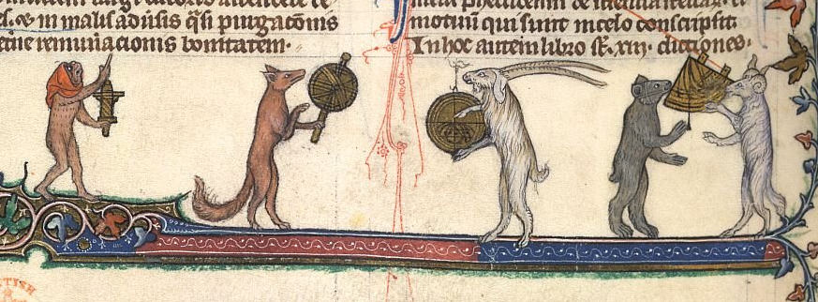Provided a supporting letter for a funding proposal by Prof. Steve Livesey (History of Science). (I will be happy to provide other such letters for suitable projects.)

