**CMRS NEWSLETTER, AUGUST 25, 2014**

o First of all: The CMRS meeting scheduled for Sept. 5 has moved to Sept. 12, owing to a schedule conflict.

So take note: Friday, Sept. 12, 3-5 pm, in Ellison Hall room 220, all faculty members of the Center for Medieval & Renaissance Studies are invited to a welcome-back party plus organizational meeting. After some time for socializing and consuming refreshments, we’ll sit down and discuss various current and potential activities related to study of the medieval and/or Renaissance periods.

Among these activities are:

* Continuing the brown-bag series launched very successfully last year by Sara Coodin
* Possible classes or activities linked to the “Galileo’s World” Exhibition planned by the curators of the History of Science Special Collections. Concurrent exhibits will run at Bizzell Special Collections and other venues. Kerry Magruder and JoAnn Palmeri are encouraging professors to plan courses that will coordinate with these exhibits and the associated events.
* Relaunching the revised, updated Medieval & Renaissance Studies minor
* Potential, perhaps collaborative MRS courses
* Any feedback or suggestions in regard to the CMRS website (http://cas.ou.edu/cmrs)
* Particular ideas suggested to me by CMRS members; I’ll be checking with them to see if they want to bring these to the meeting
* Your ideas!

We should perhaps identify one or two strong ideas for which we can then go seek funding. It doesn’t seem likely that we’ll get a regular budget line from CAS, but if we have a good proposal for a speakers’ series or a colloquium, we might well be able to find the needed funds.



*Illuminated shortbread—an idea for the CMRS party?*

*(See www.cookiepixie.com/2012/05/how-to-decorate-cookies-with-wafer.html)*

o The speakers have been lined up for this fall’s Medieval Fair Lecture Series, though we don’t have all the titles and abstracts yet. Check http://cas.ou.edu/medren-events for full details as they emerge—and think about attending and/or sending your students.

Sept. 12, 6:30-7:30 pm, Norman Public Library, Lowry Room

A “bonus” presentation:

"The Revival of Traditional Germanic Long Sword Fencing"

**Jerry Benson**, Master of Arms, Redlands Fencing Center

Sept. 19, 6:30-7:30 pm, Norman Public Library, A/B Room

“Singing in the Streets: Reconstructing the Stational Liturgies of an Early Medieval City”

**Benjamin Brand**, University of North Texas, College of Music

Oct. 17, 6:30–7:30 pm, West Wind Unitarian Universalist Church, 1309 West Boyd St.

Talk on medieval architecture, title TBA

**Catherine Barrett**, University of Oklahoma, College of Architecture

Nov. 21, 6:30-7:30 pm, Norman Public Library, A/B Room

“Machiavelli and the Corruption of Politics”

**Kevin Crow**, University of Science and Arts of Oklahoma

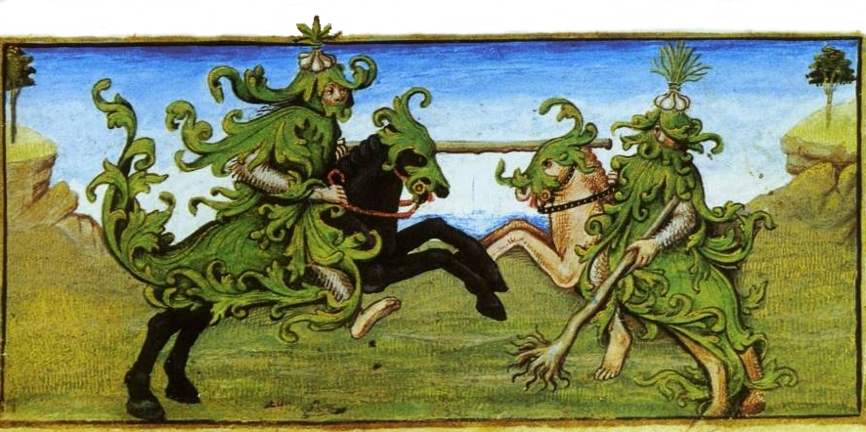

*(Hours of Charles d'Angoulême, illustrated by Robinet Testard; BnF lat. 1173, f. 3, c. 1490)*

o Sam Huskey (chair of Classics) has invited Kathleen Walker-Meikle to visit OU in connection with the Digital Latin Library project. She is a medievalist (from York University) who works on Latin medical and natural history (see www.york.ac.uk/history/staff/profiles/walker-meikle/#research).

As far as I know, the date of her visit hasn’t yet been determined (Sam, please inform us if it has). Contact Sam (huskey@ou.edu) if you'd be interested in having her visit a class, give a talk, etc.

(Thanks to Rienk Vermij for passing this news on.)

o Another medievalist currently “visiting” (as the wife of a new faculty hire) but due to head off for a job in October is Andreea Marculescu, who studies medieval French drama with a particular interest in demonic possession. A graduate of Johns Hopkins University, Andreea was most recently an ACLS New Faculty Fellow at Harvard. Her email is marculescu.andreea@gmail.com and I’m sure she’d be happy to meet with anyone who wants to hear about her research.

o Note that David Anderson and Kenneth Hodges (with help from JoAnn Palmeri) are currently investigating the possibility of a visit from a Shakespeare First Folio in fall 2016. Whether this comes off or not (there are climate-control requirements we may not be able to meet), we should thank everyone involved for the work they’ve done trying to make it happen.

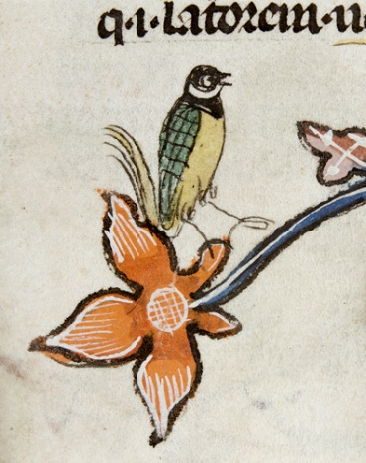o Stephen Lindsey of History of Science (who is currently on a Fulbright in Paris) wants to call our attention to a website called Mirabile (http://www.mirabileweb.it/ricerca_semplice.aspx), which is Galluzzo's digital archive for the Middle Ages. Parts of the data can be searched and seen openly, but much cannot, so Stephen is suggesting that the library subscribe to the service. He notes: “The price list for both individuals and institutions can be found at http://www.mirabileweb.it/prezzi/price_list.pdf. As you can see, the first-year subscription for institutions is 1055 euros, but in the second and subsequent years, this is reduced to 870 euros. The subscription for individuals (460/410 euros) is such a large fraction of the institutional price that having access through the Libraries would be a wonderful value to faculty and students.”

If you want to advocate for a subscription, you can write to Kerry Magruder (kmagruder@ou.edu) or JoAnn Palmeri (palmerij@ou.edu), who are the library reps for History of Science.