EARNINGS DISTRIBUTIONS REQUESTS (EDRs)
INSTRUCTIONS

EARNINGS DISTRIBUTION CHANGE INSTRUCTIONS

Percentage distribution changes alter the way in which salary expenses for an employee are charged against departments and account codes.

- Effective Date is the key to an earnings distribution. For temporary/current changes, the current date will default into this field. Unless the funding is from a grant, it is important to use the beginning of a pay period for the effective date (the ePAF will set the specific date for beginning of pay). For a new position or one that has not yet been assigned a distribution, the user will need an effective date of the beginning of the current fiscal year (07/01/XX).
- All changes remain until a new distribution is processed, so only mark as “Next Fiscal Year” those that will not be effective until July 1 of the following fiscal year.
- It is important to enter the correct payroll date for the change; otherwise, a payroll expense may be split between the old distribution and the new distribution. Please see the Payroll Calendar for correct payroll dates.
- If a distribution change includes a grant component, please enter the grant end date and the employee’s name in the comment field.

After signing into hrms.ou.edu go to Main Menu -> OU Budget Menu -> Revisions -> EDR Worksheet.
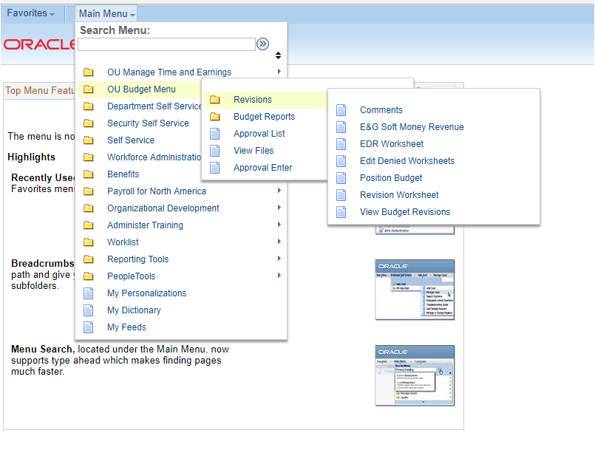

Enter a position number and select .
NOTE: The user should not press the enter key as it does not work on this screen.

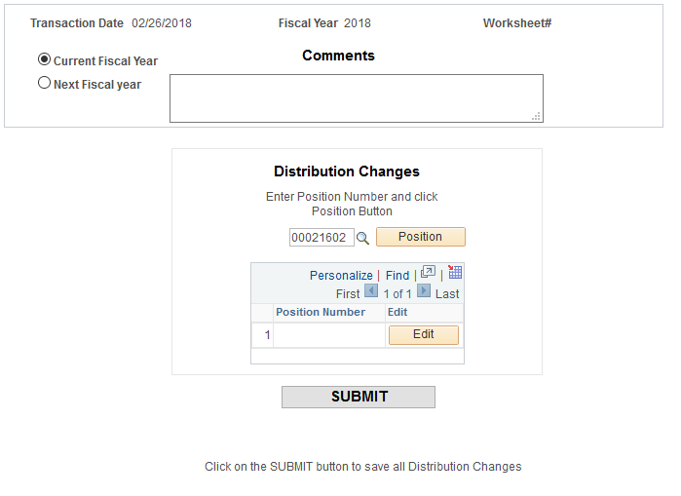

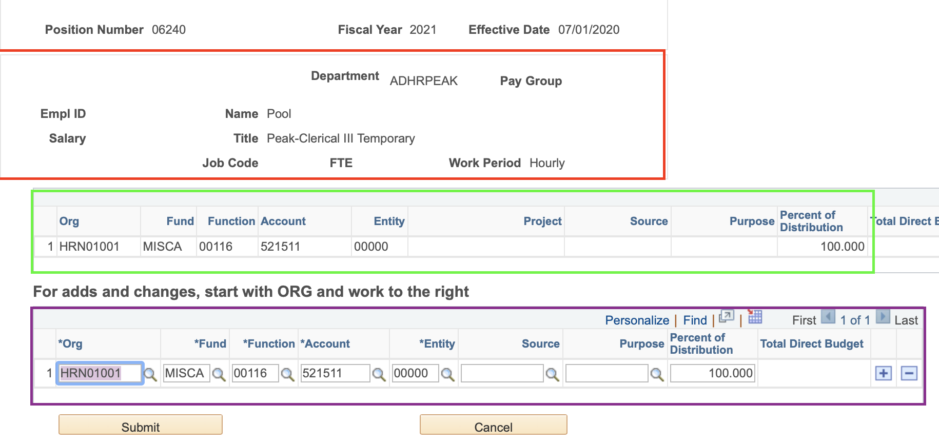

The top section includes the HR Department of the position, Pay Group, as well as the current incumbent’s EmplID, name, salary, position title, job code, FTE, and work period. The current distribution and budget information for the position is shown in the middle section. The bottom section allows the user to change the distribution.

In this example, you can see that this position funded 100% in chartfield HRN01001-MISCA-00116-521511-00000. The “+” allows the user to add a row to the distribution while the “- “allows a row to be deleted.

The EDR selections are based on valid budgets available in PeopleSoft Financials. Working left to right on the EDR screen you’ll start by choosing the Org the position needs to be funded from. After you’ve populated the Org field, you can then click the lookup (magnifying glass) next to the ‘Fund’ field. Only options with a valid budget will appear for selection.

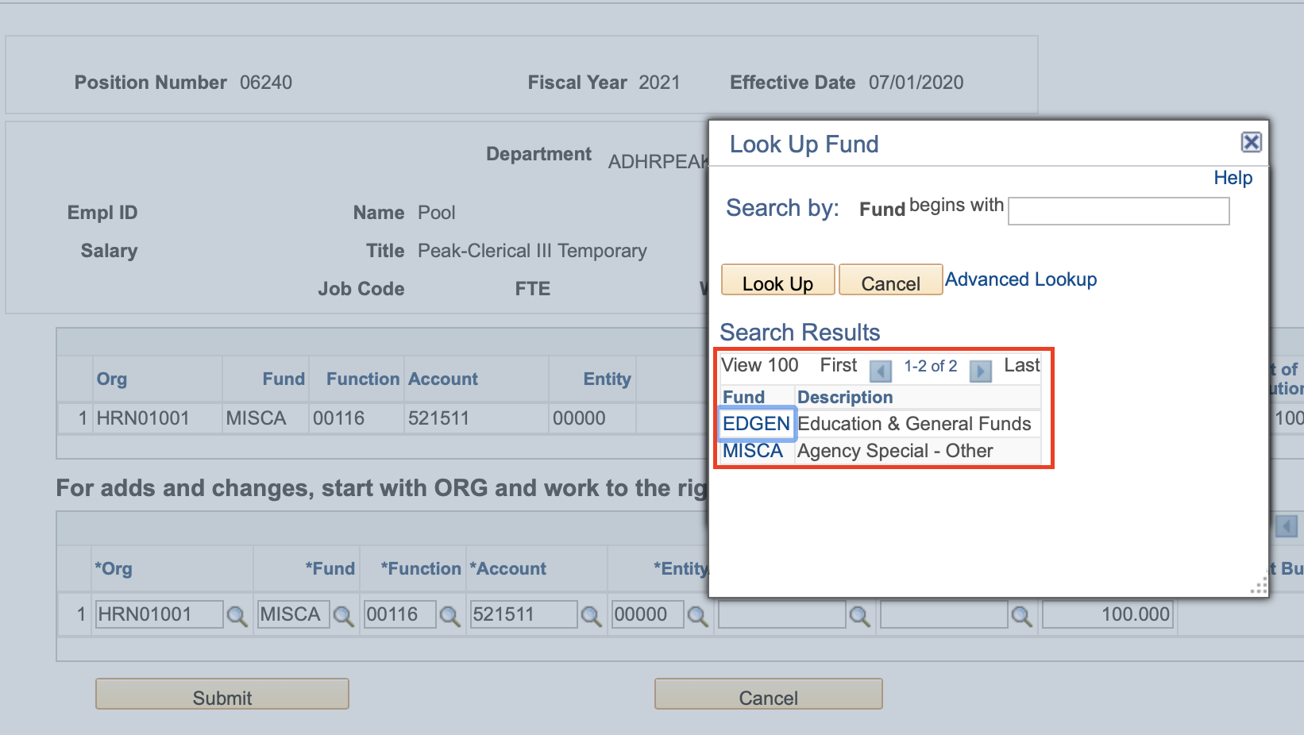

In the above example, you can see Org HRN01001 only has budget available for Funds EDGEN and MISCA. If this position needs to pay from Fund EGFEE, you would need to first submit a budget revision in PeopleSoft Financials, before the EDR could be submitted with the EGFEE fund.

The look up fields for Function, Project, and Source will also pull based on a budget being available in PeopleSoft Financials. If a required selection is not available in the Org, Fund, Function, Project, or Source field on the EDR screen a budget revision must be submitted and approved in PeopleSoft Financials before the EDR can be processed.

Once you have selected the new chartfields and the total distribution equals 100, the EDR can be submitted. Choose if no more changes are needed and you will be taken back to the main revision page.

NOTE: If you open the distribution screen after hitting submit, you will need to re-enter the effective date.

You will need to one more time and get a worksheet number to ensure the transaction has taken place. Again, record this number for tracking purposes.

APPROVAL PROCESS (for users that are reviewers/approvers)

After submission of an EDR, an approval list is generated that indicates the various levels of approval for each transaction. Approvers will be notified via email when the EDR is ready for their approval. Please note the approval email is sent to all available approvers, but only one approver for each Org actually needs to approve.

To view this list, return to OU Budget Menu, select Approval List.

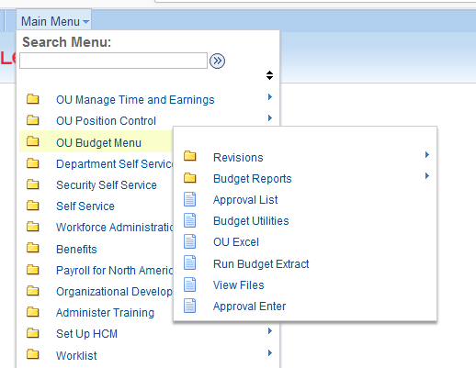

Type in the worksheet number and select “Search”.
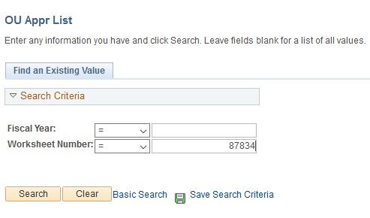

At the top of the screen the fiscal year is shown along with the worksheet number, budget revision number if approved, and approval status; Approved, Denied, or Pending.
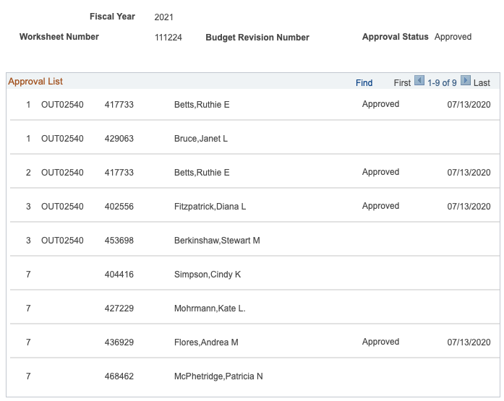

In this example, Level 1 (in the first column) indicates the individual that can approve the transaction as the sponsor or sponsor proxy. Level 2 is the academic dean or non-academic director level; and Level 3 is the vice president approval level. Depending on the transaction, additional levels may be generated: Level 5 is for grant approval of position changes within grant departments; Level 6 indicates the transaction will flow through Financial Support Services, if needed; and Level 7 is for final approval by the Budget Office. Once one person in a level approves, it will move to the next level. Also note that if a person’s name is repeated, it will approve ALL levels with that name.

To gain access for an approver, the department must email the Budget Office, budget@ou.edu. Once approver access is given Level 1 approval is assigned by the department in FAMS. If you need to add an approver at Level 2 or above, please email budget@ou.edu.

Approval Flow Routing is department sponsor, dean/director, vice president, grants (if appropriate), then Budget Office.

Worklist
For a user that may be an approver, a “Worklist” is generated along with an accompanying e-mail. The “Worklist” link can be found in the upper right-hand corner of your screen.
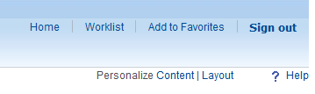

The Worklist indicates who generated the transaction and the date. The user will click on the link to the right to go to the approval screen. Note that the link will show EMPLID, fiscal year of the transaction, and the worksheet number. There is also a choice of EDR or BUD Worklists.
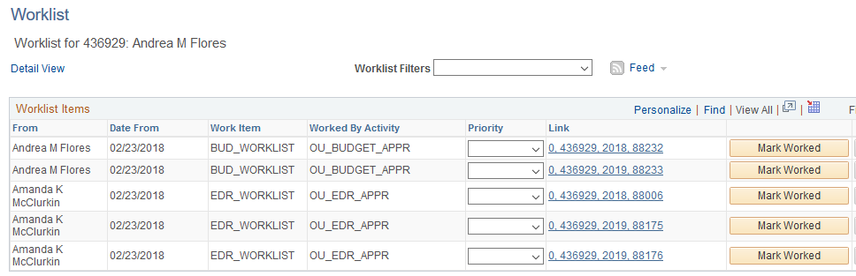

Do not check “Mark Worked” as this will remove the worksheet from your worklist. This option does not approve the worksheet. If this option is accidently checked, navigate to Main Menu -> OU Budget Menu -> Approval Enter and enter the worksheet number and it will allow you to review the worksheet.
The top section of the approval screen indicates the approver’s name, EMPLID, fiscal year, and a section for a denial reason and comments, if applicable. The middle section shows the proposed transaction changes while the bottom section indicates who has approved the revision and the date it was approved.

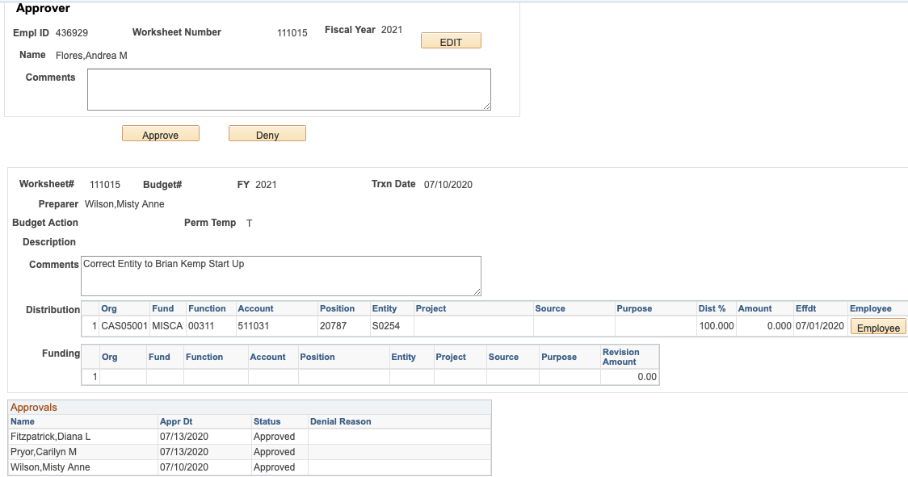

If a distribution change is submitted, the approver can choose the button and the current information becomes available. This includes EMPLID, name, title, HR department, salary, pay group, job code, FTE, work period, and current distribution information.
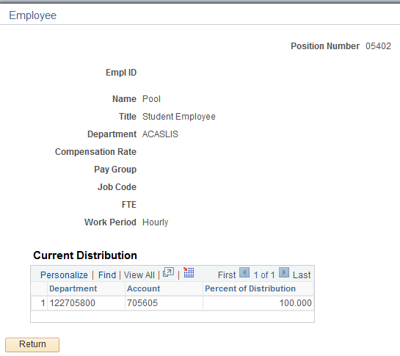
If the worksheet is approved, select and the worksheet will flow to the next level for approval.

If the worksheet is not approved, add a description to the comment box on why the worksheet was denied and then select . The preparer will be notified via email of the denial and the need to resubmit. The preparer will navigate to Edit Denied Worksheet.

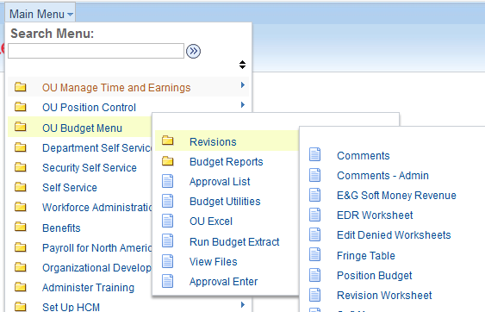

The user will then enter the fiscal year of the denied worksheet and then select the corresponding worksheet number.

The original worksheet is regenerated, and the preparer can make needed changes. Any information in Description will need to be re-entered as will the effective dates for EDRs.

When submitted, a new worksheet number is generated and will be used to track in the approval process.

The user can go back into the “Approval List” and see the status (approved, pending, or denied) of the EDR.

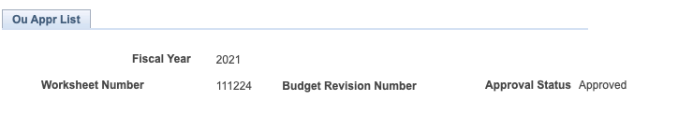

EDR REPORTS

There are several reports available to users to view current and historical information. Select Budget Reports to get started and a list of available reports will be shown.

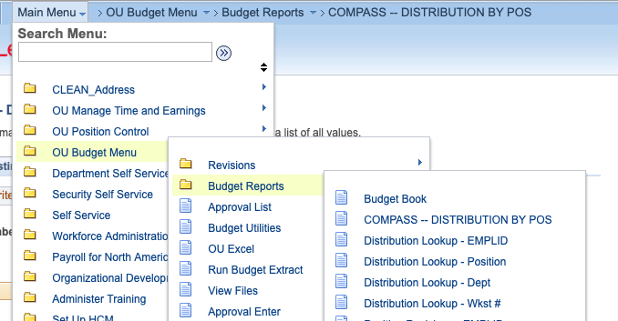

Please note: All reports can be brought into an Excel spreadsheet by choosing the symbol in the report screen. You may need to scroll to the right to see this symbol.

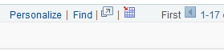

Report Descriptions

- Compass – Distribution by Pos shows all changes for a position in the new PS Compass environment.

- Distribution Lookup - EMPLID shows information about all EDRs submitted prior to the Compass update, the user has entered and the status for each.

- Distribution Lookup - Position allows the user to see a history of changes for a position prior to the PS Compass update.

- Distribution Lookup - Dept is a lookup of distribution for positions within a department, prior to the PS Compass update.

- Distribution Lookup - WKST # is a lookup of distribution for positions by a worksheet number, prior to the PS Compass update.

