INSTRUCTIONS FOR BUDGET REVISIONS
AND
EARNINGS DISTRIBUTIONS (EDRs)

BUDGET REVISION INSTRUCTIONS

The Oracle Budget Module link is: https://hrms.ou.edu/psp/hrprd/?cmd=login

You will need to enter your 4+4 and associated password.

If you need access to the system, please email: budget@ou.edu.

You will be taken to the main page where you need to navigate to “Revision Worksheet”.
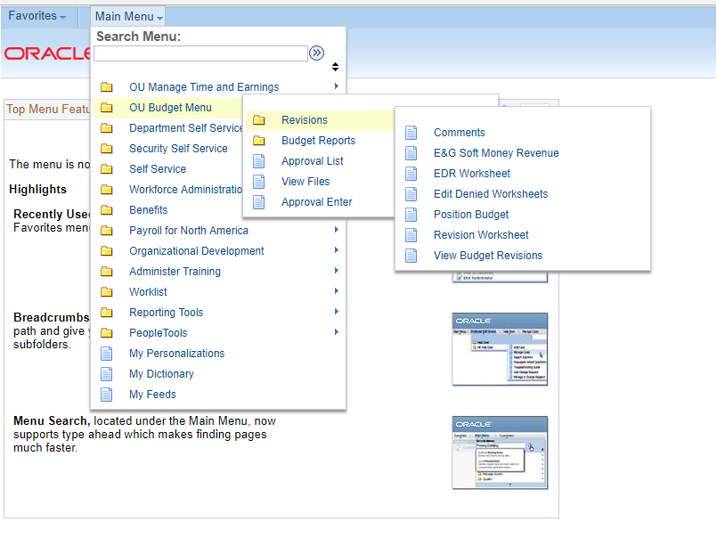

You will be taken to the main revision page.

Field descriptions – Top Section
Transaction Date: Generated date. (This will default to 7/1/20XX for permanent revisions.)
Fiscal Year: Will default to current fiscal year for a temporary revision or to the next fiscal year for a permanent revision.
Worksheet #: Generated number (given after submitting the revision)
Comments: User can add comments up to 200 characters.
Description: Short description of BR and will be reflected on your financial statements.
Temporary/Permanent: Temporary is used for revisions which need to be reflected for the current fiscal year Permanent is used for revisions which need to be reflected for the next fiscal year.
Reason Code: Budget Office use.

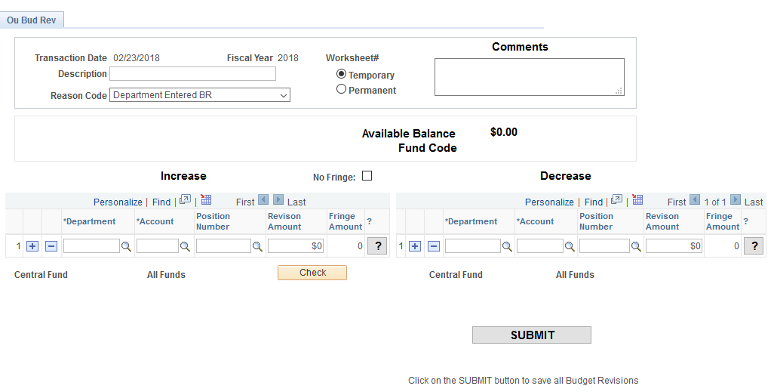

Field descriptions – Bottom Section
The bottom section is much like the paper budget revision form with an increase side and a decrease side. The department number, account number, position number (if any), and revision amount are required to complete the transaction. The user may press the to verify the department name, fund number, and account balance. Note: The available balance is only applicable to temporary or current-year revisions.

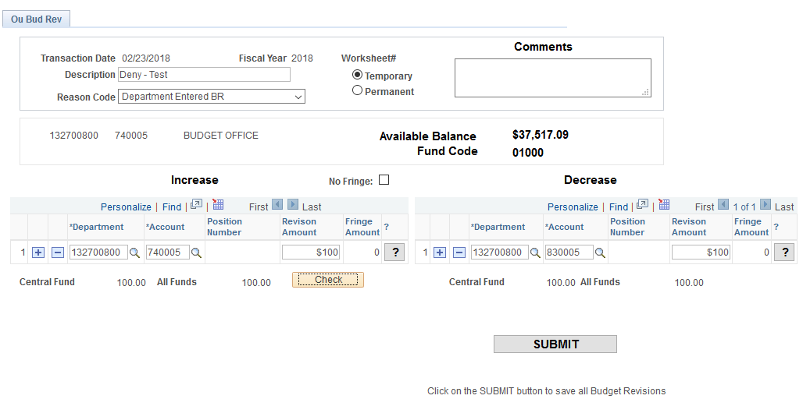

As with other Oracle screens, the user can add or subtract lines by using the “+” or “- “keys. The user may also select the button to determine if the transaction is balancing.
Please note:
- If the department is within 01000 or 03000 funds, then the revision must balance before submitting (have the same total central fund amounts on the increase and decrease sides).
- Temporary One-sided increases or decreases to budget will remain on paper budget revisions.
- Temporary One-sided increases or decreases to budget will remain on paper budget revisions. An increase to budget will need to identify in the comments section from where the funds to increase the budget are coming.

Benefit Calculation in Budget Revision Screen
Fringe benefits are budgeted centrally for all departments in fund 01000 or 03000. Changes to position funding in these departments require a corresponding increase or decrease to benefits. These benefit calculations are automatic for centrally‐funded departments. The fringe calculation is based on the current fiscal year fringe benefit rates and varies depending on the personnel account code. Due to the variable percentages for account codes 607005, 637005, and 657005, the automatic calculation will not occur. Any fringe benefit changes for these account codes will need to be completed by adding the central fringe department #, 132729600, and the corresponding fringe account codes. Please see the Budget Office web page here to view the budgeted rates by account code.

Fringe benefit changes will continue to be entered manually for all departments not in the 01000 or 03000 funds.

The fringe amount column is highlighted below.

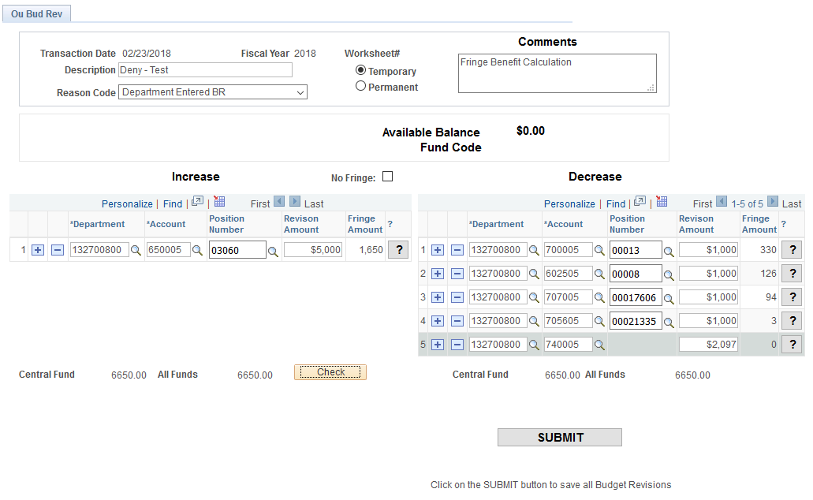

When the user is finished with data entry, the button will process the revision. A “revision worksheet number” will be generated and should be retained for tracking purposes. The user should hit return to complete the transaction. Please note that budget revision updates occur nightly in the budget system.

EARNINGS DISTRIBUTION CHANGE INSTRUCTIONS

Percentage distribution changes alter the way in which salary expenses for an employee are charged against departments and account codes.

- Effective Date is the key to an earnings distribution. For temporary/current changes, the current date will default into this field. Unless the funding is from a grant, it is important to use the beginning of a pay period for the effective date (the ePAF will set the specific date for beginning of pay). For a new position or one that has not yet been assigned a distribution, the user will need an effective date of the beginning of the fiscal year (07/01/XX).
- All changes remain until a new distribution is processed, so only mark as “Next Fiscal Year” those that will not be effective until July 1 of the following fiscal year.
- It is important to enter the correct payroll date for the change; otherwise, a payroll expense may be split between the old distribution and the new distribution. Please see the Payroll Calendar for correct payroll dates.
- If a distribution change includes a grant component, please enter the grant end date and the employee’s name in the comment field. Note that grant EDRs are more limited in account codes available for use: 630005, 631105, 632505, 637005, 650005, 700005.
- Account code should be compatible with the pay group and title. Please confirm the correct account code by checking the document found here.

After signing into hrms.ou.edu go to Main Menu -> OU Budget Menu -> Revisions -> EDR Worksheet.

Enter a position number and select .
NOTE: The user should not press the enter key as it does not work on this screen.

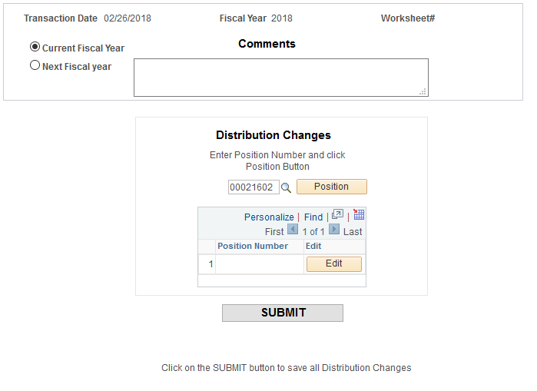

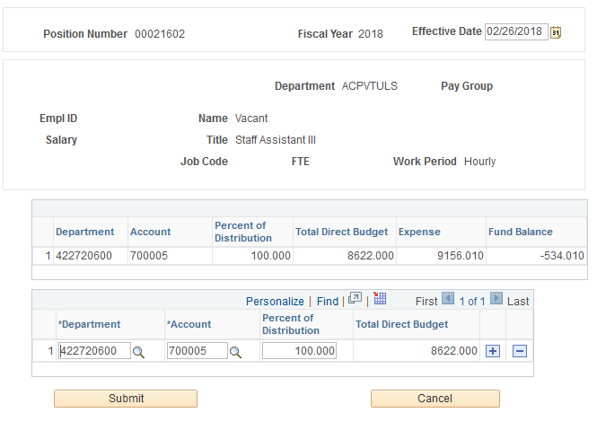

The top section includes the HR Department of the position, Pay Group, as well as the current incumbent’s EmplID, name, salary, position title, job code, FTE, and work period. The current distribution and budget information for the position is shown in the middle section. The bottom section allows the user to change the distribution percentage.

In this example, you can see that this position is 100% in department 422720600, account 700005. Also, of note is that the position is funded (Total Direct Budget for $29,494 in department 422720600, which compares to the salary of $29,494). Again, the “+” allows the user to add a row to the distribution while the “- “allows a row to be deleted. Please note that the total distribution must always equal 100% to submit.

Choose if no more changes are needed and you will be taken back to the main revision page.

NOTE: If you open the distribution screen after hitting submit, you will need to re-enter the effective date.

You will need to one more time and get a worksheet number to ensure the transaction has taken place. Again, record this number for tracking purposes.

APPROVAL PROCESS (for users that are reviewers/approvers)

After submission of a budget revision or EDR, an approval list is generated that indicates the various levels of approval for each transaction. Only the decreasing side of transactions from a budget revision is generated.

To view this list, return to OU Budget Menu, select Approval List.

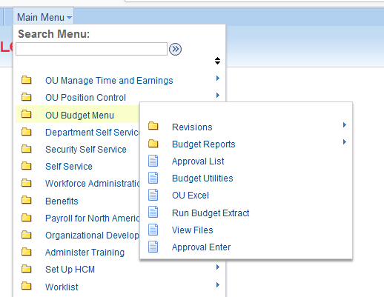

Type in the worksheet number and select “Search”.
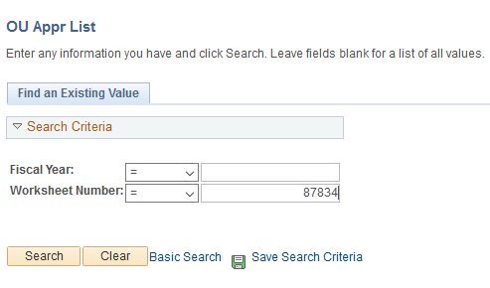

At the top of the screen the fiscal year is shown along with the worksheet number, budget revision number if approved, and approval status; Approved, Denied, or Pending.
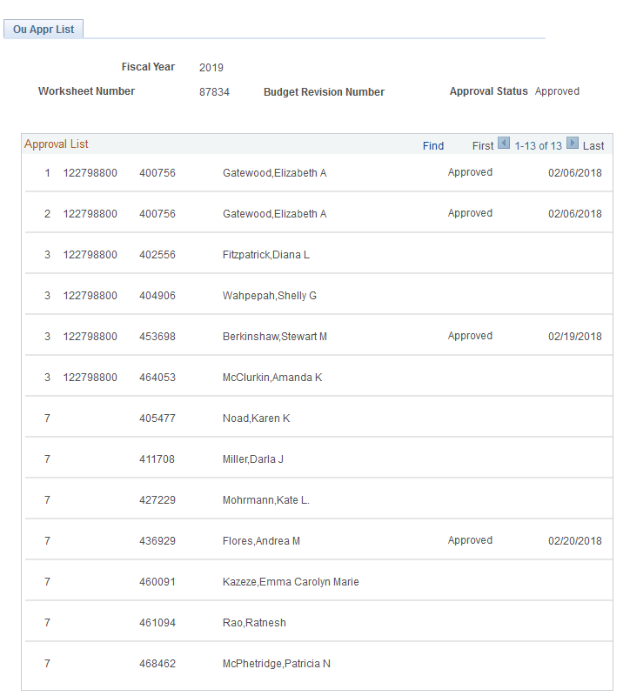

In this example, Level 1 (in the first column) indicates the individual that can approve the transaction as the sponsor or sponsor proxy. Level 2 is the academic dean or non-academic director level; and Level 3 is the vice president approval level. Depending on the transaction, additional levels may be generated: Level 5 is for grant approval of position changes within grant departments; Level 6 indicates the transaction will flow through Financial Support Services, if needed; and Level 7 is for final approval by the Budget Office. Once one person in a level approves, it will move to the next level. Also note that if a person’s name is repeated, it will approve ALL levels with that name.

To gain access for an approver, the department must email the Budget Office, budget@ou.edu. Once approver access is given Level 1 approval is assigned by the department in FAMS. If you need to add an approver at Level 2 or above, please email budget@ou.edu.

Approval Routing is as follows:
- Approvals are guided by whether Temporary or Permanent.

- Temporary (current year):
  - If the revision is balanced and is Educational and General funds only and after vice
president level approval, the transaction goes to the Budget Office for final
review and approval. 01000 fund departments changes cannot be submitted
unless balanced. Any unbalanced E&G revisions must be submitted on paper
revisions.
  - Departmental changes with self-supporting funds flow through Financial
Support Services.
- Grant position or earnings distribution changes also flow through grant teams for
review and approval.
- After all approvals, revisions are applied to either finance or HR systems depending
on the transactions.

- Permanent (subsequent year/next fiscal year):
  - After vice president level approval, all permanent revisions flow directly to
the Budget Office.

Approval Flow Routing is department sponsor, dean/director, vice president, grants (if appropriate), then Budget Office.

Worklist
For a user that may be an approver, a “Worklist” is generated along with an accompanying e-mail. The “Worklist” link can be found in the upper right-hand corner of your screen.

The Worklist indicates who generated the transaction and the date. The user will click on the link to the right to go to the approval screen. Note that the link will show EMPLID, fiscal year of the transaction, and the worksheet number. There is also a choice of EDR or BUD Worklists.
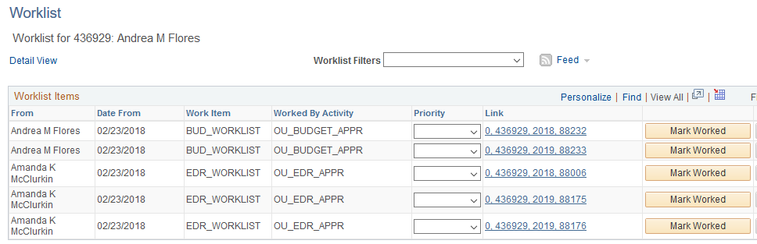

Do not check “Mark Worked” as this will remove the worksheet from your worklist. This option does not approve the worksheet. If this option is accidently checked, navigate to Main Menu -> OU Budget Menu -> Approval Enter and enter the worksheet number and it will allow you to review the worksheet.
The top section of the approval screen indicates the approver’s name, EMPLID, fiscal year, and a section for a denial reason and comments, if applicable. The middle section shows the proposed transaction changes while the bottom section indicates who has approved the revision and the date it was approved.
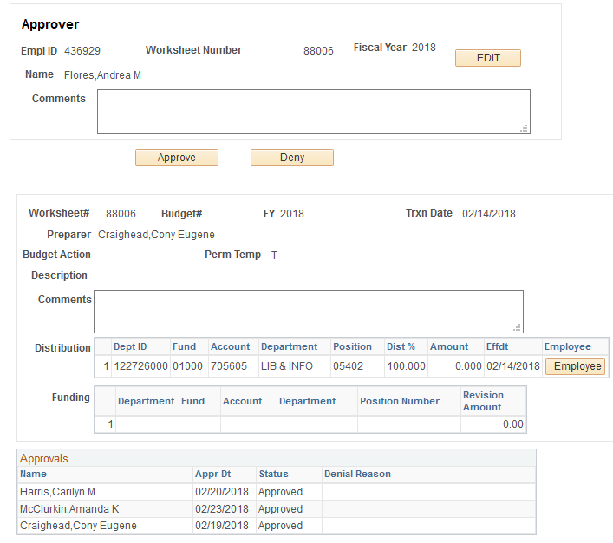

If a distribution change is submitted, the user can choose the button and current information becomes available. This includes EMPLID, name, title, HR department, salary, pay group, job code, FTE, work period, and current distribution information.
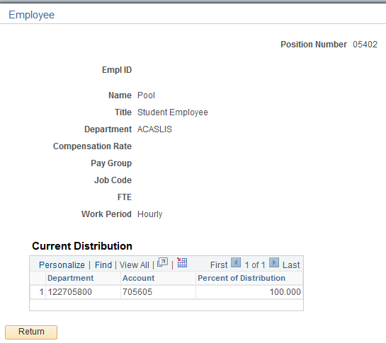
If the worksheet is approved, select and the worksheet will flow to the next level for approval.

If the worksheet is not approved, add a description to the comment box on why the worksheet was denied and then select . It will go back to the preparer for needed changes. The preparer will navigate to Edit Denied Worksheet.

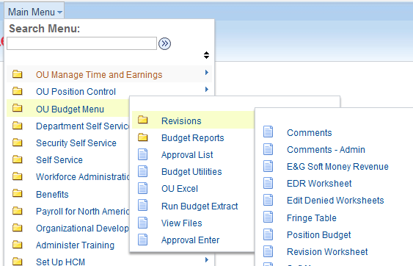

The user will then enter the fiscal year of the denied worksheet and then select the corresponding worksheet number.

The original worksheet is regenerated, and the preparer can make needed changes. Any information in Description will need to be re-entered as will the effective dates for EDRs.

When submitted, a new worksheet number is generated and will be used to track in the approval process.

The user can go back into the “Approval List” and see the status, as well as view the Budget Revision Number that will be reflected on the department’s monthly statement for temporary revisions.

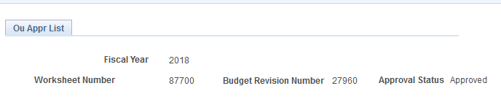

EDUCATIONAL & GENERAL SOFT MONEY (revenue)
Educational & General self-supporting departments (non-01000 fund) should use this screen to enter soft money revenue into the budget system. (Note: Only approvers/reviewers in the system will have the menu choice of Educational & General Soft Money. Please check with your dean/director to coordinate data entry.)

The user will be asked to enter a fiscal year (in this example, 2019) and a department number that has E&G soft money as a component.
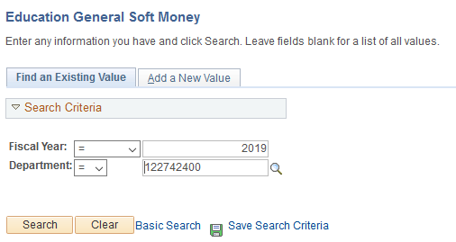

Here the user can change account code, position number, amount, soft code, and soft foundation account number. Lines can be added or deleted using the “+” or “- “signs on the far right.
Please to complete the changes.
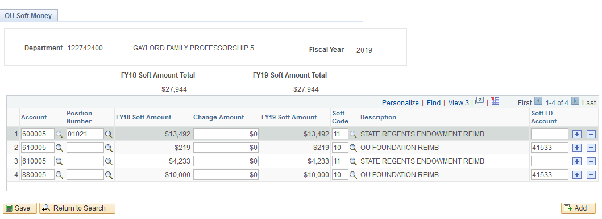
INFORMATION VIEWS AND REPORTS

View – Budget Revisions

After final approval of current-year revisions, users can view a budget revision by department and account to see activity for the current year.

Enter the fiscal year, a department number, and an account code and select Search.
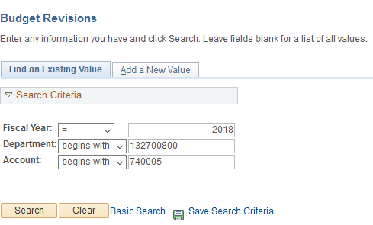

The budget revision view shows the department ID, account and fiscal year. Also shown are the beginning budget, a list of budget revisions, and the ending budget.
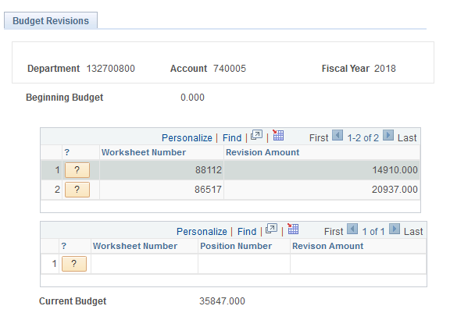
Choosing the question mark allows the user to see more detail of the transaction as the example below shows.
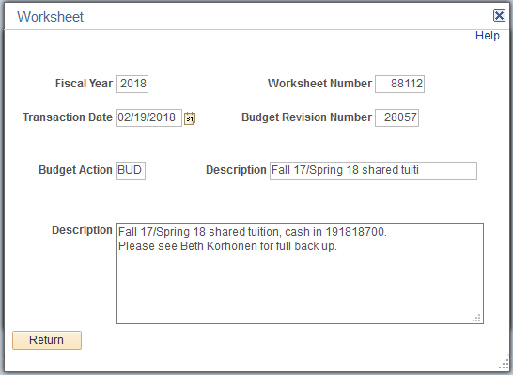

View – Budget Books
Approvers/reviewers have authorization to view current and prior-year budget book information (in PDF format). These may be accessed via the “View Files” menu choice.

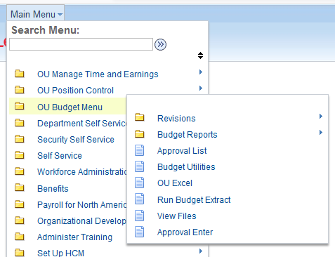
Budget book information is available for fiscal years 2005 – the current fiscal year.

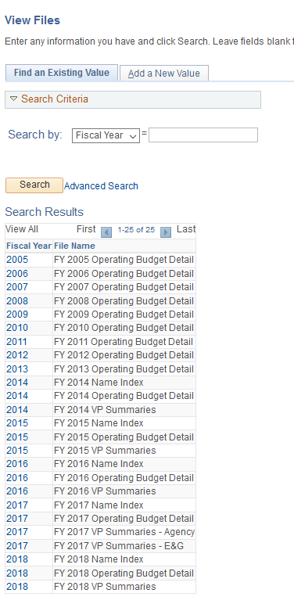

Budget Reports
There are several reports available to users to view current and historical information. Select Budget Reports to get started and a list of available reports will be shown.
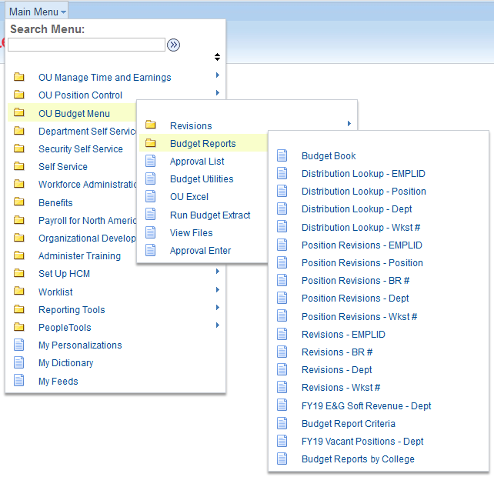

Please note: All reports can be brought into an Excel spreadsheet by choosing the symbol in the report screen. You may need to scroll to the right to see this symbol.

Report Descriptions

- Budget Book report has a similar look to the annual operating budget. Both positions and M&O are listed with corresponding information for the subsequent fiscal year.

- Distribution Lookup - EMPLID shows information about all EDRs the user has entered and the status for each.

- Distribution Lookup - Position allows the user to see a history of changes for a position.

- Distribution Lookup - Dept is a lookup of distribution for positions within a department.

- Distribution Lookup - WKST # is a lookup of distribution for positions by a worksheet number.

- Position Revisions - EMPLID is a lookup of budget revisions for positions by the EMPLID of the person initiating the revision.

- Position Revisions - Position is a lookup of all budget revisions affecting a position since FY 2007.

- Position Revisions – BR # is a lookup of budget revisions for positions by the BR number.

- Position Revisions - Dept is a lookup of budget revisions for a department since FY 2007.

- Position Revisions – Wkst # is a lookup of budget revisions for positions by the worksheet number.

- Revisions - EMPLID is a lookup of revisions by the user’s EMPLID.

- Revisions – BR # is a lookup of budget revisions by BR number.

- Revisions - Dept is a lookup of budget revisions by department number for a selected fiscal year.

- Revisions – Wkst # is a lookup of budget revisions by worksheet number.

- FYXX E&G Soft Revenue - Dept is a lookup of soft money by department for the upcoming fiscal year.

- FYXX Vacant Positions - Dept is a lookup of budgeted vacant positions by department for the upcoming fiscal year.

