NORMAL PROCEDURES PA-28-181 PIPER PILOT |  |  |  | NORMAL PROCEDURES PA-28-181 PIPER PILOT
PREFLIGHT CHECKLIST  COCKPIT  TIE DOWN & PITOT COVER REMOVE  AIRCRAFT DOCUMENTS AROW  PARKING BRAKE SET  ALL INSTRUMENT PANEL SWITCHES OFF  MIXTURE IDLE CUT-OFF  LEFT/RIGHT MAGS OFF  BATTERY MASTER ON  PANEL LIGHTING VERIFY OPERATION  PITOT HEAT ON  EXTERIOR LIGHTING ON & VERIFY OPERATIONS  STALL WARNING TONE CHECK  PITOT/STATIC HEAD CHECK – WARM  *CAUTION*  PITOT HEAD CAN BE VERY HOT  DO NOT OPERATE LONGER THAN 3 MIN  SEE POH FOR FULL CAUTION MESSAGE  P HEAT OFF CAS MESSAGE EXTINGUISHED  FUEL CHECK QUANTITY &  IMBALANCE  ALL LIGHTING OFF  PITOT HEAT OFF  P HEAT OFF CAS MESSAGE ILLUMINATED  BATTERY MASTER OFF  FLAPS EXTEND  PRIMARY FLIGHT CONTROLS PROPER OPERATION  STABILATOR AND RUDDER TRIM NEUTRAL  ALTERNATE STATIC CHECK  PITOT & STATIC SYSTEMS DRAIN  WINDOWS CHECK, CLEAN  BAGGAGE SECURE  RIGHT WING  SURFACE CONDITION CLEAR OF ICE/FROST/SNOW  FLAP AND HINGES NO DAMAGE OR INTERFERENCE  AILERON AND HINGES NO DAMAGE OR INTERFERENCE  STATIC WICKS (3) CHECK SECURE  WING TIP AND LIGHTS CHECK  FUEL TANK SUMP DRAIN, CHECK FOR WATER,  SEDIMENT, AND PROPER FUEL  FUEL TANK VENT CLEAR  MAIN GEAR STRUT PROPER INFLATION (4.5 ± .25IN.)  TIRE CHECK  BRAKE BLOCK AND DISCS CHECK  FUEL TANK CHECK SUPPLY, SECURE CAP  FRESH AIR INLET CLEAR |  |  |  | NOSE SECTION  GENERAL CONDITION CHECK  VENT FAN INLET CLEAR  COWLING SECURE  WINDSHIELD CLEAN  OIL CHECK LEVEL  DIPSTICK PROPERLY SEATED & SECURED  OIL FILLER DOOR SECURE  PROPELLER AND SPINNER CHECK  AIR INLETS (4) CLEAR  NOSE CHOCK REMOVE  NOSE GEAR STRUT PROPER INFLATION (3.25 ± .25 IN.)  NOSE TIRE CHECK  FUEL STRAINER DRAIN  LEFT WING  SURFACE CONDITION CLEAR OF ICE/FROST/SNOW  FRESH AIR INLET CLEAR  MAIN GEAR STRUT PROPER INFLATION (4.5 ± .25 IN.)  TIRE CHECK  BRAKE BLOCK AND DISC CHECK  FUEL TANK SUMP DRAIN, CHECK FOR WATER,  SEDIMENT, AND PROPER FUEL  FUEL TANK VENT CLEAR  FUEL TANK CHECK SUPPLY, SECURE CAP  PITOT/STATIC HEAD CLEAR  OAT PROBE CHECK  WING TIP AND LIGHTS CHECK  AILERON AND HINGES NO DAMAGE OR INTERFERENCE  FLAP AND HINGES NO DAMAGE OR INTERFERENCE  STATIC WICKS (3) CHECK SECURE  FUSELAGE  ANTENNAS CHECK  EMPENNAGE CLEAR OF ICE/FROST/SNOW  STABILATOR AND TRIM TAB NO DAMAGE OR INTERFERENCE  RUDDER NO DAMAGE OR INTERFERENCE  STATIC WICKS (3) CHECK SECURE  ELT PLATE SECURE  EXTERNAL POWER DOOR SECURE  WALK AROUND AIRCRAFT  NOTE GENERAL CONDITION
University of Oklahoma School of Aviation  Printed 11/18/2024 |  | 1 |  | University of Oklahoma School of Aviation  Printed 11/18/2024 | 2
NORMAL PROCEDURES PA-28-181 PIPER PILOT |  |  |  | NORMAL PROCEDURES PA-28-181 PIPER PILOT  BEFORE ENGINE START THROUGH ENGINE SHUTDOWN – CHECKLIST WILL BE VERBALIZED  ENGINE RUN-UP (GROUND CHECK)  PARKING BRAKE SET  THROTTLE 2000 RPM  LEFT/RIGHT MAG CHECK CHECK L & R  (MAX DROP 175 & MAX DIFF 50 RPM)  OIL TEMPERATURE CHECK  OIL PRESSURE CHECK  VOLTS INDICATION CHECK BUS (28 ±1 VOLT)  ALT AMPS INDICATION CHECK NORMAL  ALT. AIR CHECK FOR RPM DROP  FUEL PUMP OFF, VERIFY ENGINE OPERATION  THROTTLE IDLE CHECK, 1000 RPM  FLIGHT CONTROLS FREE & CORRECT  ELECTRIC TRIM TEST  AUTOPILOT ENGAGE  VERIFY AP CAN BE OVERPOWERED  A/P DISC BUTTON PRESS, VERIFY AP DISENGAGES  AND AUDIO ALERT  TRIM NEUTRAL  CABIN DOOR CLOSED AND SECURE  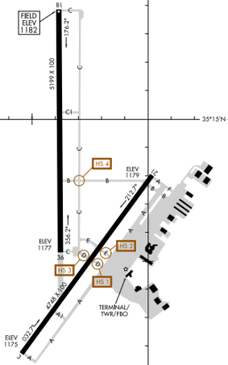
BEFORE ENGINE START THROUGH ENGINE SHUTDOWN – CHECKLIST WILL BE VERBALIZED
BEFORE ENGINE START
MX TIME CHECK TIME REMAINING
VS TIME ON CHECKLIST COVER
BILLING TIME/HOBBS TIME RECORD
FLAPS RETRACT
CABIN DOOR CLOSED AND SECURE
SEATS ADJUSTED AND LOCKED IN POSITION
SEATBELTS AND HARNESSES FASTEN AND SECURE
PARKING BRAKE SET
PASSENGER BRIEF COMPLETE

ENGINE START
CIRCUIT BREAKERS IN
ALT. AIR CLOSE
ALTERNATE STATIC SOURCE OFF
FUEL SELECTOR CYCLE, FULLEST TANK
MASTER ON
ALTERNATOR ON
DATABASES VERIFY CURRENCY
AUTOPILOT VERIFY PREFLIGHT
SELF-TEST COMPLETED
LEFT/RIGHT MAG SWITCHES ON
ANTI-COLLISION LIGHTS ON
AREA CLEAR
THROTTLE OPEN 1/8 INCH
FUEL PUMP ON
MIXTURE
COLD START GPH ~4.5 THEN IDLE CUT-OFF
HOT START IDLE CUT-OFF
STARTER ENGAGE
MIXTURE ADVANCE
THROTTLE 1000 RPM
OIL PRESSURE CHECK

PRE-TAXI
CAS MESSAGE (G3X) CONSIDER ANY ILLUMINATED
PFD ANNUNCIATIONS NO RED X’S
FUEL CALC TAB (ENG PAGE) ENTER FUEL QUANTITY
SYSTEM MESSAGES CONSIDER
LIGHTS AS REQUIRED
VENTILATION, HEATER, AND DEFROSTER AS DESIRED
COM/NAV RADIOS & AVIONICS CHECK & SET
STANDBY FLIGHT INSTRUMENT VERIFY ON WITH NO RED-X’S
OR FAILURE ANNUNCIATIONS
AWOS/ATIS CHECK
ALTIMETER SET, VERIFY BOTH
TRANSPONDER LOCAL CODE & ALT
PARKING BRAKE RELEASE
BRAKES TEST

University of Oklahoma School of Aviation  Printed 11/18/2024 |  | 3 |  | University of Oklahoma School of Aviation  Printed 11/18/2024 | 4
NORMAL PROCEDURES PA-28-181 PIPER PILOT |  |  |  | NORMAL PROCEDURES PA-28-181 PIPER PILOT
BEFORE ENGINE START THROUGH ENGINE SHUTDOWN – CHECKLIST WILL BE VERBALIZED  BEFORE TAKE-OFF  TYPE OF TAKEOFF DETERMINE  AIRSPEEDS: ROTATION, CLIMB OUT,  AND BEST GLIDE BRIEF  PRE-TAKEOFF BRIEFING COMPLETE  FLAPS SET  FUEL PUMP ON  FLIGHT INSTRUMENTS NO RED X’S  STANDBY FLIGHT INSTRUMENT NO RED X’S  CAS MESSAGE (G3X) CONSIDER ANY ILLUMINATED  SYSTEM MESSAGES CONSIDER  ENGINE INDICATIONS CHECK  ANTI-COLLISION LIGHTS ON  LANDING LIGHTS ON  MIXTURE RICH  BELTS/HARNESS FASTENED & CHECK  STABILATOR/RUDDER TRIM SET  CABIN DOOR LATCHED  TAKE-OFF TIME RECORD  V_{S0} – 45 KIAS  V_{S1} – 50 KIAS  V_{R} – 60 KIAS  V_{X} – 64 KIAS  V_{Y} – 76 KIAS  Best Glide – 76 KIAS  Cruise Climb – 87 KIAS  V_{FE} – 102 KIAS  V_{O} – 113 KIAS  V_{NO} – 125 KIAS  V_{NE} – 154 KIAS |  |  |  | BEFORE ENGINE START THROUGH ENGINE SHUTDOWN – CHECKLIST WILL BE VERBALIZED  CLIMB (BETWEEN 500 AND 1500 AGL)  POWER SET  TRIM SET  FUEL PUMP OFF  LANDING LIGHTS OFF  CRUISE (AT TOP OF CLIMB FOR X/C AND LCL FLIGHTS)  POWER SET  TRIM SET  MIXTURE AS REQUIRED  TRUE AIR SPEED (X/C FLTS) VERIFY  IN-RANGE (X/C – BEFORE TOP OF DESCENT; LCL – BEFORE TURNING TO OUN)  COM/NAV RADIOS & AVIONICS CHECK & SET  AWOS/ATIS CHECK  ALTIMETER SET, VERIFY BOTH  SEATBELTS FASTEN AND SECURE  MIXTURE RICH  FUEL PUMP ON  FUEL SELECTOR FULLEST TANK  LANDING LIGHTS ON  APPROACH AND LANDING (BEFORE PATTERN ENTRY AND BEFORE MIDFIELD DOWNWIND EACH SUBSEQUENT APPROACH)  TYPE LANDING DETERMINE  FLAPS SET (102 KIAS MAX.)  ALT. AIR AS REQUIRED  AUTOPILOT DISCONNECT (ABOVE 200AGL)  INITIAL APPROACH SPEED 75-95 KIAS  FINAL APPROACH SPEED 66 KIAS  GO-AROUND  MIXTURE FULL RICH  THROTTLE FULL OPEN  CONTROL WHEEL BACK PRESSURE TO OBTAIN  POSITIVE CLIMB ATTITUDE  FLAPS RETRACT INCREMENTALLY
University of Oklahoma School of Aviation  Printed 11/18/2024 |  | 5 |  | University of Oklahoma School of Aviation  Printed 11/18/2024 | 6
NORMAL PROCEDURES PA-28-181 PIPER PILOT |  |  |  | NORMAL PROCEDURES PA-28-181 PIPER PILOT
BEFORE ENGINE START THROUGH ENGINE SHUTDOWN – CHECKLIST WILL BE VERBALIZED  AFTER LANDING (AFTER CLEARING RUNWAY)  FLAPS RETRACT  FUEL PUMP OFF  LANDING LIGHTS AS REQUIRED  TRANSPONDER LOCAL CODE & ALT |  |  |  | BEFORE ENGINE START THROUGH ENGINE SHUTDOWN – CHECKLIST WILL BE VERBALIZED  ENGINE SHUTDOWN  PARKING BRAKE RELEASED  FLAPS VERIFY RETRACTED  FUEL PUMP VERIFY OFF  ELECTRICAL SWITCHES OFF  ALTERNATOR OFF  THROTTLE IDLE  MIXTURE IDLE CUT-OFF  LEFT/RIGHT MAG SWITCHES OFF  INTERIOR LIGHTS OFF  EXTERIOR LIGHTS OFF  BATTERY MASTER OFF  BILLING/MX TIME RECORD  POST-FLIGHT  - PUT SUN VISOR IN WINDOW (IN SUMMER)  - GATHER PERSONAL BELONGINGS – NO TRASH LEFT  - PLACE YELLOW PLACARD -- IF MX REQUIRED  - SECURE COCKPIT DOOR (TOP LATCH IF RAINING SOON)  - LOCK AIRCRAFT DOOR  - WALK AROUND AIRCRAFT – LOOK AT CONDITION STRAP DOWN (3 STRAP POINTS) OR CHOCK (IF NO STRAP AREA AVAILABLE CROSS-COUNTRY)  IF NECESSARY  - CLOSE FLIGHT PLAN  - TURN IN AIRCRAFT KEY TO DISPATCH OR NIGHT MX  - FILL OUT ANY SAFETY REPORTS ONLINE  - REPORT SQUAWKS OR ANY DISCREPANCY TO DISPATCH OR NIGHT MX  - TURN IN FUEL CARD WITH RECEIPT (IF USED)  - FILL OUT YOUR “PERSONAL LOGBOOK WITH FLIGHT TIME/DETAILS”  ABNORMAL PROCEDURES  HARD LANDING (TAXI TO MX AND INFORM AVIATION STAFF)  UNCONTROLLED DEPARTURE FROM PAVEMENT (RUNWAY OR TAXIWAY)  - DO NOT ATTEMPT TO TAXI BACK ONTO PAVEMENT  - RUN ENGINE SHUTDOWN CHECKLIST  - CONTROLLED FIELD: NOTIFY TOWER AND ADVISE AIRCRAFT MUST BE TOWED  - UNCONTROLLED FIELD: CALL OU MOBILE PHONE AND INSTRUCTOR  SYMPTOMS OF VAPOR LOCK  - FLUCTUATION OF IDLE SPEED AND FUEL FLOW  - POOR ENGINE RESPONSE TO THROTTLE MOVEMENT  - ENGINE WILL NOT OPERATE WHEN THROTTLE IS CLOSED  - HIGH RPM DROP (GREATER THAN 175 RPM) DURING MAG CHECK  CORRECTIVE ACTION FOR VAPOR LOCK  - ADVANCE THROTTLE TO ~2000 RPM FOR 1-2 MIN OR UNTIL SMOOTH ENGINE OPERATIONS  - RETARD THROTTLE TO IDLE AND CHECK FOR SMOOTH OPERATION  - DURING TAXI, LEAN MIXTURE AND OPERATE AT A HIGH POWER SETTING (MAX 1200 RPM) AS PRACTICAL  - PRIOR TO TAKEOFF SET MIXTURE TO FULL RICH  - VERIFY SMOOTH ENGINE OPERATION DURING TAKEOFF ROLL
University of Oklahoma School of Aviation  Printed 11/18/2024 |  | 7 |  | University of Oklahoma School of Aviation  Printed 11/18/2024 | 8
EMERGENCY PROCEDURES PA-28-181 PIPER PILOT |  |  |  | EMERGENCY PROCEDURES PA-28-181 PIPER PILOT
ENGINE FIRE DURING START  STARTER CONTINUE TO CRANK ENGINE  MIXTURE IDLE CUT-OFF  THROTTLE OPEN  FUEL PUMP OFF  FUEL SELECTOR OFF  IF FIRE CONTINUES  EVACUATE AIRCRAFT  USE FIRE EXTINGUISHER IF AVAILABLE  ENGINE FIRE IN FLIGHT  FUEL SELECTOR OFF  THROTTLE CLOSED  MIXTURE IDLE CUT-OFF  FUEL PUMP OFF  HEAT/DEFROSTER OFF  DEFROSTER OFF  VENTS OPEN  IF FIRE CONTINUES  AIRSPEED INCREASE IN ATTEMPT TO BLOW OUT FIRE  ENGINE SECURE  ENGINE SECURE IN FLIGHT  FUEL SELECTOR OFF  LEFT/RIGHT MAGS OFF  THROTTLE CLOSED  MIXTURE IDLE CUT-OFF  SEAT BELTS TIGHTEN  DOOR UNLATCH  ELT ON  *PREPARE FOR EMERGENCY LANDING (66 KNOTS SHORT FINAL)  AFTER TOUCHDOWN  MASTER/ALTERNATOR OFF  ELECTRICAL FIRE  MASTER OFF  ALTERNATOR OFF  VENTS OPEN  HEAT/DEFROSTER OFF  FIRE EXTINGUISH  EMERGENCY DESCENT (IF NEEDED) TO A SAFE ALTITUDE  *LAND ASAP |  |  |  | ENGINE ROUGHNESS  ALT. AIR OPEN  IF ROUGHNESS CONTINUES AFTER 1 MIN  MIXTURE ADJUST FOR MAX SMOOTHNESS  ALT. AIR CLOSE  FUEL PUMP ON  FUEL SELECTOR SWITCH TANKS  ENGINE INDICATORS CHECK  LEFT/RIGHT MAGS INDIVIDUALLY  SELECT OFF AND ON  *LAND ASAP  ENGINE FAILURE/PARTIAL POWER LOSS  PITCH (BEST GLIDE) 76 KTS  TRIM 76 KTS  FIELD SELECT SUITABLE  FUEL SELECTOR SWITCH TANKS  LEFT/RIGHT MAGS OFF THEN ON  ONE AT A TIME  FUEL PUMP ON  THROTTLE ADJUST  MIXTURE RICH  ALT. AIR OPEN  IF POWER RESTORED  ALT. AIR CLOSE  FUEL PUMP OFF  IF POWER NOT RESTORED  TRANSPONDER 7700  RADIO 121.5  RADIO FAILURE  AUDIO PANEL VERIFY RADIO SELECTION  MIC JACK CHECK  VOLUME TEST  CIRCUIT BREAKERS IN  FREQUENCY CHECK  AUDIO CONTROL C.B. PULL  TRANSPONDER 7600  *FOLLOW LOST COMM PROCEDURES  OPEN DOOR  SLOW AIRPLANE TO 87 KIAS  CABIN VENTS CLOSE  IF UPPER LATCH IS OPEN LATCH  IF SIDE LATCH IS OPEN PULL ON ARMREST  WHILE CLOSING LATCH  IF BOTH CLOSE SIDE, THEN TOP LATCH
University of Oklahoma School of Aviation  Printed 11/18/2024 |  | 9 |  | University of Oklahoma School of Aviation  Printed 11/18/2024 | 10
EMERGENCY PROCEDURES PA-28-181 PIPER PILOT |  |  |  | EMERGENCY PROCEDURES PA-28-181 PIPER PILOT
ALTERNATOR FAILURE  VERIFY FAILURE CHECK ALT AMPS INDICATION  ALTERNATOR OFF  ALT CIRCUIT BREAKER RESET IF TRIPPED  ALT FIELD CIRCUIT BREAKER RESET  ALTERNATOR ON  IF POWER NOT RESTORED  ALTERNATOR OFF  ELECTRICAL LOAD SHED  *LAND AS SOON AS POSSIBLE*  COMPLETE ELECTRICAL FAILURE  STANDBY INSTRUMENT VERIFY OPERATIONAL  AIRCRAFT CONTROL USE STANDBY INSTRUMENT  AIRSPEED DO NOT EXCEED 110 KIAS  AFTER ENGINE SHUTDOWN  STANDBY INSTRUMENT OFF (PRESS AND HOLD  PWR BUTTON FOR 5 SECONDS)  PFD FAILURE  STANDBY INSTRUMENTS VERIFY OPERATIONAL  AIRCRAFT CONTROL USE STANDBY INSTRUMENTS  AIRSPEED DO NOT EXCEED 110 KIAS  COM 1 (EXTERNAL COM) TUNE AS NECESSARY  NAVIGATION USE G5 DISPLAY  WITH GPS1 (EXTERNAL GPS)  OR NAV 2 (VOR/LOC/ILS) SOURCE INFO  EXIT AND AVOID IFR CONDITIONS AS SOON AS PRACTICAL.  *Warning* All aural alerts, except stall warning, become  inoperative when the PFD fails. Maintain  additional airspeed awareness during low and  high speed flight. |  |  |  | CYLINDER HEAD TEMPERATURE  ENGINE PAGE SELECT  CYLINDER HEAD TEMPERATURES MONITOR  THROTTLE CONSIDER REDUCING  MIXTURE CONSIDER ENRICHENING  AIRSPEED CONSIDER INCREASING  IF CYLINDER HEAD TEMPERATURE CONTINUES TO RISE  THROTTLE MINIMUM REQUIRED  MIXTURE RICH  AIRSPEED INCREASE IF PRACTICAL  CYLINDER HEAD TEMPERATURES MONITOR  IF CYLINDER HEAD TEMPERATURE REMAINS IN WARNING RANGE  *LAND AS SOON AS POSSIBLE*  *PREPARE FOR POWER OFF LANDING*  OIL PRESSURE  LOW OIL PRESSURE  THROTTLE MINIMUM REQUIRED  IF HIGH OIL TEMP LAND AS SOON AS POSSIBLE  IF NORMAL OIL TEMP LAND AS SOON AS PRACTICAL  HIGH OIL PRESSURE  THROTTLE MINIMUM REQUIRED  LAND AS SOON AS PRACTICAL  OIL TEMPERATURE  THROTTLE MINIMUM REQUIRED  MIXTURE FULL RICH  AIRSPEED INCREASE IF PRACTICAL  LAND AS SOON AS POSSIBLE  SEE POH FOR OTHER EMERGENCIES OR ABNORMALITIES LISTED  - LOSS OF FUEL FLOW  - FUEL QUANTITY LOW  - ADAHRS FAILURE  - ADAHRS DEGRADED MODES  - ERRONEOUS OR LOSS OF ENGINE AND FUEL DISPLAYS  - LOSS OF NAVIGATION DATA  - AUTOPILOT OR ESP MALFUNCTIONS  - AUTOMATIC AUTOPILOT DISCONNECT  - ELECTRIC PITCH TRIM FAILURE  - ELECTRIC PITCH TRIM RUNAWAY  - ESP ACTIVATION  - AUTOPILOT OVERSPEED RECOVERY  - AUTOPILOT UNDERSPEED RECOVERY  - AUTOPILOT OUT-OF-TRIM  - ABNORMAL FLIGHT DIRECTOR MODE TRANSITIONS  - AUTOPILOT PREFLIGHT TEST FAILURE  - AUTOPILOT – LOSS OF NAVIGATION INFORMATION  - AUTOPILOT – LOSS OF AIRSPEED/ALTITUDE INFORMATION  - AUTOPILOT – LOSS OF GPS INFORMATION  - PITOT HEAT FAILURE  - STARTER ENGAGED  - SPIN RECOVERY
University of Oklahoma School of Aviation  Printed 11/18/2024 |  | 11 |  | University of Oklahoma School of Aviation  Printed 11/18/2024 | 12
EMERGENCY PROCEDURES PA-28-181 PIPER PILOT |  |  |  | EMERGENCY PROCEDURES PA-28-181 PIPER PILOT
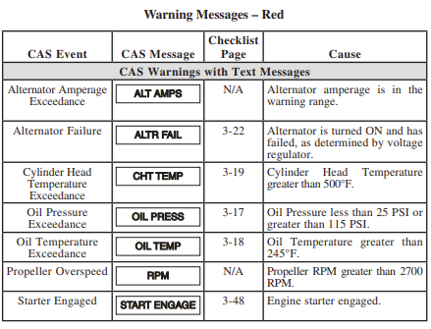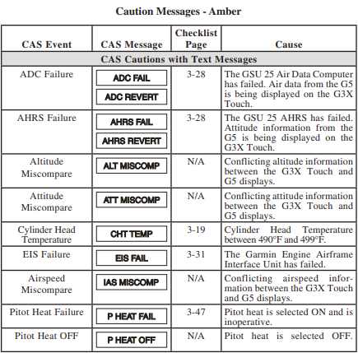 |  |  |  | 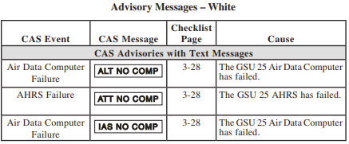  SYMPTOMS OF VAPOR LOCK  - FLUCTUATION OF IDLE SPEED AND FUEL FLOW  - POOR ENGINE RESPONSE TO THROTTLE MOVEMENT  - ENGINE WILL NOT OPERATE WHEN THROTTLE IS CLOSED  - HIGH RPM DROP (GREATER THAN 175 RPM) DURING MAG CHECK  CORRECTIVE ACTION FOR VAPOR LOCK  - ADVANCE THROTTLE TO ~2000 RPM FOR 1-2 MIN OR UNTIL SMOOTH ENGINE OPERATIONS  - RETARD THROTTLE TO IDLE AND CHECK FOR SMOOTH OPERATION  - DURING TAXI, LEAN MIXTURE AND OPERATE AT A HIGH POWER SETTING (MAX 1200 RPM) AS PRACTICAL  - PRIOR TO TAKEOFF SET MIXTURE TO FULL RICH  - VERIFY SMOOTH ENGINE OPERATION DURING TAKEOFF ROLL
University of Oklahoma School of Aviation  Printed 11/18/2024 |  | 13 |  | University of Oklahoma School of Aviation  Printed 11/18/2024 | 14
COMMON FREQUENCIES
Max Westheimer (KOUN)  AWOS 119.55  Ground 121.60  Tower 118.00  LOC IPHY 111.10  ILS IBWM 111.95  OU Traffic 123.30  Cruise Aviation 122.95  David Jay Perry (1K4)  CTAF 122.7  Chickasha (KCHK)  AWOS 118.175  CTAF 123.00  Shawnee (KSNL)  AWOS 118.275  CTAF 122.70  Will Rogers (KOKC)  ATIS 125.85  Clearance Delivery 124.35  Ground 121.90  Tower 119.35  IRW 114.10 | Okla. City Approach Control  NW 124.60  NE 124.20  SW 124.60  SE 120.45  S 133.60  Transponder Codes  7500 Hijack  7600 Lost Comm.  7700 Emergency  Contact Numbers  Aviation Department  405-325-7231  Mobile Phone  405-919-6319  OU Police Department  405-325-1717
University of Oklahoma School of Aviation  Printed 11/18/2024 |  | 15
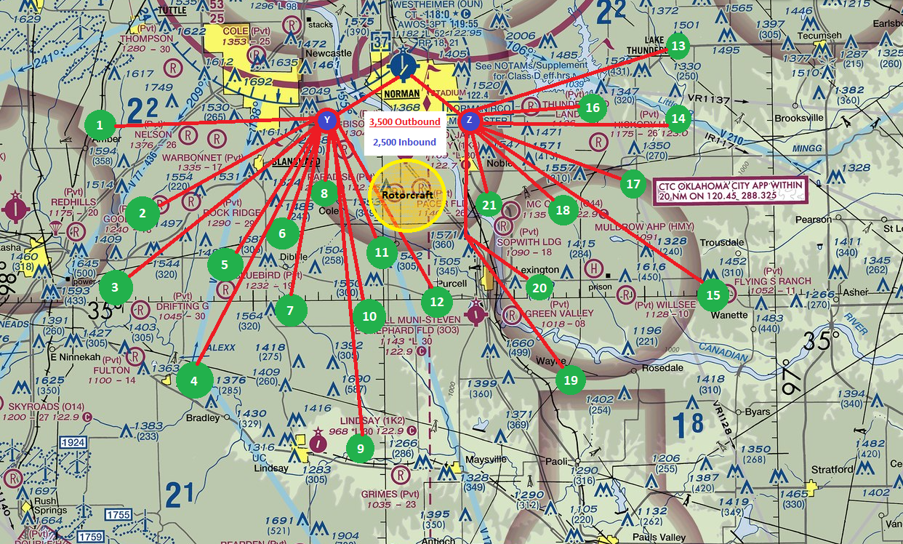 |  |  |  | Training Checkpoints  - 1 = Amber  - 2 = Good Life (170K) 18 DME off the IRW 203 radial  - 3 = East Chickasha (watch for active parachute jumping area*)  - 4 = Alexx  - 5 = West Dibble – 19 DME off the IRW 220 Radial  - 6 = North Dibble  - 7 = South Dibble  - 8 = Cole  - 9 = Lindsay  - 10 = Woody Chapel  - 11 = Washington  - 12 = Purcell* Always check NOTAM for possible sUAS activity up to 5,000 MSL  - 13 = Pink  - 14 = Oil Silo  - 15 = Wanette  - 16 = East Lake Thunderbird  - 17 = South Hickory Hills  - 18 = McCaslin  - 19 = Wayne  - 20 = Lexington * Always check Lexington NOTAM (possible sUAS activity)  - 21 = Thunder Valley
University of Oklahoma School of Aviation  Printed 11/18/2024 |  | 16 |  | University of Oklahoma School of Aviation  Printed 11/18/2024 | 17

