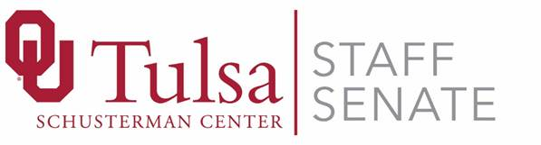
July 17, 2018
Meeting Minutes
Meeting Type: New Member Meeting

Attendees:
Staff Senate: Laura Kent, Angie Childers, Lisa Eshenour, Khanh Luong, Jennifer Lee, September Boles, Carrie Harrison, Juli Mize, Ann, Nelson, Shelley Fowler, Brittany Cole, Mitch Braden, Hanna Lee, Catlin Cundiff, Brittnee Powell, Vicki Ford
Call to Order: Completed by Laura Kent at 8:35 am
Quorum confirmed
- Member Introductions
  - Each member introduced him/herself
- History of Staff Senate
  - Laura briefly spoke on the history of OU-Tulsa Staff Senate
- Staff Senate By-Laws
  - Duties of Representative and Alternates
    - Representatives
      - Term—Two years, can serve two terms
      - Attend all meetings (three absences may be cause for dismissal)
      - Serve on at least one committee
      - Report Staff Senate activities and actions back to your department/building
      - Notify your Group Alternate when absent
      - Vote (either in person or in absentia)
    - Alternates
      - Term—One year, can serve two terms
      - Attend all meetings (three absences may be cause for dismissal)
      - Serve on at least one committee
      - Enjoy voting privileges when acting in absence of a Representative
      - Notify Staff Senate when absent
  - Duties of Officers
    - Chair—Monica Burke
    - Chair-Elect—Angie Childers
    - Secretary—September Boles
    - Treasurer—Khanh Luong
    - Past Chair—Laura Kent
- Staff Senate Mission and Constitution
- Description of Staff Senate Committees
  - Merit
  - Membership & Policy Review
  - Communications
  - Staff Week and Activities
  - Marketing and Fundraising
  - Sustainability Committee
- Meeting Adjourned at 9:30 am

Next Meeting: Tuesday, August 14, 2018

Respectfully Submitted,
September Boles, Secretary

