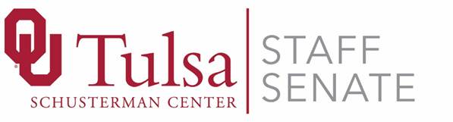
October 9, 2018
Meeting Minutes
Meeting Type: Regular
Attendees:
Angie Childers, September Boles, Juli Mize, Mitch Braden, Kerri Thomas, Brittany Cole, Lisa Eshenour, Khanh Luong
Call to Order: Completed by Angie Childers at 8:30 am
Quorum not confirmed
- Approval of Minutes

  - There are not enough members for quorum, so approval of Sept. minutes will be done at the November meeting.

- Treasurer’s Report: Khanh Luong

  - Total Ending Fund Balance for all Accounts: $7,493.65
  - The annual support from the President’s Office was transferred to the account: $1,250.00.

- Committee Reports

  - Merit
    - Nothing to report on this committee.
  - Membership & Policy Review
    - Nothing to report on this committee.
  - Communications
    - Nothing to report on this committee.
  - Staff Week and Activities (SWAC)
    - Holiday Pop-Up Shops
      - External vendors are wanted. If you know of a vendor to participate, contact the Staff Week committee.
      - Scheduled for Thurs., 11/29/18 in Innovation Commons from 11 AM – 1 PM.
    - Cocoa Bar
      - Scheduled for Thurs., 1/24/19
    - Staff Senate Chilli Cook-off and Costume Contest:
      - Oct. 31, from 11 AM – 1 PM, Founder’s Hall. Email Tulsa Staff Senate (TulsaStaffSenate@ouhsc.edu) for participation in the chilli cook-off.
      - The goal is to have 20 chilli contestants; so far, we have 8 confirmed chilli cooks.
      - Costume Deadline—10/31/18; Winners Announced—11/02/18
      - Sample/tasting cups—2 ounce cups are offered
      - Chilli judges include: Dr. Peter Aran; Danny Bolton; Emma Kientz; Chief Walter Evans; Dana Saliba
      - SWAC is looking for a photographer for the backdrop at the chilli cook-off. A SWAC committee member may be able to take pictures. Volunteers will be needed at the ticket table and the judges table.
  - Marketing and Fundraising
    - Lisa Eshenour is working on requesting donations for marketing and fundraising events.
  - Police Advisory Council
    - Nothing to report on this committee.
  - Sustainability Committee
    - Nothing to report on this committee.
- New Business
  - Nothing to report

- Round Robin discussion

  - Next Meeting: Tuesday, Nov. 13, 2018 at Schusterman, Room 2C33

- Adjournment—9:00 AM

Respectfully Submitted,
September Boles, Secretary

