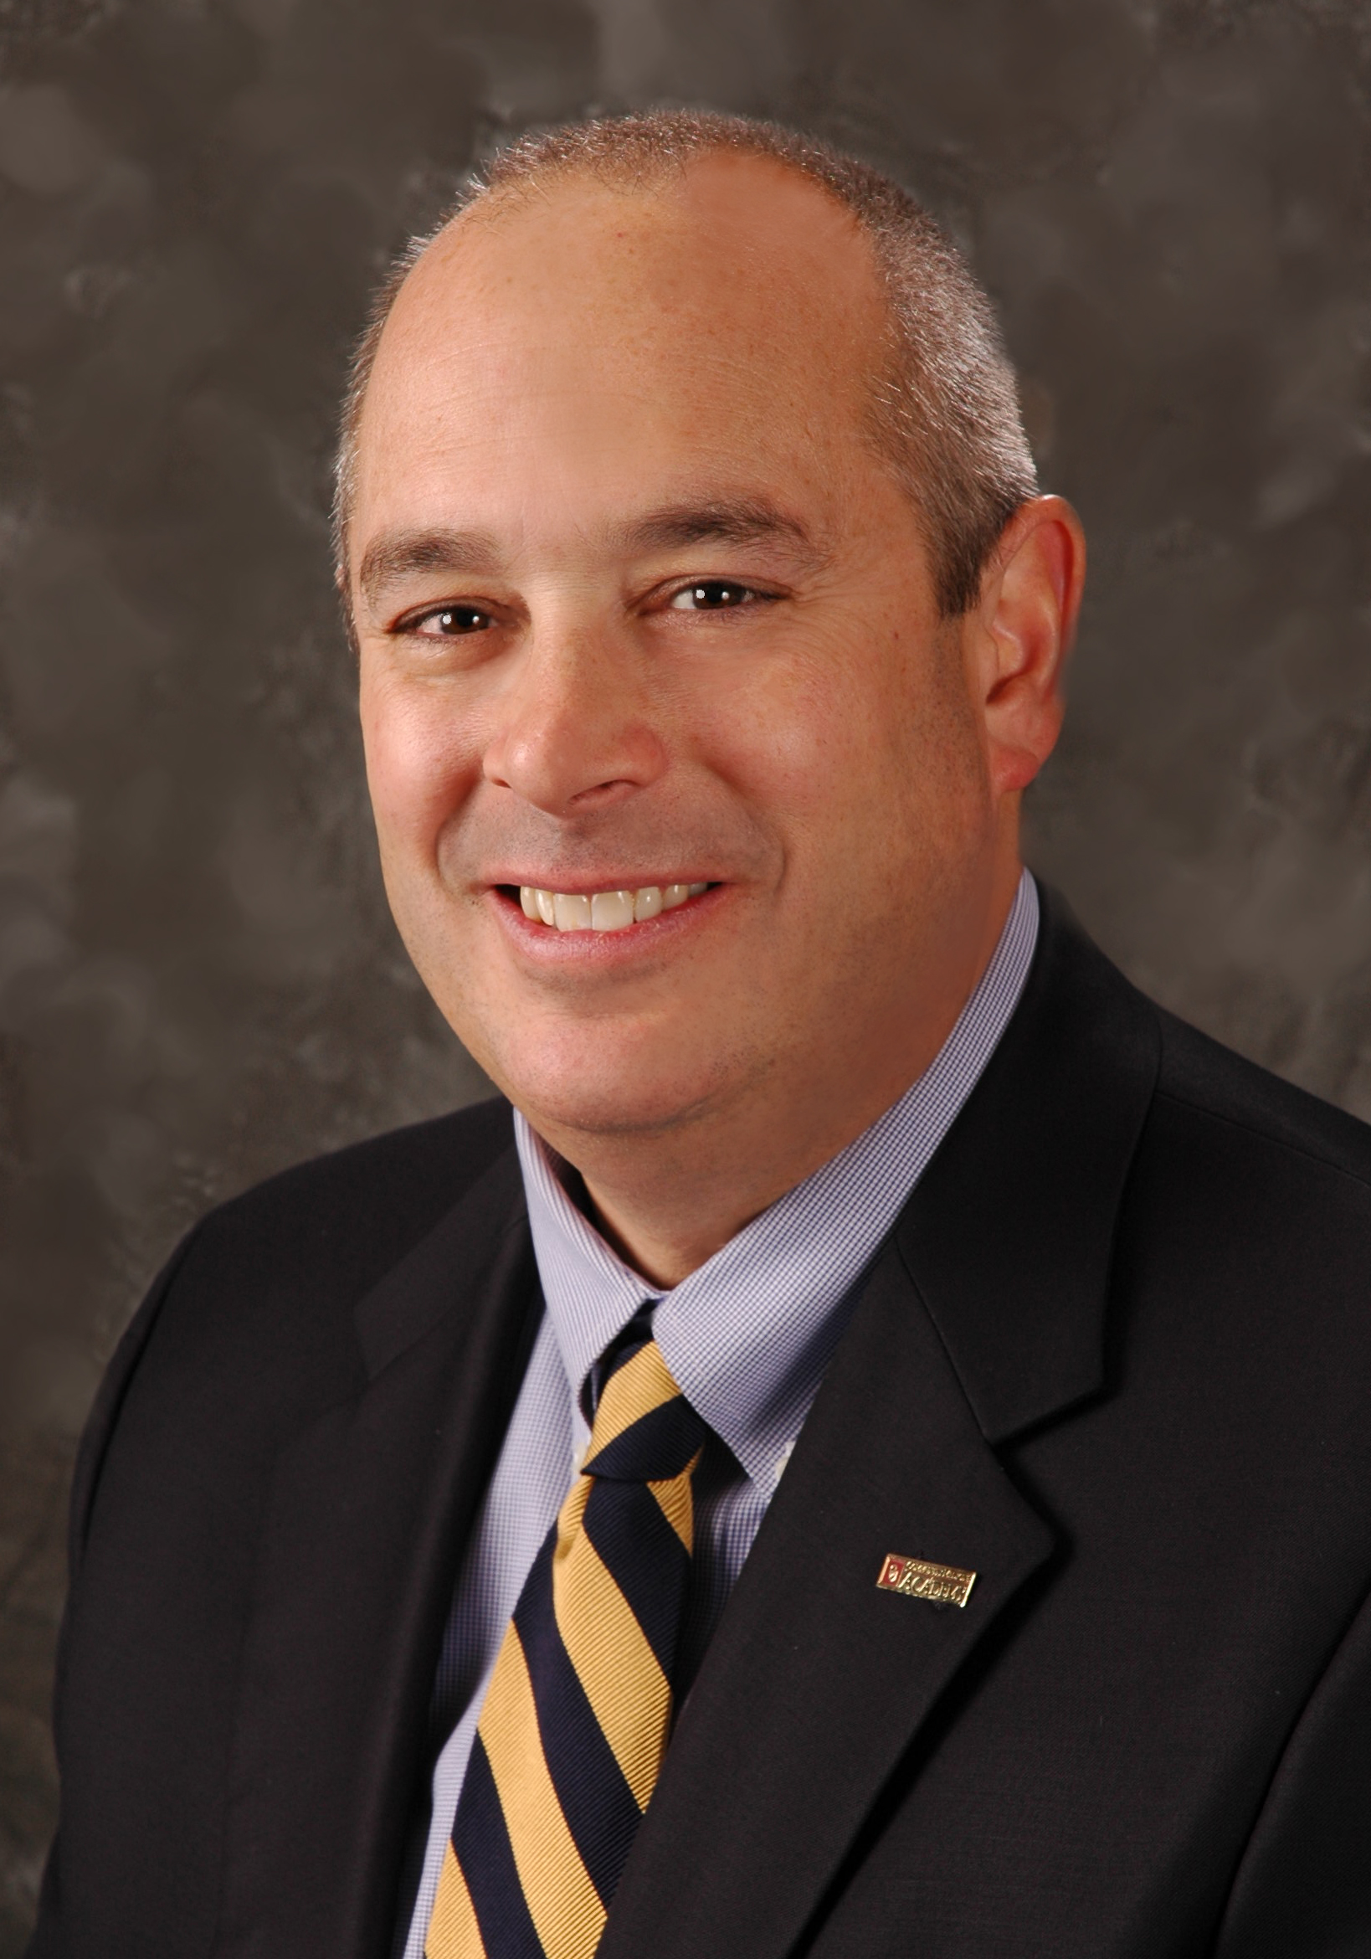

**Gerard P. Clancy, M.D.**

**President, University of Oklahoma – Tulsa**

**Professor, Department of Psychiatry**

**Morningside Health Care Foundation Endowed Chair in Leadership**

Dr. Gerry Clancy joined the University of Oklahoma in 2001 as Dean of the OU College of Medicine in Tulsa, Professor of Psychiatry, and Morningside Health Care Foundation Endowed Chair in Leadership. Five years later, he assumed the additional role of President of OU-Tulsa, and is its third president.

Under his leadership, the OU-Tulsa Schusterman Center campus has added more than $130,0000,000 in new facilities, new academic degree programs, endowed faculty chairs and student scholarships, and established educational and research partnerships with more than 100 community agencies. Dr. Clancy also helped develop a community health network that includes after-hours free clinics for the underserved, pediatric school-based clinics in disadvantaged areas of Tulsa, mobile psychiatric teams, and the OU Wayman Tisdale Specialty Health Clinic. OU-Tulsa physicians are the primary providers of care to the underserved in northeastern Oklahoma.

In 2008, with a $50 million donation from the George Kaiser Family Foundation, Dr. Clancy led a successful effort to transform medical education at OU-Tulsa. The OU College of Medicine’s Tulsa branch was renamed the University of Oklahoma School of Community Medicine. The first of its kind in the nation, the school’s mission is to improve the health of all Oklahomans, particularly those in underserved rural and urban populations. In 2011, OU and The University of Tulsa announced plans to collaborate in the creation of a four-year community medicine educational program in Tulsa. That year, Dr. Clancy resigned as Dean of the School of Community Medicine to devote his full energies to the planning of the OU-TU program and oversight of all Norman-based and OU Health Sciences programs in Tulsa. The first class of community medicine students is scheduled to begin studies in fall 2015.

Born and reared in Iowa City, Iowa, Dr. Clancy earned his bachelor’s degree in biochemistry from the University of Iowa. He completed an American Heart Association Basic Science Research Fellowship before completing his medical degree with Alpha Omega Alpha honors, also from the University of Iowa. Before joining OU, Dr. Clancy served as a faculty member and Vice Chairman of the Department of Psychiatry at the University of Iowa. Students and resident physicians honored him with seven major teaching awards during his tenure, and he led several major initiatives to provide services to the homeless mentally ill and others with severe mental illness. The University of Iowa honored Dr. Clancy as a Distinguished Alumnus in 2011.

He is also a graduate of the Harvard University Medical School Programs in Health Care Policy and Management and Non-Profit Financial Stewardship.

Dr. Clancy served on active duty in the United States Air Force, achieving the rank of Major and serving as a flight surgeon, aircraft and helicopter pilot.

He has been active on the boards of many community and national organizations, including board chairman of the Tulsa Metro Chamber of Commerce in 2011. He was recently named to lead a multi-city effort to promote regional cooperation for advancing economic development and quality of life initiatives in northeast Oklahoma. He is also Chair-Elect of the 2014 Tulsa Area United Way Campaign.

Dr. Clancy has been honored with many awards for his work on behalf of the underserved, the advancement of education and regional economic development, including the “Service to the Homeless Award” and the “Exemplary Psychiatrist Award” from the National Alliance for the Mentally Ill. *Tulsa People* Magazine named him “Tulsan of the Year” in recognition of his efforts to transform the region’s health.

He is published in the basic, clinical and educational sciences and is frequently called upon as a speaker and expert on the topics of public and mental health, health care delivery and medical education. A practicing psychiatrist, he continues to see patients and teach medical students and residents in many of OU’s Tulsa programs.

Dr. Clancy and his wife, Paula, have three children: Sam, Mary and Joey.