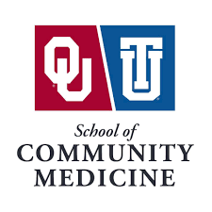
Area: University of Oklahoma School of Community Medicine PA Program, Tulsa
Title: Teaching Out Policy

In the event of PA Program closure and/or loss of accreditation, the PA Program will teach out currently matriculated students in accordance with the institution’s regional accreditor and federal law.
Policy Date: 8/2/2023

