University of Oklahoma
Emergency Response Plan for
(Insert event name here)

Date of Event: ___________________
Time Period of Event: ______________ (Account for set up time/tear down time)
Location of Event: _________________________
Anticipated Attendance: _____________________
Is the event Indoors/Outdoors?

Assignment of Event Personnel:
Event Coordinator (required): NAME AND CELL PHONE NUMBER.
Deputy Event Coordinator (required): NAME AND CELL PHONE NUMBER.
Event Safety Coordinator (required): NAME AND CELL PHONE NUMBER.
(NOTE: The Event Safety Coordinator MUST be ON-SITE during the ENTIRETY of the event):
Deputy Safety Coordinator: NAME AND CELL PHONE NUMBER .
(List ANY additional key event personnel with cel phone contact numbers)

Emergency Contact Numbers:
Kevin Leach, Director Risk Management: 405-325-2983
Justin Daniels, Fire Marshal: 405-824-4601
Kevin Kloesel, University Meteorologist: 405-397-9652
OUPD: 405-325-1911 or 911
Norman PD: 911
Norman Fire: 911
Norman EMS: 911
Emergency Operations Center: OU Police Department 2775 Monitor Ave. or OU Office of Emergency Preparedness (NEL Room 121)

OU Event Emergency Plan Principles:

Preparedness for events on the OU campus involves the OU Executive Policy Group, OU Emergency Preparedness Manager, OU Fire Marshal, University Meteorologist, city and county emergency management, city and county police and fire departments and volunteer citizens. To meet these challenges and provide cohesion to organizing preparedness activities as well as event safety management, OU has created an Office of Emergency Preparedness (OEP). The OEP continually works to ensure that the OU campus is prepared for any events held on its’ property. OU takes an all-hazards approach to disaster preparedness for events, one that encompasses terrorist attacks, natural hazards such as weather, health emergencies, etc. The guiding principle to be shared with each event staff member is “If you see something, say something.”

Emergency Response Plan objectives include:

•Life Safety – Minimize suffering, loss of life, and personal injury resulting from hazardous or emergency conditions that could occur during this event.

•Incident Stabilization – Provide a framework for a comprehensive emergency management system that addresses preparedness, response, recovery and mitigation.

•Protection of Property – Minimize damage to property resulting from hazardous or emergency conditions that could occur during this event.

Special areas of concern on our campus include, but are not limited to:
• Hazardous weather conditions
• Injuries/medical emergencies
• Suspicious behavior, activity, or packages
• Fire
• Missing/Lost Person

This Emergency Response Plan establishes OU’s response to any emergency that might occur during this event. In the event of an emergency, OUPD, first responders, and the OU Emergency Preparedness Manager will coordinate incident command.

EVENT DETAILS:

Event Area:
BE AS DETAILED AS POSSIBLE REGARDING THE LOCATION AND ANY PLACEMENT OF TENTS, INFLATABLES. ANIMALS. GAMES. FOOD BOOTHS, STAGES, ETC. INCLUDE A MAP OF EVENT.

Road/Sidewalk Closures:
ANY ALTERATIONS TO VEHICLE OR FOOT TRAFFIC PATTERNS INCLDUING SIDEWALK AND ROAD CLOSURES SHOULD BE DOCUMENTED HERE. A MAP NOTING THESE LOCATIONS IS ADVISABLE. IF NONE, INSERT NA

Equipment in Use at the Event:
LIST EQUPIPMENT NEEDED SUCH AS BARRIERS TO BLOCK STREETS, BOOTHS, TENTS, FOOD TABLES, GAMES, AUDIO OR VISUAL EQUIPMENT, INFLATABLES, ETC.

Inclement Weather:
The University Meteorologist in coordination with the Emergency Preparedness Manager and/or personnel at the National Weather Center will monitor weather conditions before and during this event. Concerns that may postpone, cancel or halt this event include the forecast/anticipation of:

- Lightning within eight (8) miles of the event,
- High winds sustained at 30 mph or gusts of 40 mph or greater (these values are typical if temporary or inflatable structures are in use),
- Hail of any size,
- Extreme temperatures such as heat or cold. For winter season events, wind chill values below 32F will be monitored. If wind chills dip below 10F, outdoor activities could be suspended/cancelled. For summer season events, the Oklahoma Mesonet Wet Bulb Globe Temperature (WBGT) will be monitored. If WBGT exceeds 80F, heat and hydration advisories will be issued. If WBGT exceeds 90F, outdoor activities could be suspended/cancelled.
- Precipitation LIST ANY OPERATIONAL EVENT DECISIONS THAT ARE IMPACTED BY RAIN, SNOW, ETC. FOR EX.; WOULD ANY AMOUNT OF RAIN RESULT IN MOVING, POSTPONING OR CANCELING THE EVENT? IS FOOD BEING SERVED OUTDOORS THAT WOULD NEED TO BE MOVED INDOORS IN THE EVENT OF RAIN? ARE THERE ANIMALS AT THE EVENT THAT WOULD BE IMPACTED BY RAIN? WHAT YOU LIST IN THIS BOX HELPS THE WEATHER SUPPORT TEAM KNOW WHAT TO LOOK FOR TO PROVIDE EVENT TEAM WITH ACCURATE WEATHER INFORMATION. or
- The risk of a tornado.

Cancellation/Postponement
Decision to postpone, cancel or halt the event will be made by in INSERT THE NAME AND CELL PHONE NUMBER OF PERSON WITH AUTHORITY TO POSTPONE, CANCEL OR HALT EVENT conjunction with the University Meteorologist and the OU Emergency Preparedness Manager.

Evacuation and Refuge Considerations:
In the event of imminent danger due to any of the above weather conditions, participants may be directed to evacuate the area and seek refuge.

For refuge against lightning, dangerously high winds, hail, or heavy rains seek refuge in INSERT THE NEAREST BEST AVAILABLE COVERED REFUGE AREAS HERE OR SEVERE WEATHER REFUGE AREAS SUITABLE TO HOLD THE EXPECTED ATTENDANCE FOR THE EVENT. IF YOU DO NOT KNOW LEAVE THIS AREA BLANK AND DEPARTMENT OF EMERGENCY PREPAREDNESS CAN FILL IN AREAS..

For a tornado event where a more substantial refuge is required, and the tornado warning is issued with limited lead-time (15 minutes or less), attendees should seek refuge in INSERT THE NEAREST BUILDING WITH THE SEVERE WEATHER REFUGE AREAS OR BUILDING WITH BEST AVAILABLE REFUGE AREAS SUITABLE TO HOLD THE EXPECTED ATTENDANCE FOR THE EVENT. IF YOU DO NOT KNOW LEAVE THIS AREA BLANK AND DEPARTMENT OF EMERGENCY PREPAREDNESS CAN FILL IN AREAS.. Take refuge in the interior rooms on the lowest floor away from windows, interior glass, and doors. Get IN, Get DOWN, Cover UP.

For a tornado with an anticipated longer lead-time of 30 minutes or more, evacuation of attendees from the event site may be necessary. Attendees should seek shelter in one of the nearest campus Best Available Refuge Areas denoted in blue on the maps below.

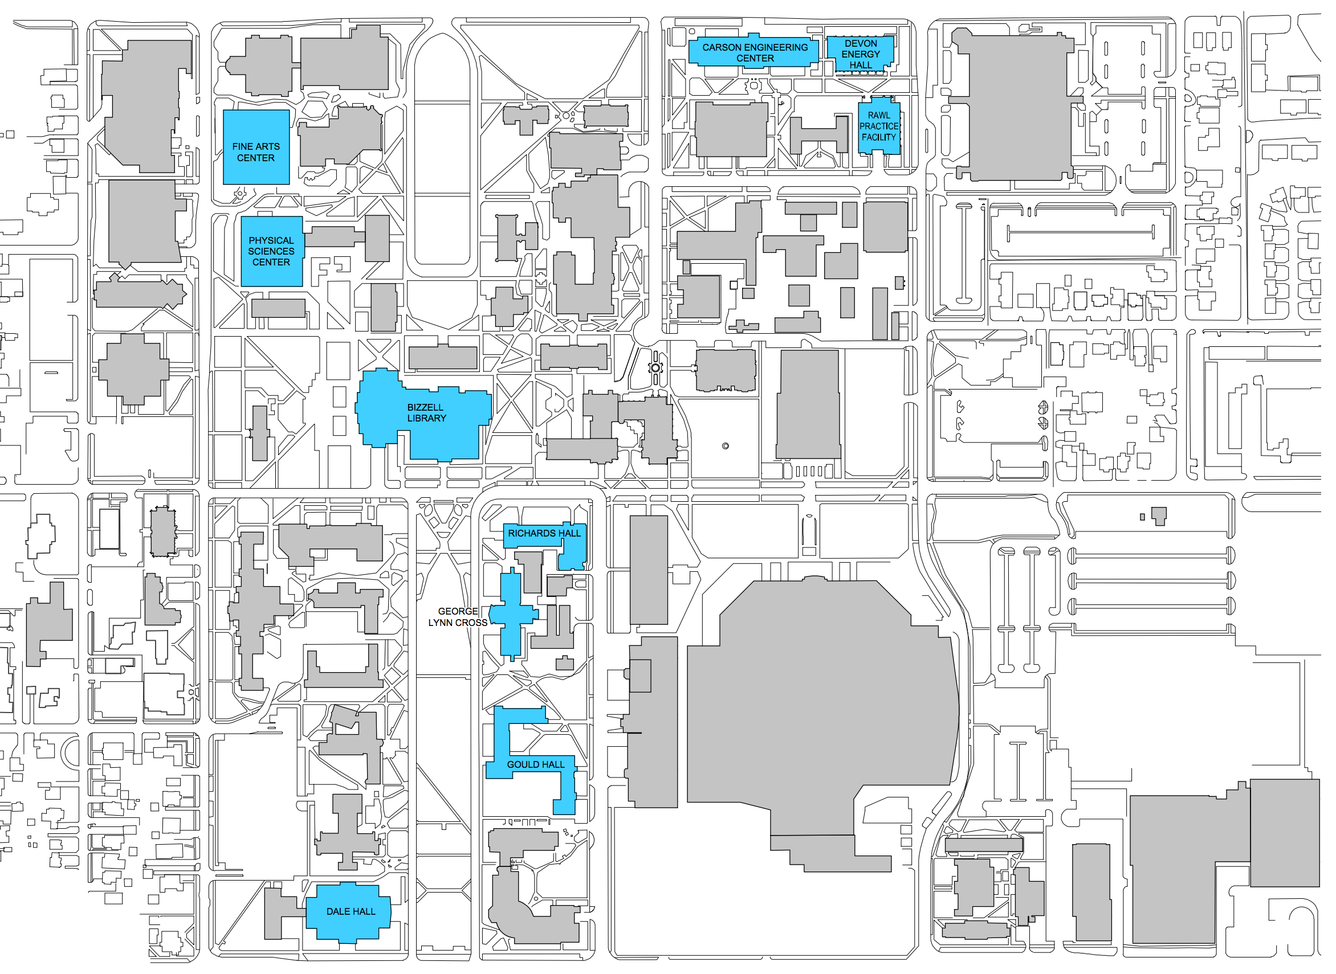

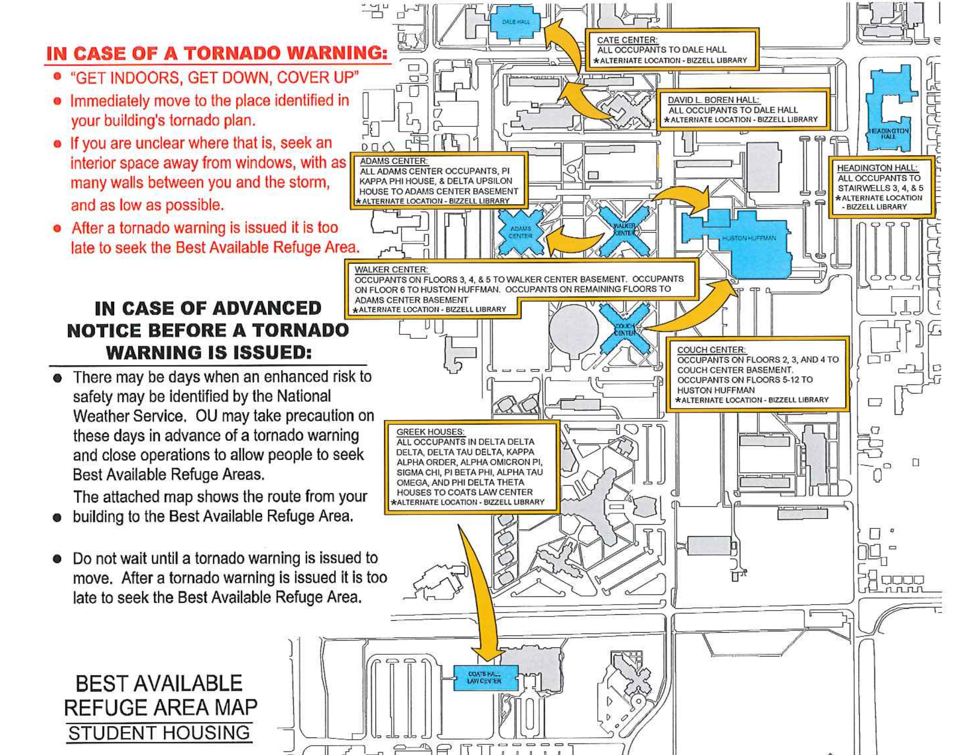

Take refuge in the interior rooms on the lowest floor away from windows, interior glass, and doors. Get IN, Get DOWN, Cover UP.

The University Meteorologist in conjunction with the Emergency Preparedness Manager or OUPD has the responsibility to issue an “all clear” message when it is safe to resume the event.

Fire:
The Event Coordinator will ensure that the OU Fire Marshal has inspected the event area and any equipment associated with the festivities prior to the event. Report all fires immediately to OUPD by calling 405-325-1911 or 911 and evacuate the area by moving event participants/spectators to INSERT EMERGENCY ASSEMBLY LOCATIONS FOR BUILDING EVACUATION. IF YOU DO NOT KNOW LEAVE THIS AREA BLANK AND DEPARTMENT OF EMERGENCY PREPAREDNESS WILL COMPLETE.

Injuries:
Report immediately any injuries or medical emergencies to OUPD by calling 405-325-1911 or 911. These include any injuries to participants, spectators and/or event personnel.

Event Safety Focal Point:
Always have an Event Safety Focal Point or Deputy designated to observe the festivities and spectators for any signs of distress, injuries, or suspicious activity. The name and mobile contact information for the Event Safety Focal Point must be listed on the first page of this emergency response plan. The Event Safety Focal Point must be on site at the event for the duration of the event.

Suspicious behavior or activity:
Event staff and volunteers should be staged throughout the event area. Participants, spectators, and staff are encouraged to report any suspicious behavior or activity to OUPD by calling 405-325-1911 or 911. In the event the area is evacuated due to an armed subject follow carefully the instructions given by OUPD or other properly identified first responders. Due not attempt to re-enter any evacuated areas until given direction from properly identified first responders.

Suspicious package:
If a suspicious package is reported or found do not handle the package. Discontinue the use of all electronic devices such as cell phones or radios; instead, report in person the package to the nearest OUPD officer. Follow their directions concerning evacuation or notification to participants/spectators. Do not attempt to re-enter the area unless directed by properly identified first responders.

Missing Persons:
If notified of a missing person report it immediately to OUPD. Attempt to stay with the person making the notification until OUPD arrives and interviews the person making the notification. Follow all instructions from OUPD.

Media Relations:
All media will check-in at the media relations’ table located INSERT LOCATION OF MEDIA CHECK-IN. IF NO MEDIA EXPECTED YOU MAY DELETE THIS PARAGRAPH.. An event volunteer member will be present to assist with any logistics. Interviews will be directed to the OU Office of Public Affairs.

Assisting Agencies/Departments:
OU Fire Marshal
OU Risk Management
OUPD
(list any additional assisting agencies or departments)
(v3.23.17)

