PHIL 3263

2A. Ancient Virtue Ethics

CTE preparer: Angie Calton
Goal/objective: Describe how early thinkers defined virtue. Looks at similarities and differences.
Course fit: This is the first video after the course overview video. This video represents the earliest ideas about virtue chronologically.
Notes: The timeline is very important. We should add an image and space for the Pre-Socratics in the timeline. Also need to make Artistotle’s conception of virtue from Nichomacchean Ethics very clear.

Outline/Script | Production notes
The ancient Greek philosophers all agreed that there is a natural order and humans have a place in it. | Choose from  Detail from the School of Athens  https://commons.wikimedia.org/wiki/File:Raffael_071.jpg  or headshot of Linda
Nature determines that our end is eudaimonia, which means well-being, or happiness. They also agreed that virtue---arete, in Greek, is connected with eudaimonia, and they agreed that the cardinal virtues of wisdom, justice, fortitude, and temperance are important virtues. | Perhaps build up a mind map bit-by-bit. Here’s an example but you could improve on this:  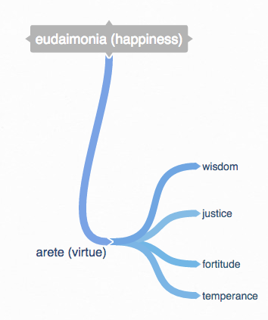
They disagreed about what human nature is and what the world is like as a whole, and  they disagreed about the relationship between happiness and virtue.  There are also some differences in the virtues they thought were most important.  But the groundwork laid by these philosophers came to shape Western ethics in one way or another for 2500 years. | In the mind map above, perhaps highlight/emphasize/wiggle the connection between eudaimonia (happiness) and arete (virtue).  Then highlight or draw attention to the connections from arete (virtue) to each example one-by-one: wisdom, justice, fortitude, temperance.  Then highlight/emphasize each word in the mind map to communicate that the basic elements stay in play for 2500 years.  **The idea is to show that there are a couple of disagreements about the fine points, but the overall framework still stands and persists for 2500 years.
This week you are reading selections from Aristotle and the Stoic philosopher, Seneca. Linda was worried about saying “this week” when the content spans longer than one week. Including this also means less flexibility with readings in the future. In addition, it is sort of an aside. It is simply signposting content, which can be done elsewhere on the platform. | Can we simply edit out this phrase entirely? It would improve flow of the narrative of the video.
Stoicism was a form of Hellenistic philosophy. Hellenism is the word we use for philosophy in the later ancient world influenced by Greece. | No need for word on screen. This is just background knowledge.
Here is a time line of ancient Greek and Hellenistic philosophy.  Greece Roman Empire  Roman empire  Pre-Socratics..... Socrates.. Plato.. Aristotle.. Epicurus. Zeno of Citium (founder of Stoicism) ... Seneca..Epictetus.. Marcus Aurelius  [The pre-Socratics were Greek philosophers whose work we have in fragmentary form, dating from the 6th and 5th centuries before the Christian era. Socrates, his student Plato, and his student Aristotle, lived in Athens in the 5th and 4th centuries. Epicurus lived in the generation after Aristotle and was the founder of Epicureanism. His contemporary, Zeno of Citium, started a school in Athens and was the founder of Stoicism. | Title the timeline:  Ancient Greek and Hellenistic Philosophy  Can we add this to the timeline? See her description below to see which are Greek and which are Roman  Add Pre-Socratics to group of individuals. Image of Pre-Socratics here. It shows Pythagoras with book. Show the group, don’t just focus on one person.  https://en.wikipedia.org/wiki/Pythagoras#/media/File:Sanzio_01_Pythagoras.jpg  If you want more choices, some options for the Greeks:  Socrates (choose one):  Shutterstock: Image ID: 237425218  Shutterstock: Image ID: 280614920  Plato: https://commons.wikimedia.org/wiki/File:Plato_Silanion_Musei_Capitolini_MC1377.jpg  Aristotle:  Shutterstock: Image ID: 377031211  Shutterstock: Image ID: 202409776  Zeno of Citium:  https://commons.wikimedia.org/wiki/File:Zeno_of_Citium_pushkin.jpg
Stoicism was very popular in the Roman Empire, and Seneca was one of the later Roman Stoics. He was born in southern Spain in 4 BC, which means he might have been born in the same year as Jesus since historians believe that Jesus was probably born a few years before the year 1.  Epictetus was another Stoic whose writings you would enjoy. Epictetus was born a slave, but Marcus Aurelius, another important Stoic was emperor of Rome]. | Indicate Roman Empire on timeline  Seneca  https://commons.wikimedia.org/wiki/File:Duble_herma_of_Socrates_and_Seneca_Antikensammlung_Berlin_07.jpg  Epictetus - ok  Marcus Aurelius - ok
I have decided to have you read selections from Aristotle’s Nicomachean Ethics because it is still the classic work in virtue ethics, and it is the first systematic treatment of ethics in Western history.  I have selected Seneca because I want you to see an example of an especially influential form of ancient ethics that makes an interesting comparison with Aristotle.  When you read Seneca, I think you will find that Stoicism is different from what you expect from the English word “stoical,” and in my opinion, it is much more appealing. | Just do headshot for this. No text on screen needed.  She is giving background and rationale, rather than test-worthy material.
Let’s start with the Greeks before Aristotle.  Even as far back as Homer’s Iliad and Odyssey, composed many centuries before Plato and Aristotle, we find the view that there is a natural order in which each person has a social role, and there are virtues that enable the person to perform that role well.  The Homeric scale of values emphasizes the virtues of the warrior, like courage in battle. | I like the way the timeline works in the original cut, peeling away the later thinkers and focusing on ones before Aristotle. Let’s keep it like that.  However, focus on the image of Pre-Socratics  Some ideas:  https://en.wikipedia.org/wiki/Trojan_War#/media/File:Hydria_Achilles_weapons_Louvre_E869.jpg  (move focus from person to person – right to left to indicate “that there is a natural order in which each person has a social role…”  https://en.wikipedia.org/wiki/Trojan_War#/media/File:Amphora_death_Priam_Louvre_F222.jpg
By the time of Plato and Aristotle in the 5th and 4th centuries in Athens, we see a shift to the importance of justice.  City life requires the virtue of justice even more than the virtue of courage. | Refer back to timeline, focusing on Plato and Aristotle (with others hidden).
Plato’s Republic is primarily devoted to answering the question, “What is justice,” and “Why should we want to be just?”  The tight connection among the ideas of nature, a function or role, virtue, and happiness is set in the Republic and continues in different forms in Aristotle and throughout the Hellenistic era and beyond. I think it would be fair to say that the connection among these ideas has never really disappeared. | Choose one:  https://commons.wikimedia.org/wiki/File:Parz_-_Fresco_Allegorie_Justitia.jpg  https://commons.wikimedia.org/wiki/File:Gabriël_Metsu_008.jpg  (move over image, focusing first on man underfoot (his face), then move over to her foot and up her body for a slow reveal of “Justice” personified.  http://morguefile.com/search/morguefile/1/justice,statue%20of%20liberty/pop  https://commons.wikimedia.org/wiki/File:Volta_della_stanza_della_segnatura_05_giustizia.jpg  Back to headshot of Linda
At the beginning of the Nicomachean Ethics, Aristotle says that everyone agrees that the aim of human living is a good life,  or eudaimonia.  Eudaimonia is usually translated “happiness,” but that can be misleading because we sometimes think of happiness very narrowly as just feeling good, but eudaimonia is more like well-being or flourishing.  So everyone agrees that what they aim for is eudaimonia. | put eudaimonia on screen  add eudaimonia = happiness on screen and then strike through “happiness”  eudaimonia = happiness, and then replace the word ‘happiness’ with “well-being, flourishing”.  Headshot
What they disagree about is the kind of life that is eudaimon, or happy. Is it a life of pleasure, a life of honor, a life of virtue, a life of thought, or something else? | Pleasure  https://commons.wikimedia.org/wiki/File:Bacchus-Caravaggio_(1595).jpg  Honor  https://commons.wikimedia.org/wiki/File:Jacques-Louis_David_-_Oath_of_the_Horatii_-_Google_Art_Project.jpg  (focus on men reaching for sword)  Virtue  https://commons.wikimedia.org/wiki/File:Achilles_Xanthos_Simoeis_Couder_decoration_Louvre_INV3379.jpg  (tight at face of central character and then pull back)  Thought (a couple of options)  https://commons.wikimedia.org/wiki/File:Leon_Benouville_The_Wrath_of_Achilles.jpg  (you don’t have to show the full image – to protect our modesty).  https://commons.wikimedia.org/wiki/File:Sanzio_01_Heraclitus.jpg  https://commons.wikimedia.org/wiki/File:1878_Frederick_Leighton_-_Nausicaa.jpg  - Might need to add a pause between different virtues to allow enough time for images.
To resolve the disagreement, Aristotle asks an interesting question.  What is the ergon (the function or task) of a human being as a human being? He is not asking what is one’s function in society, or in one’s family or business or community, but what is one’s function by nature as a human being.  You can ask this question whether you are a mother or a son, a soldier or a tailor or a farmer, or a modern worker in a large urban corporation. Everybody can ask this question, and everybody expects the same answer as long as human beings have a function in nature. | Split screen:  Image of Aristotle (with label) on one side.  On other side….  Title: ergon  Body text: What is the ergon (one’s function by nature) as a human being?  Back to Linda, heashot
Aristotle says that the function of a thing is determined by the kind of thing that it is, and to see that, we need to look at how it differs from other kinds of things.  So to give one of Plato’s examples, the function of a knife is to be a tool of a specific kind– one that cuts. | Headshot Linda
In the biological realm also, the function of each kind of animal has something to do with what makes that kind of animal different from other kinds.  Fish and dogs and pigs and humans all have different functions that we can determine by looking at what makes them different from each other.  For humans, Aristotle says that what makes us different is our power of reason. We are the only species that has rational powers as well as powers of perception, activity, and feeling | Some options – choose one (or more):  https://commons.wikimedia.org/wiki/File:Human_pidegree.jpg  (for this one, only zoom in on certain areas of the image – perhaps do not include the typed title at the bottom)  https://upload.wikimedia.org/wikipedia/commons/d/d8/Jan_van_Kessel_II_-_Noah%27s_Family_Assembling_Animals_before_the_Ark_-_Walters_371998.jpg  https://commons.wikimedia.org/wiki/File:The_Peaceable_Kingdom_Edward_Hicks.jpg  https://upload.wikimedia.org/wikipedia/commons/b/b7/The_Great_Chain_of_Being_%281579%29.jpg  Fish  https://commons.wikimedia.org/wiki/File:Nature_neighbors,_embracing_birds,_plants,_animals,_minerals,_in_natural_colors_by_color_photography,_containing_articles_by_Gerald_Alan_Abbott,_Dr._Albert_Schneider,_William_Kerr_Higley...and_other_(14751049735).jpg  Dogs  https://commons.wikimedia.org/wiki/File:Henry_Bernard_Chalon_-_A_Pug_dog_(1802).jpg  Pigs  https://commons.wikimedia.org/wiki/File:James_Ward_-_Hereford_Boar_-_Google_Art_Project.jpg  Humans  https://commons.wikimedia.org/wiki/File:%27Ignudo%27_by_Michelangelo_JBU33.jpg
A good life for an animal of a certain kind is a life of performing its function well. A good dog does distinctively dog activities well. A good human does human activities well under the guidance of reason. |  | Suggestion –  https://commons.wikimedia.org/wiki/File:Alfred_Wierusz-Kowalski_-_My%C5%9Bliwi.jpg  ** I think this is best choice……tight focus on dogs. Then pull back to reveal man riding horse…and then pull back more to reveal men riding in distance (depending on time)  Another option (not ideal)  https://commons.wikimedia.org/wiki/File:Thomas_Rowlandson_-_Man_with_Barrow_and_dog_-_Google_Art_Project.jpg  (focus on dog first then man with wheelbarrow)
A virtue or excellence is a quality that enables an animal to perform its function well, which in the case of humans, includes traits that allow us to perform human physical, social, and intellectual activities in a way that controls and directs the emotions and keeps the activities under the guidance of reason.
Temperance, courage, justice, wisdom, communicative and social virtues, virtues of friendship, virtues that enable us to properly handle honor and shame, virtues that enable us to properly handle money– all of these traits are virtues because they are what humans need to live a life of well-being, a life of happiness. | You could add each of these virtues to the screen in a random way and then bring them into order under the title:  Virtues for a life of well-being
So Aristotle closely connects the ideas of nature, function, well-being, and virtue:  - The end by nature of any kind of animal is to live well.  - To live well is to perform well the function of that kind of animal.  - The function of a kind of animal is the performance of distinctive activities of that kind of animal.  - A virtue is a quality that enables an animal to perform its function well.  - What is distinctive of humans is the power of reason.  6. So a human virtue is a quality that enables humans to perform characteristic human activities under the governance of reason.  7. A life of human well-being, or happiness, is a life of characteristic human activities lived virtuously. | This image also helps illustrate this point but I’m not sure how to integrate it. It might not work but here’s the image.  https://commons.wikimedia.org/wiki/File:Philipp_ferdinand_hamilton,_anatre_selvatiche_cacciate_da_un_cane.JPG  Put terms on screen as they are mentioned. I’ll number these for clarity:  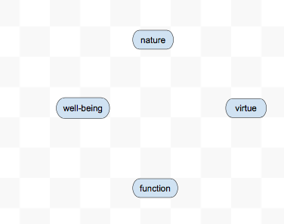  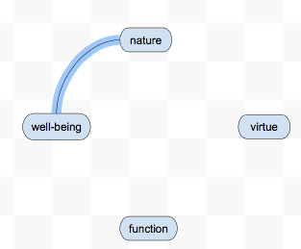  2.  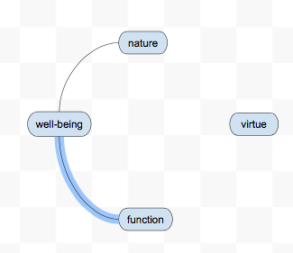  3.  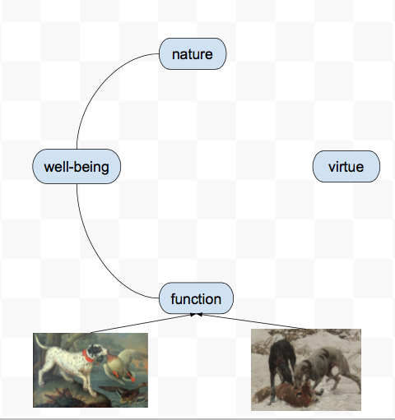  4.  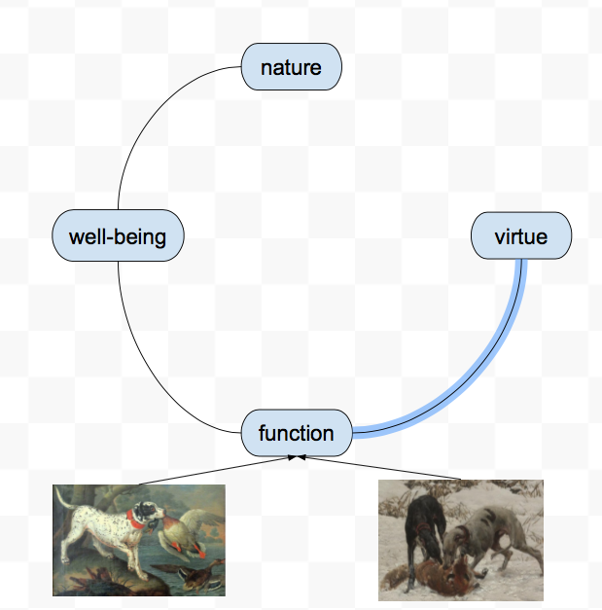  Add words like “loyal”, “strong”, “social”, “obedient” as examples of virtue (because those qualities enable animals to perform function)  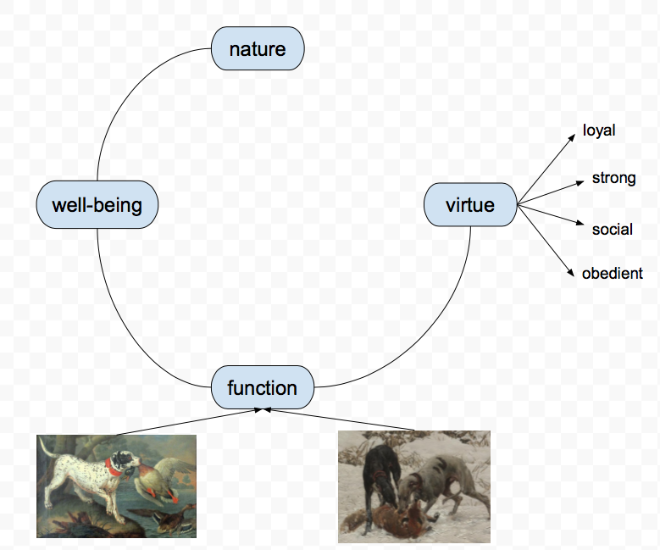  Power of Reason  https://commons.wikimedia.org/wiki/File:%27Ignudo%27_by_Michelangelo_JBU33.jpg
Is happiness up to us? If virtue is up to us, it is not by chance that we are happy because the major part of happiness is living virtuously. However, Aristotle admits that chance can deprive us of complete happiness. If all our friends die, or we are poor, or we live in an unjust city, we will not be able to fully flourish, to live a life of complete well-being. So there are things we can’t control, but for the most part, our happiness is in our own hands | Simple headshot. No text on screen.

