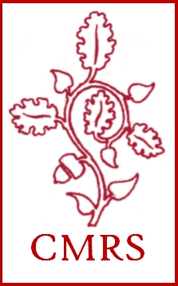

CENTER FOR MEDIEVAL & RENAISSANCE STUDIES
College of Arts & Sciences, University of Oklahoma
Newsletter, September 29, 2017

Welcome-back plus organizational meeting
Sept. 29, 3-5 pm, Ellison Hall 220
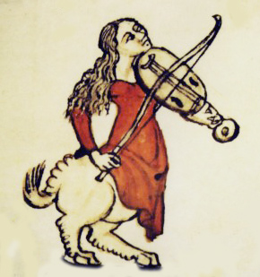
Picking up from last September’s very successful welcome-back plus organizational meeting, we invite all CMRS members and interested other people to join us in Ellison Hall, room 220, on Friday, Sept. 29, from 3-5 pm.
As always, there will be a Forward Foods cheese tray plus wine and water, and time to chat and catch up with each other plus meet new people. Then we’ll sit down and discuss various current and potential activities related to study of the medieval and/or Renaissance periods.

TABLE OF CONTENTS

- LOOKING FORWARD TO 2017-18
- Launch of MRS 3023
- Derdeyn-CMRS Graduate Student Research-Travel Scholarship
- Medieval Fair / CMRS Lecture Series
- The CMRS on Social Media
- Our First Donation!
- LOOKING BACK AT 2016-17: The CMRS’s accomplishments last academic year

LOOKING FORWARD TO 2017-18
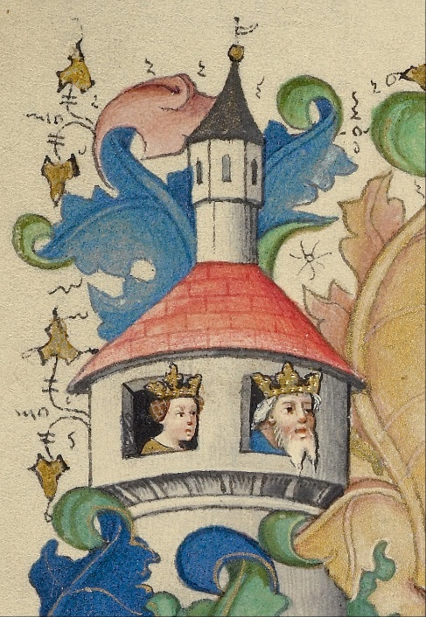
On the horizon this academic year: the CMRS’s first course, an interdepartmental med/Ren survey with dream-course status that brings us four visiting speakers; a class visit to the Museum of the Bible collection of manuscripts, in Oklahoma City; a call for applications for the second Derdeyn/CMRS Grad-Student Research Travel award; a full set of Medieval Fair/CMRS public lectures; a CMRS-powered podcast on the medieval in Game of Thrones; and surprise money possibly funding a symposium on images in manuscripts.
Please send your students to the events, and come yourself, and encourage your students to apply for the grant—and keep the good ideas coming for future events and projects.

MRS 3023: 20 undergrads from 15 different majors enroll in “Exploring Medieval & Renaissance Studies”

An interdisciplinary presidential
dream course taught by experts
in each field, plus distinguished
visiting scholars

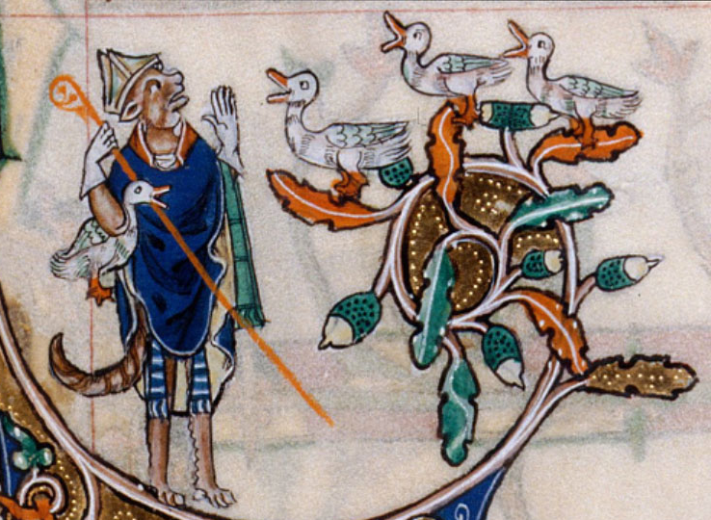
An interdepartmental array of undergrads (along with four grad-students attendees and auditors) are experiencing the first course created and run by the CMRS.
Designed by the CMRS’s Curriculum Committee—Joyce Coleman (English and CMRS), Kathleen Crowther (History of Science), Roberta Magnusson (History), Jennifer Saltzstein (Musicology), and Rienk Vermij (History of Science)—the course is being taught by thirteen CMRS professors from ten departments, along with four distinguished visitors. Each professor is lecturing in his or her area of expertise, allowing the class to cover 1,200 years (c. 500-c. 1700) of history, art, literature, and music. The course includes a field trip to the Museum of the Bible collection in Oklahoma City—a chance for students to see and interact with actual medieval manuscripts.
The class’s syllabus is online at http://cas.ou.edu/mrs-3023-fall-dream-course. CMRS members are welcome to drop in to hear lectures, including those of our dream-course visitors (Tuesday/Thursday 1.30-2.45, Farzaneh 148).
Prof. Coleman is the instructor of record, ensuring continuity across the semester, while welcoming her visiting OU colleagues:

Art History: Alison Palmer
Classics & Letters: Sara Coodin
English: Joyce Coleman
History: Roberta Magnusson; Jane Wickersham
History of Science: Kathleen Crowther; Rienk Vermij
International Area Studies: Gershon Lewental
Law: Brian McCall
Modern Languages: Roberto Pesce; Joe Sullivan
Musicology: Jennifer Saltzstein
Women’s and Gender Studies: Andreea Marculescu

Our dream-course visitors have been / will be:

Sept. 14: Dr. Jane Gilbert, French, University College London, England
Sept. 21: Dr. Nükhet Varlık, History, Rutgers University, Newark
Oct. 12: Dr. Martha Carlin, History, University of Wisconsin, Milwaukee
Nov. 16: Dr. Pamela Long, independent scholar

Dr. Gilbert’s talk on “Medieval Monsters and Maps” and Dr. Varlik’s on "Plague, Ecology, and Empire: Rethinking the Black Death Pandemic" both drew large and appreciative crowds at the Regents Room in the Memorial Union.
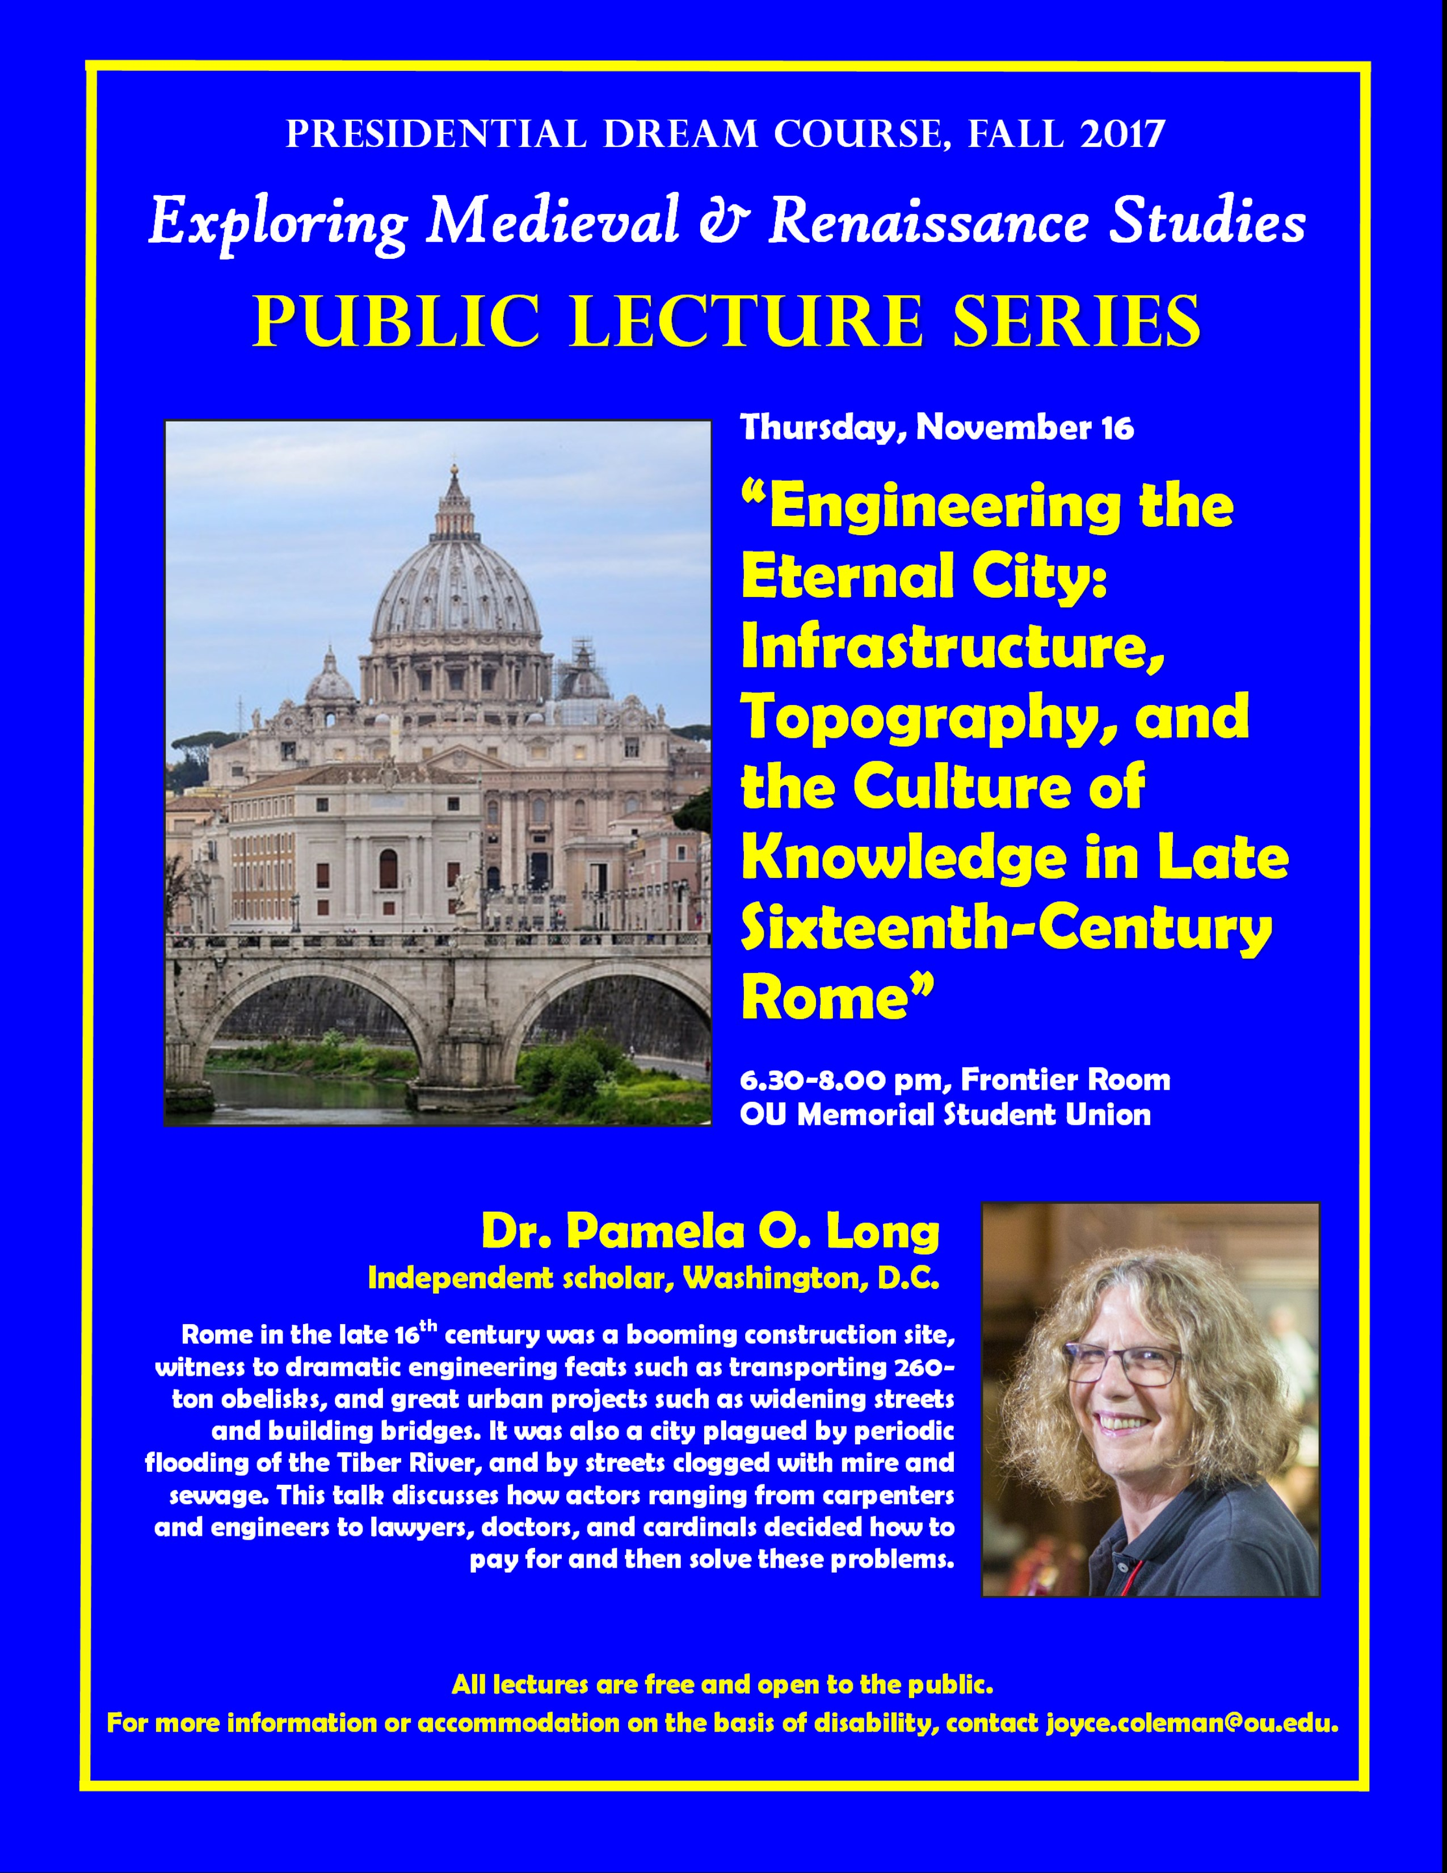
Dr. Carlin’s and Dr. Long’s upcoming public lectures are advertised below. (Medieval refreshments are planned for Dr. Carlin’s lecture.)
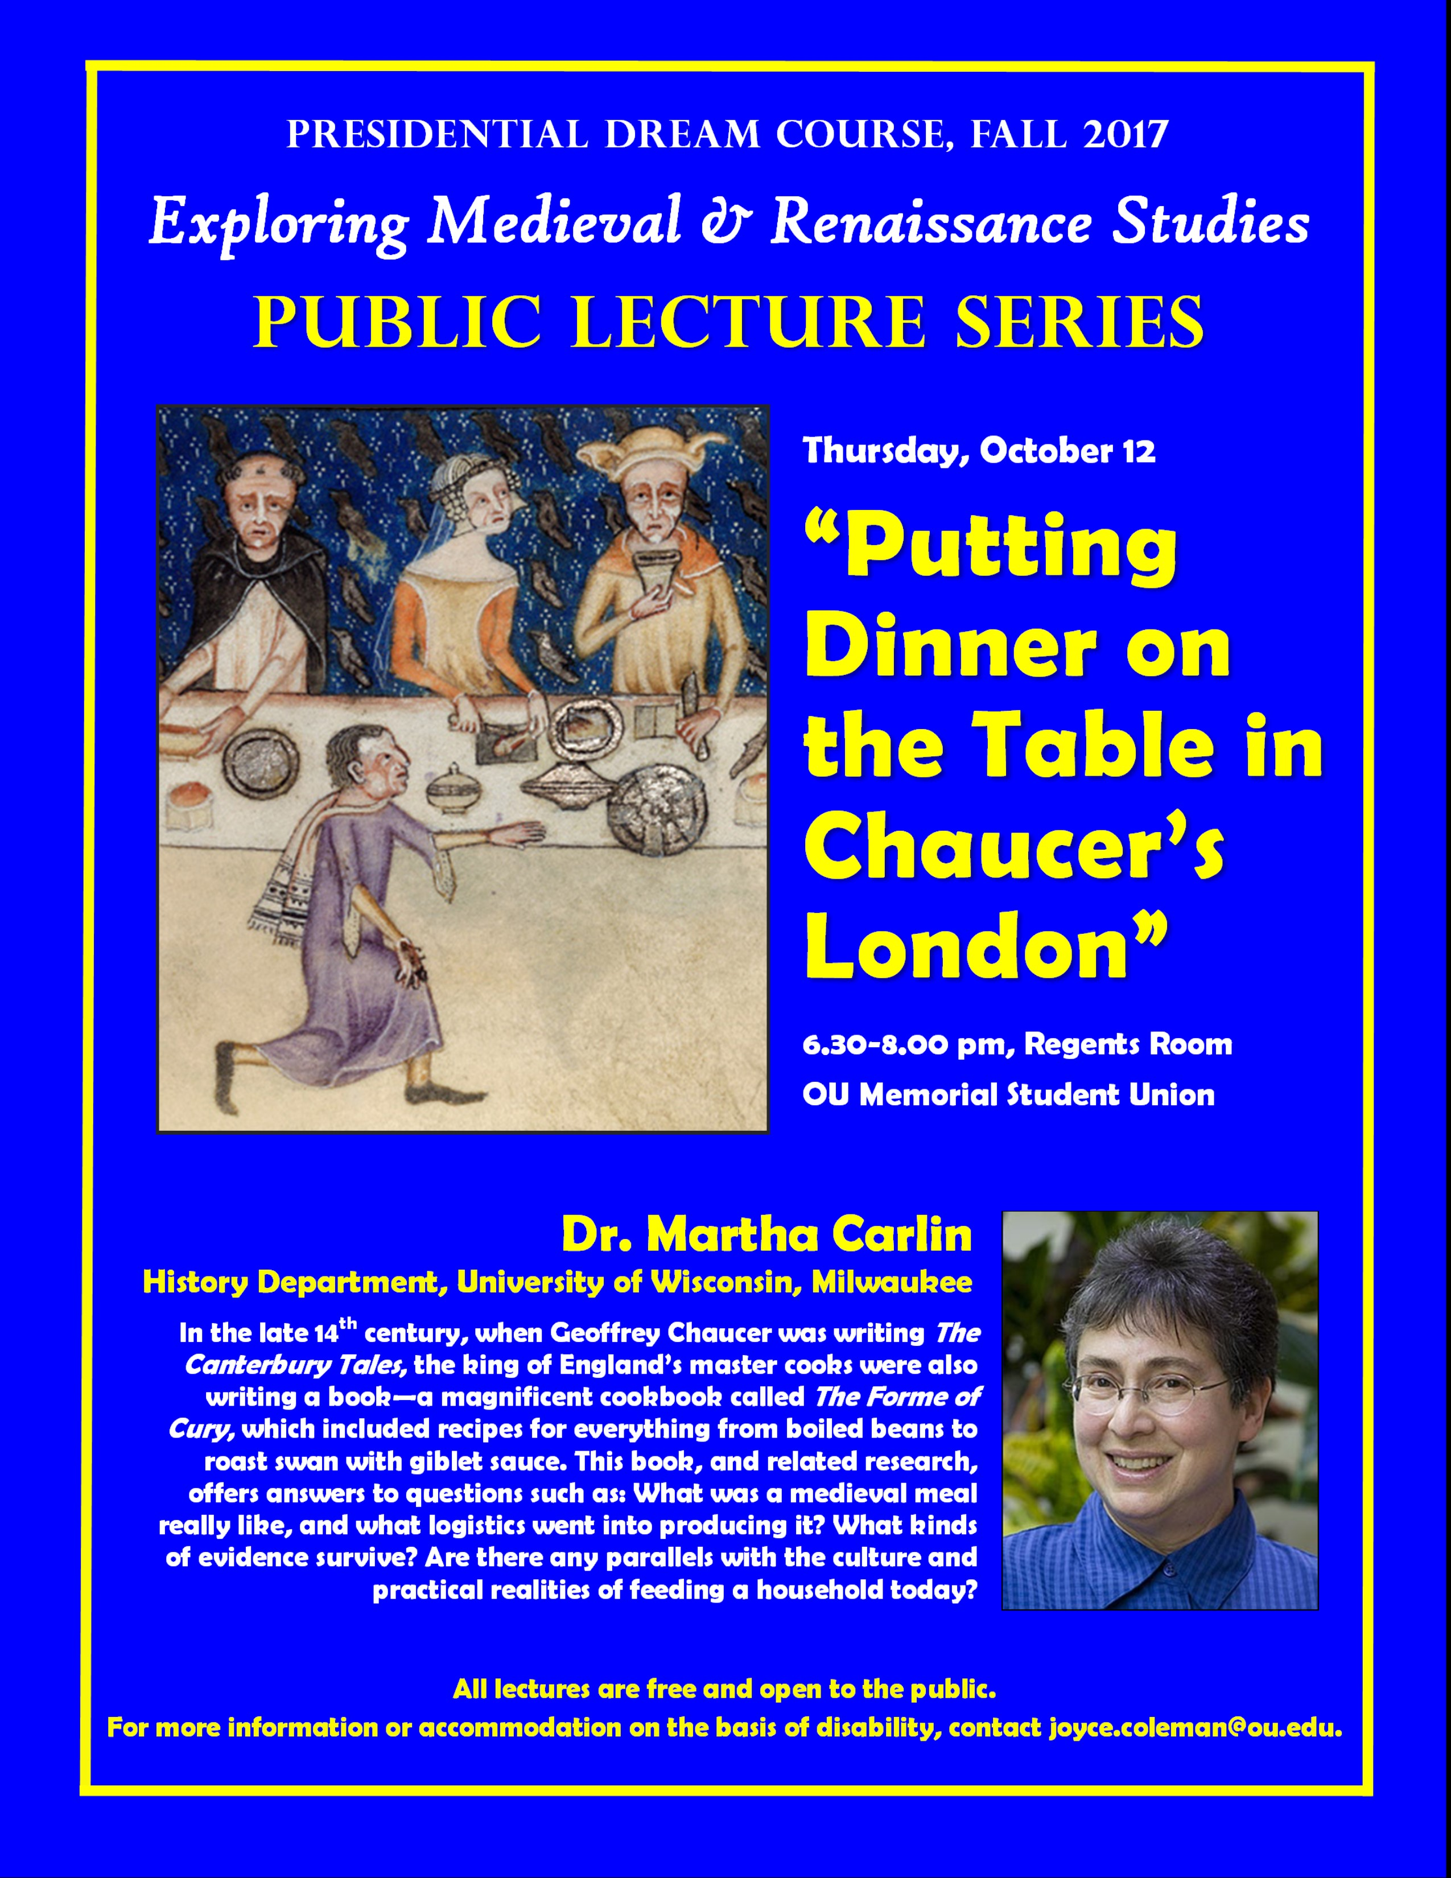

The Derdeyn-CMRS Graduate Student Research-Travel Scholarship

Our first Derdeyn-CMRS awardee
spent a rewarding two weeks in
England this summer

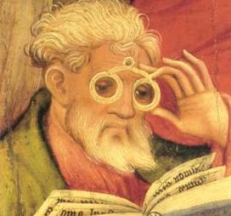
Jason Lubinski, a Ph.D. student in the English Department, was the first recipient of the Derdeyn-CMRS Scholarship. The award was established last year at the instigation of Conrad Derdeyn, in honor of his aunt Frieda Derdeyn Bambas. It uses unexpended income in the Rudolph C. Bambas Scholarship endowment account to fund travel by OU graduate students in medieval or Renaissance studies to libraries, archives, and historical sites of importance to their research.
The scholarship enabled Jason to visit England for the first time and to do research in the British Library and the Bodleian on medieval English ideas about masculinity. He also visited important med/Ren sites such as Westminster Abbey, the Tower of London, and Hampton Court. I strongly believe that experiencing the co-existence of such ancient monuments with the ongoing life of the 21st century is a crucial learning experience for American students. It takes some of the fantasy factor out of their studies, grounding them in the lived reality of the time and place they study.
The amount of the Derdeyn-CMRS Scholarship will vary with the funds available each year, but the hope is to provide enough funding to cover a round-trip flight from Oklahoma to the research site, as well as some local travel. Last year’s award was for $2,500.
The call for applications for next summer will go out in March 2018. If you know of any eligible grad students who would benefit from such an award, please call it to their attention.

Medieval Fair / CMRS Public Lecture Series

The CMRS’s oldest-running
program is back with another
stimulating lineup of public lectures

Medieval and Renaissance scholars at OU and neighboring institutions continue to reach out to a general audience through this series of public lectures co-organized by CMRS members Joyce Coleman (English) and Joe Sullivan (German) with Ann Marie Eckart, organizer of Norman’s Medieval Fair.
Below is a run-down of the speakers and topics scheduled for this academic year. All talks are at Norman West Library, 300 Norman Center Court, from 6.15-7.30 pm.

- Friday, Aug. 25: John McWilliams (Professor of Natural Science, Oklahoma Baptist University), “Science, Sheep Gut, and Souls: A Brief History of Medieval and Renaissance Strings”

- Friday, Oct. 6: Andreea Marculescu (Women’s and Gender Studies), "The Wicked Witch of the West: Brooms, Black Cats, and Stolen Babies"

- Friday, Nov. 3: Gershon Lewental (International & Area Studies), “Jewish and Christian Minorities in the Medieval Islamic World”

- Friday, Dec. 1: Roberta Magnusson (History), “Water, Power, and Beauty: Aqueducts and Fountains in Medieval Italy”

- THURSDAY, Feb. 8: Yael Lavender-Smith (Modern Languages), “Conversion to Judaism in Seventeenth-Century Amsterdam: The Tragic Story of Uriel da Costa”

- Friday, March 2: Rienk Vermij (History of Science), "Aristotelian Meteorology: Fire Dragons, Blood Rains, and Comets"
- Friday, April 13: John Cole (Laurel in the Society for Creative Anachronism), “Medieval Jewelry”

The CMRS on Social Media

Facebook, Twitter—and coming soon, a podcast
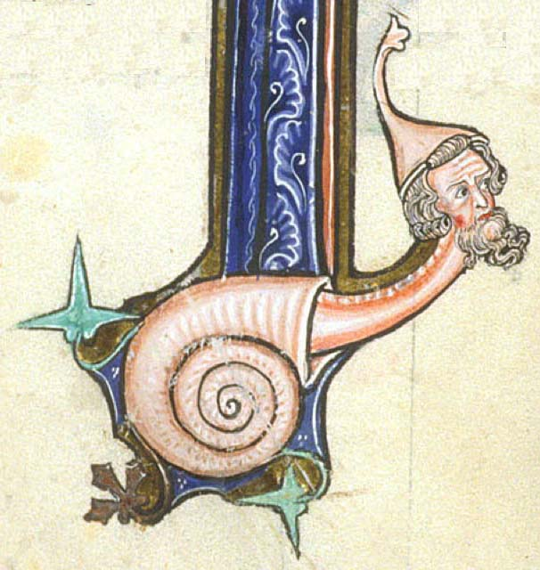
OU_MedRen: English grad student Cortney Wilmering continues to populate the CMRS’s Facebook and Twitter accounts with announcements of talks and events. We even have some likes!
Plus, we are doing our first podcast, by proxy, with History professor Jane Wickersham and English grad student Katy Krieger discussing the medieval antecedents of Game of Thrones for a College of Arts & Sciences podcast. Due out very soon.

Our First Donation!

A $1,000 check falls out of an
envelope …
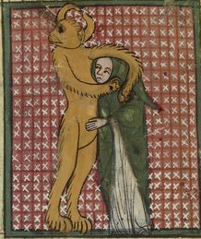
One of the attendees at last March’s Science of Parchment Symposium (see “Looking Back at 2016-17,” below) so much appreciated the event that he sent me a card with a check for $1,000. “Use it for the next symposium,” he wrote.
Apart from surprise and gratitude for receiving a donation, I and the very helpful staff in English then faced the challenge of finding an account to which we could deposit the check. A meeting in April with a CAS staffer revealed that the CMRS had a dormant “state account.” By May we had filled out a form to revive the account, under my name. In June I was told that the account was open, and I counter-signed and submitted the check. In August, when I returned from summer travels, I found that the account had not been open. The form was filled out again and resubmitted, and the account is now reportedly open and ready for deposits. As of this writing, however, it is not sure where in the system the signed check is.
We are optimistic, nonetheless, that check and account will find each other. Once they do, we may even set up a donation page on the CMRS website, in the hopes of attracting other generous supporters.
Meanwhile, I and some others have an idea for a “next symposium”—on images in manuscripts—but are holding off till the check clears …

LOOKING BACK AT 2016-17

The CMRS’s accomplishments for the
academic year 2016-17

Working as individuals or groups, the CMRS last year:

- With CMRS members Su Fang Ng (English) and Sara Coodin (Classics & Letters), presented a six-event Global Shakespeare Festival:
Sept. 15: Richard Loncraine, Richard III (1995); with after-film discussion including guests Profs. Tim Huston Orr and Alissa Mortimer (Helmerich School of Drama) and James Hart (History)
Oct. 20: Akira Kurosawa, Throne of Blood (1957, Japanese version of Macbeth); with after-film discussion including guest Prof. Man Fung Yip (Film and Media Studies)
Nov. 17: School of Drama professors and students performing/discussing scenes
Feb. 23: Ralph Fiennes, Coriolanus (2011, English); with after-film discussion
March 23: Sulayman al-Bassam, Al-Hamlet Summit (2004, Arabic); with after-film discussion including guest Prof. Mohammad Al Masri (International Area Studies / Modern Languages)
April 20: School of Drama professors and students performing/discussing scenes

- In co-operation with Ann Marie Eckart, of the Medieval Fair, Joyce Coleman (English; CMRS) and Joe Sullivan (German) organized seven Medieval Fair / CMRS lectures:
Sept. 9: Susan Havens Caldwell (Art History) and Eugene J. Enrico (Musicology), “King Alfonso X of Spain and His Songs to the Virgin Mary: Las Cantigas de Santa María”
Oct. 7: Fred Striz (Engineering), “Fortifications and Siege Warfare in the Middle Ages (part 2)
Nov. 4: Theresa A. Vaughan (UCO, Humanities & Philosophy), “Medieval Meals: Food, Drink, and Gender”
Dec. 12: Joe Sullivan (German), “Walking the Camino de Santiago in 2015 and 2016, through a Professional Medievalist's Eyes”
Feb. 3: Emily Graham (OSU, History), “How St. Francis and the Franciscans Changed the Medieval World”
March 3: Margaret Gaida (Ph.D. Candidate, History of Science), “Arabic Astrology in Medieval Europe: Texts and Practices”
April 7: Joyce Coleman (English; CMRS), “J.R.R. Tolkien’s Medieval Mythology”

- With Prof. Jennifer Borland of Oklahoma State University, and with the help of Kathleen Crowther (OU, History of Science), co-organized a two-university series of Science of Parchment events, featuring talks by Profs. Bruce Holsinger (English medieval literature, Univ. of Virginia) and Matthew Collins (Bioarcheology, Univ. of York).
The OU events included a Science of Parchment Symposium on March 23 in Meacham Auditorium. Provost and Senior Vice President Kyle Harper introduced the event. The talks that followed:
Bill Endres (English, OU), “Digitized Vellum: Discoveries in 2D and 3D ”
Christina Warinner (Anthropology, OU), “The Genetics of Grime and Dust”
Matthew Collins (University of York, Archaeology) and Bruce Holsinger (University of Virginia, English), “Animals in the Archives”
The Symposium was followed by a reception in Bizzell Library’s Special Collections, including an exhibit of parchment items from the Library’s collection and a tour of the Library’s Digitization Laboratory.
On March 24, Prof. Collins talked to Prof. Crowther’s “History of Science” class, in Special Collections, about “biomolecular codicology.”
Profs. Warinner and Collins then held a brown bag on the “Archaeology of the Invisible: A Discussion and Guided Tour of OU’s Laboratories of Molecular Anthropology and Microbiome Research.”

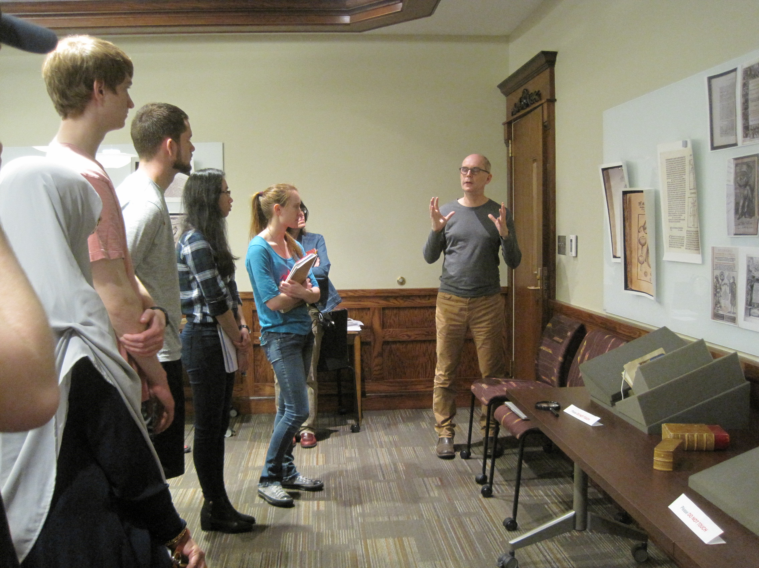
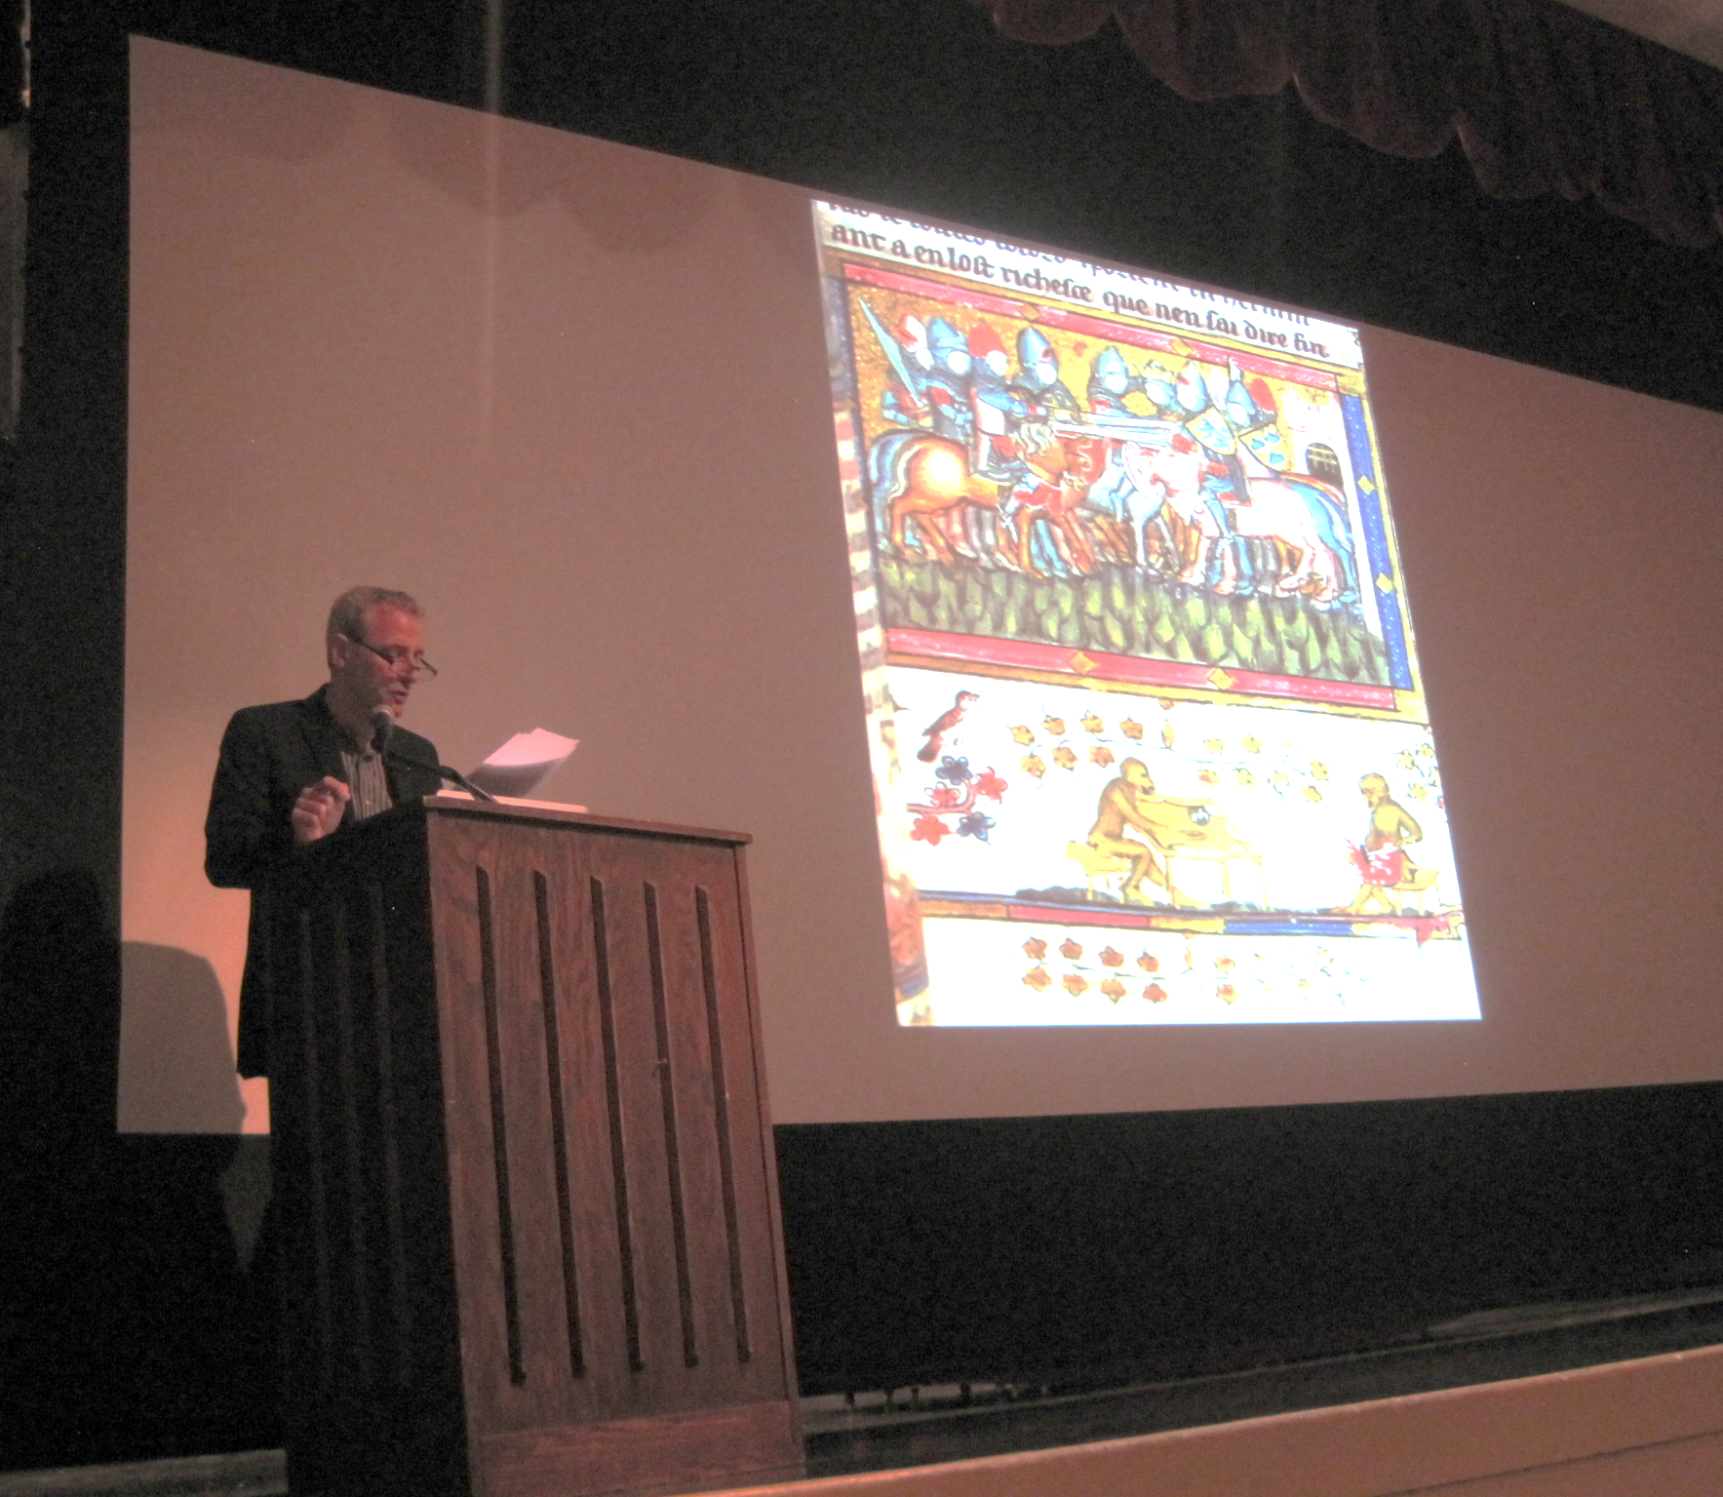
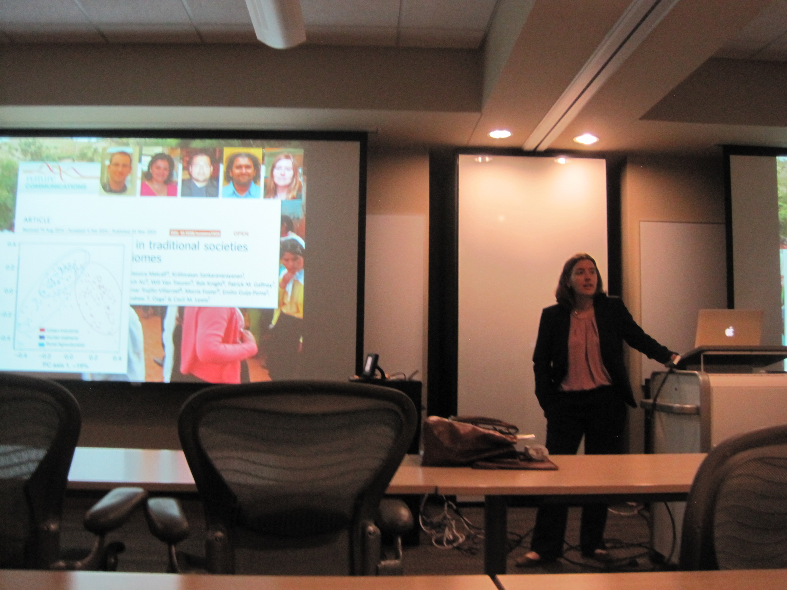

Prof. Holsinger lecturing; Prof. Collins talking to “History of Science” class; Prof. Warinner explaining her microbiome research

(For a follow-up story of Prof. Collins and colleagues working on an early gospel manuscript at Oxford, go to http://www.sciencemag.org/news/2017/07/goats-bookworms-monk-s-kiss-biologists-reveal-hidden-history-ancient-gospels.)

- On April 25, at the invitation of JoAnn Palmeri, acting curator of the John and Mary Nichols Collection, and with the cooperation of Kim Thomas of Boomer Buzz, launched the First Annual Shakespeare Birthday Party in Bizzell Library’s Helmerich Collaborative Learning Center Community Room (the “glass room” on lower level 1).
Cortney Wilmering (Ph.D. candidate, English) organized a series of events: “Shakespeare Bingo”; “How to Shakespeare” (in which Cortney, along with fellow English grad students Kevin Aschenbach, Jason Lubinski, and Whitney Whitaker, shared advice about how to read and enjoy the Bard); and “Impromptu Shakespeare,” in which undergrads were handed scripts for their roles, and launched into performances of scenes from A Midsummer’s Night’s Dream and The Taming of the Shrew. The English grad students, including Amanda Cuellar, joined in the acting and Sarah Wade of the Renaissance Fair put in a special appearance in full Elizabethan costume. There was a good turnout and a good experience for all.
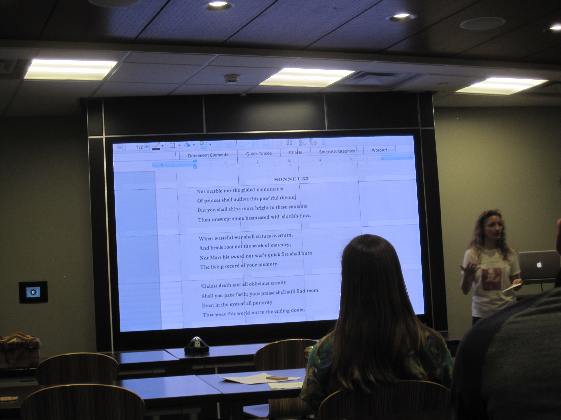
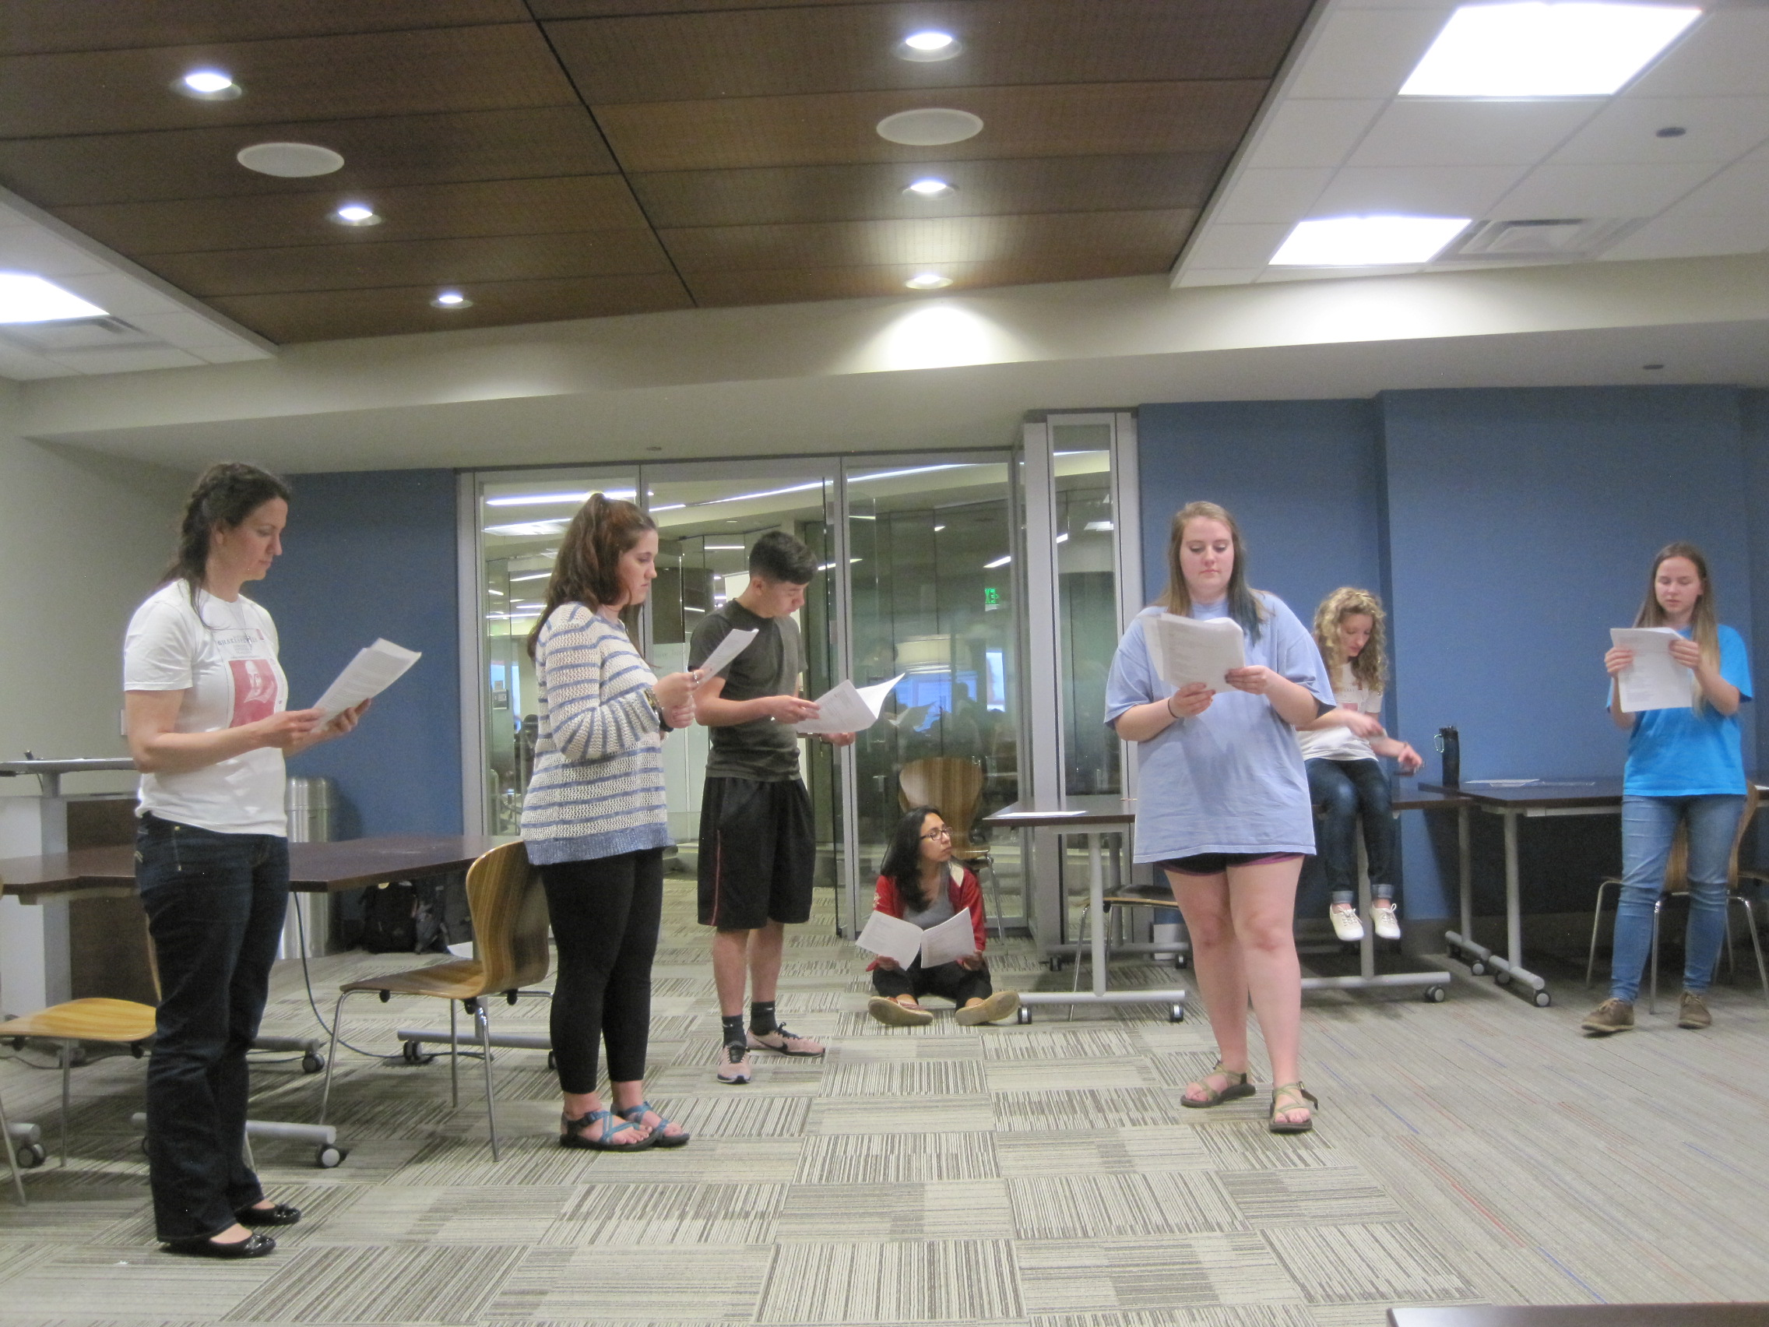
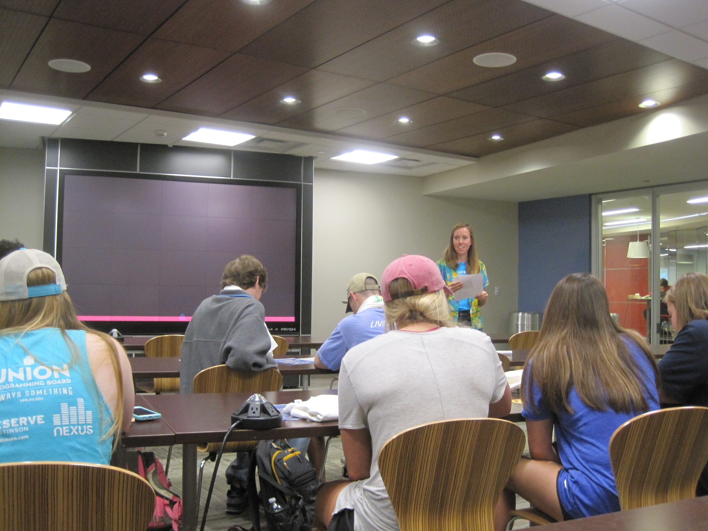

Boomer Buzz organizer reads out clues for Shakespeare Bingo; Whitney Whitaker explains enjambement; Cortney Wilmering, Amanda Cuellar, and undergrads perform a scene from “Midsummer Night’s Dream”

- Returned for the fifth year to man a table at the Majors and Minors Fair.

- Also manned a table at CAS’s Open House in April.

Gratias ago

Grateful thanks go to:

The English Dept., especially the chair, Daniela Garofalo, for continuous financial and institutional support for CMRS activities, and to department staff Kathy Bell and Brenda Mackey for managing the collection and disbursement of CMRS-related funds.

Dr. JoAnn Palmeri and Barbara Laufersweiler of Bizzell Library’s Special Collections for hosting the reception after the Science of Parchment Symposium, and Kim Thomas of Boomer Buzz for supporting and hosting the Shakespeare Birthday Party.

Ann Marie Eckart, of the Medieval Fair, for her continuing good will, for her tireless persistence in promoting and enabling the study and enjoyment of the medieval period, and for her energetic endorsement and promotion of the CMRS minor.

Our generous funders: The Office of the Senior Vice President and Provost; OU Libraries; and the Departments of Classics & Letters, English, and History of Science.

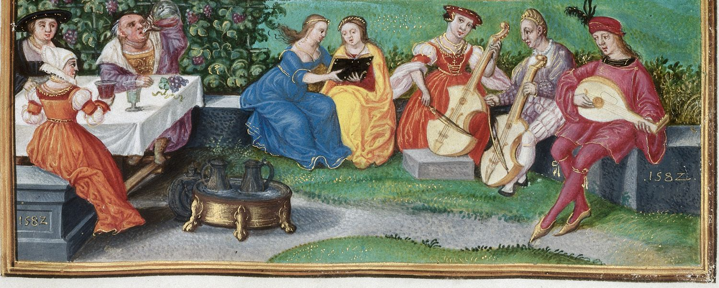

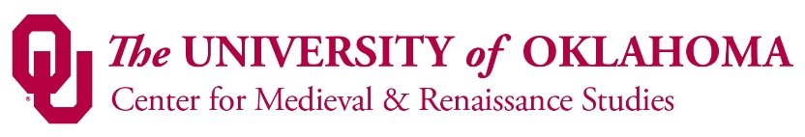

Director: Joyce Coleman
Rudolph C. Bambas Professor of Medieval English Literature & Culture
English Department
joyce.coleman@ou.edu

